**Algebra I Unit Plan for Quadratics**

**Instructional Pathway**

|  |  |
| --- | --- |
| **Learning Activities & Teaching Strategies Used in This Unit**  **CB =** choice board: different options for activities/tasks/problems are presented on a grid or table  **CC** = compare/contrast topic  **CS** = card sort: sort cards into groups with a common theme, or match multiple sets of cards (e.g. graph, equation, table)  **EA** = error analysis: teacher models a common mistake and students determine where the mistake was made, or teacher presents alternative approaches, and students determine which, if any, are wrong  **GO =** graphic organizer (e.g. Frayer model for vocabulary terms, flowchart diagrams for solving equations, blank Venn diagrams, etc.)  **MR** = multiple representations (e.g. verbal, algebraic, numeric, symbolic, graphical)  **MS** =math Sprint. Kill and Drill  **RWC** = real world connections  **S** = stations: for review, targeted intervention, differentiation, enrichment, etc.  **T** = technology; graphing calculator  **WB** = whiteboard: students do/correct their work on mini whiteboards and share with a partner, group, or class  **WP** = writing prompt: for collection (i.e. exit slip) or journal | **Grouping Structures**  (I) = individual  (P) = with a partner  (S) = station  (C) = whole class |
| **Common Core Standards**  **F-IF.1** Understand that a function from one set (called the domain) to another set (called the range) assigns to each element of the domain exactly one element of the range. If *f* is a function and *x* is an element of its domain, then *f(x)* denotes the output of *f* corresponding to the input *x*. The graph of *f* is the graph of the equation *y = f(x)*.  **F-IF.2** Use function notation, evaluate functions for inputs in their domains, and interpret statements that use function notation in terms of a context.  **F‐IF.4** For a function that models a relationship between two quantities, interpret key features of  graphs and tables in terms of the quantities, and sketch graphs showing key features given a verbal description of the relationship.  **F‐IF.5** Relate the domain of a function to its graph and, where applicable, to the quantitative  relationship it describes.  **F‐IF.7** Graph functions expressed symbolically and show key features of the graph, by hand in simple cases and using technology for more complicated cases.  a. Graph linear and quadratic functions and show intercepts, maxima, and minima.  **F‐IF.8** Write a function defined by an expression in different but equivalent forms to reveal and explain different properties of the function.  a. Use the process of factoring and completing the square in a quadratic function to show zeros, extreme values, and symmetry of the graph, and interpret these in terms of a context.  **F‐BF.1** Write a function that describes a relationship between two quantities.  a. Determine an explicit expression, a recursive process, or steps for calculation from a context.  **F‐BF.3** Identify the effect on the graph of replacing *f(x)* by *f(x) + k*, *k f(x)*, *f(kx)*, and *f(x + k)* for specific values of *k* (both positive and negative); find the value of *k* given the graphs. Experiment with cases and illustrate an explanation of the effects on the graph using technology.  **F‐LE.3** Observe using graphs and tables that a quantity increasing exponentially eventually exceeds a quantity increasing linearly, quadratically, or (more generally) as a polynomial function.  **A-REI.4** Solve quadratic equations in one variable.  a. Use the method of completing the square to transform any quadratic equation in *x* into an equation of the form *(x – p) 2 = q* that has the same solutions. Derive the quadratic formula.  b. Solve quadratic equations by inspection (e.g., for x*2* = 49), taking square roots, completing the square, the quadratic formula and factoring, as appropriate to the initial form of the equation. Recognize when the quadratic formula gives complex solutions and write them as *a* ± *bi* for real numbers *a* and *b*.  **F-LE.1** Distinguish between situations that can be modeled with linear functions and with exponential functions.  b. Recognize situations in which one quantity changes at a constant rate per unit interval  **F-LE.2** Construct linear and exponential functions, including arithmetic and geometric sequences, given a graph, a description of a relationship, or two input-output pairs (include reading these from a table  **F-LE.5** Interpret the parameters in a linear or exponential function in terms of a context.  **A-SSE.3** Choose and produce an equivalent form of an expression to reveal and explain properties of the quantity represented by the expression.  a. Factor a quadratic expression to reveal the zeros of the function it defines.  b. Complete the square in a quadratic expression to reveal the maximum or minimum value of the function it defines.  **A-APR.3** Identify zeros of polynomials when suitable factorizations are available, and use the zeros to construct a rough graph of the function defined by the polynomial.  **A-CED.2** Create equations in two or more variables to represent relationships between quantities; graph equations on coordinate axes with labels and scales.  **A-REI.10** Understand that the graph of an equation in two variables is the set of all its solutions plotted in the coordinate plane, often forming a curve (which could be a line).  **N-Q.1** Use units as a way to understand problems and to guide the solution of multi-step problems; choose and interpret units consistently in formulas; choose and interpret the scale and the origin in graphs and data displays |  |

|  |  |  |  |
| --- | --- | --- | --- |
| **Standards** | **Aim** | **Lesson Content** | **Activities & Strategies** |
| F-IF.1  F-IF.2 | 1. How do we graph quadratic functions using a table of values? | 1. Recognize the relationship between table values and coordinate points 2. Identify quadratic functions from a table of values 3. Distinguish between quadratic functions and non-linear through tables | MR(C) Students will analyze the process of creating a table and comparing the domain and range of the quadratic function for similarities for future use  CS(P) Students will categorize quadratic functions with its equivalent table  WB/CC(P): Students will create quadratic function from a given table on WB. Students will compare graphs with their partners and then the instructor’s board (which will have an error). Furthermore students will discuss with partner the errors or the differences in the whiteboards of the instructors  WP (I) Exit Slip: Students will be given a parabola and must match the graph with its table. |
| F-IF.4  F-BF.3 | 1. What effect does changing a, b, or c have on the graph of a quadratic function? | 1. Identifying the effect of changing constants or coefficients on quadratic functions 2. Using technology to verify such changes | MS/T(I) Students must identify the effects of the coefficients on the quadratic equation and verify against technology. Students must be able to use descriptive words to compare the functions against the parent function or previous function given  GO(C): Three door foldable which explains the connection of a, b, and c to the quadratic function.  CC(P): How does the graph of the parabola change when a negative coefficient is given? What happened when any of the coefficient is less than 1 but greater than 0?  EA(C): James sees the quadratic function 3x2+2x-4 and compares it to the function x2+2x-4. He determines the graph shifts to the right by 3. Is his statement correct? What misconceptions may James have and how could you help him state the correct answer? |
| F-IF.8A  A-APR.3  F-IF.4  A-SSE.3A | 1. How do we determine the roots/solutions of a quadratic function? | 1. Determine the roots of a quadratic function from its graph and without its graph 2. Identify the relationship between the functions zeros/solutions with its factors 3. Recognize the symmetric relationship between the roots of the quadratic function thus creating the axis of symmetry | MR(C): Students will watch the YOUTUBE video of graphing a function in a discrete and continuous domain and extract important information to relay in their Cornell Notes  CC/GO(G) Students compare and contrast the method of finding the solutions of the quadratic function with the use of a graph verses algebraically (factoring). Students will state equivalence of both methods.  WP(P): Using Costa’s Levels of Thinking (Level Two), describe the relationship between the factors and the axis of symmetry? If the roots cannot be found, how can the axis of symmetry be found? |
| A-CED.2  A-APR.3  F-IF.8A  F-BF.1A  A-SSE.3A | 1. How can we use the roots/ zeros and the properties of a quadratic function to create its equation? | 1. Creating a quadratic function given its specific roots or imaginary roots 2. Creating quadratic functions given its axis of symmetry and vertex | GO(C): Flowchart: Given the specific roots -7 and 5, students will work backwards to create a trinomial.  CC(C): Using Costas Level Of Thinking 3, create multiple functions of the same quadratic function. What are the key similarities of each function? Why is it possible to have multiple functions with the same roots? |
| F-LE.2  F-BF.1A  A-REI.10 | 1. How can we use the roots/ zeros and the properties of a quadratic function to sketch its graph? | 1. Determining the roots and axis of symmetry of a quadratic equation and using the step pattern to create further points 2. Speculating the structure of a quadratic graph with two distinct root, one root, or no real roots before sketching 3. Distinguishing the maximum or minimum value of a parabola and its relation to its “a” value | WB(C): Students graph quadratic functions on whiteboard using only roots and vertex.  CC (C): What information does the vertex provide when sketching a parabola? How is it interrelated with the axis of symmetry? Which piece of information is necessary to graph the parabola using the step pattern?  T(I): Students verify the step pattern using technology.  WP(I): Using the AVID strategy, Quickwrite, mathematically defend why the step pattern is a shortcut method to graphing a parabola and describe effect of “a” on the step pattern.  GO(C): Tri Fold which represents the three directional phases of the step pattern: vertex, step pattern, and create pattern |
| F-LE.2  F-BF.1  A-CED.2  F-IF.4  F-IF.5  F-IF.7A  F-LE.5  N-QN.1 | 1. What is vertex form and when do we use it? | 1. Conversion of standard from to vertex form by using “completing the square” factoring technique | CS(P): Students will match the steps of completing the square to the original quadratic function. In each step, students will justify with mathematical reasoning.  CC (I): Using the quadratic function 2x2+30x+52, compare the steps of completing the square verses factoring using any other method given in class. Which method is more advantageous when figuring out the roots algebraically? Which technique is more advantageous when finding the vertex? Defend your answer using mathematical justification  MR (P): Given the graph of the quadratic, students will see the similarity between the vertex of the quadratic and the technique of completing the square. |
| F-LE.2  F-BF.1  A-CED.2  F-IF.4  F-IF.5  F-IF.7A  F-LE.5  N-QN.1 | 1. How do we use vertex form to determine the zeros and show symmetry in quadratic functions? | 1. Interpret the relationship between the vertex and the axis of symmetry and the relation to its roots 2. Using completing the square factoring technique to determine the vertex of a quadratic function 3. Recognize the roots and vertex in the quadratic function with and without completing the square factoring technique | CB (I): Given the quadratic function 5x2+8x+3, determine the vertex and the roots of the function and determine the discriminant of the roots. Students have the opportunity to use either completing the square or the properties of quadratic functions  EA(C): Julian wants to find the vertex and the roots following quadratic function 3x2-19x-14 . He decides to complete the square and takes half of B and then square of b first and rewrites the first three terms as a trinomial. Which step did he neglect and what is the importance of this step? |
|  | 1. How can we model and solve real world problems leading to quadratic functions? | 1. Choose appropriate domains in context to the problem 2. Identify the parts of a function and relate the findings to the original problem 3. Introduction of quadratic functions using substitution of important information | CC(P) Dissect the problem using the three steps in class (understand the problem, model, and evaluate) with particular focus on understand and model using WICOR strategy “close reading”. Compare finding with another pair  MR(S) Emphasis on understanding the problem through color coding or highlighting (Below Standards), modeling the problem using any means: equations, visually, number sense combinations of either (Approaching Standards), and modeling using only equations and/or solving the equation (Meeting Standards)  WP(I) Exit Slip: Focusing on the first two steps, understand and model the equation of a word problem leading to a quadratic function. Is there any restriction on your domain based upon the given problem and does it have any effect on the range? |
| F-LE.1B  F-LE.1C | 1. How can we extend the relationship between zeros and factors to cubic functions? | 1. Identify the domain of the cubic functions 2. Create the factors of cubic functions without the use of graph | WB(P): Students will share out their whiteboard answers and determine the context in which there should be a curved line or straight line(share and fix mistakes)  GO(C): Generate key words from each translation which signify exponential or linear. Describe the rate of change and interpret its similarities; i.e. y-intercept, slope, solution set |
|  | 1. End Of Unit Exam | a. Assessment of student content mastery |  |

**Differentiation strategies used in this unit & modifications embedded within this unit to provide access for all learners**

|  |
| --- |
| 1. When developing list of vocabulary words for the unit, provide students with the opportunity to draw graphic representations/examples of the words and add them to the word wall. 2. Provide multiple representations of solutions and solution sets throughout unit. 3. Choice provided to students in product via choiceboards and learning stations. 4. Use of open-ended questions provides students at varying levels with entry points. 5. Students are provided with independent think time prior to answering questions in any grouping setting. 6. Real world connections help to build relevance. 7. Geared for all ELL’s and students with IEP’s: specific graphic organizers such as Frayer Models and Four Corners which highlight academic vocabulary with a visual representation of the term and a visual representation of what the term may be confused with in non-academic language. 8. WICOR strategy Compare and Contrast Graphic Organizer given to students who may not understand the commonalities between methods |

**Development of Academic & Personal Behaviors and 21st Century Skills**

|  |
| --- |
| 1. Students maintain portfolios and contribute work from this unit to it; students are provided with opportunities to revise their work, after receiving feedback from peers and teacher (including the unit performance task). 2. Through the use of strategic grouping, driven by formative assessment data, students interact with pairs, groups, and the whole class on a routinely changing basis; tasks and classroom activities are developed to promote independence (e.g. the use of “Ask Three Before Me” and related strategies), effective collaboration, and leadership. 3. Students utilize Cornell notes to help them stay organized and reflect on their learning. |

**Post-Test on Quadratics**

**Name: __________________________**

1. Expand the following :

(2x – 5) (x+ 2)

(1) *2x*2 + 9x + 10 (2) *3x – 3*

(3) *2x*2 - 10 (4) *2x*2 – x - 10

Top of Form

2. Solve 64*x*2 – 25 = 0 by finding square roots.

(1) ,  (2) ,  (3) -8, 8 (4) no solution

3. Solve *x*2 + 8*x* = -15

(1) -3, 5 (2) 3, -5 (3) -3, -5 (4) 3, 5

4. If the quadratic formula is used to find the roots of the equation

x2 – 6x - 19 = 0, the correct roots are :

(1) 3 ± 2 (2) 3 ± 4

(3) -3 ± 2 (4) -3 ± 4

5. Identify the graph of *y* = –5*x*2 – 5.

(1) 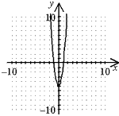 (2) 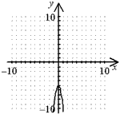

(3) 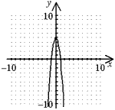 (4) 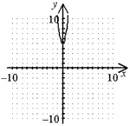

6. When you graph (–6, –1), (–3, 2), (–1, 4), and (2, 7). Which model is

most appropriate for the set?

(1) 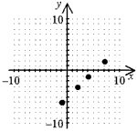 exponential (2)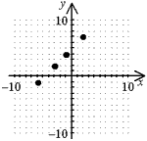linear

(3) 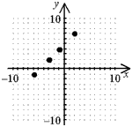quadratic (4) 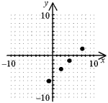cubic

7. Find the side of a square with an area of 79 ft2. If necessary, round

to the nearest tenth.

(1) 4.3 ft. (2) 8.9 ft. (3) 6,241 ft. (4) 39.5 ft.

8. Which quadratic function has the widest graph?

(1) *y* = 1 over 5*x*2 (2) *y* = 4*x*2  (3) *y* = 1 over 4*x*2 (4) *y* = 0.6*x*2

9. Find the number of solutions of : 0 = 2*x*2 + 8*x* – 10

(1) 0 solutions (2) 1 solutions

(3) infinite solutions (4) 2 solutions

10. Which equation best models the data?

|  |  |  |  |  |  |
| --- | --- | --- | --- | --- | --- |
| **x** | **-3** | **-2** | **-1** | **0** | **1** |
| **Y** | **5** | **0** | **-3** | **-4** | **-3** |

(1) *y* = *x*4 + *x*2 + *x* + 4 (2) *y* = –2*x* – 3

(3) *y* = *x*2 – 4 (4) *y* = 4*x*

11. Identify the vertex of the graph. Tell whether it is a minimum or maximum.  
 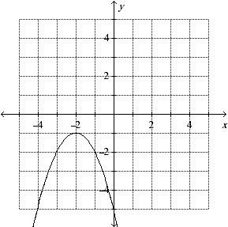

(1) (–2, –1); minimum (2) (–2, –1); maximum

(3) (–1, –2); minimum (4) (–1, –2); maximum

12. Use the Zero-Product Property to solve –2*x*(2*x* + 5) = 0.

(1) 2,  (2) 0,  (3) 2,  (4) 0, 

13. Solve 16*x*2 – 81 = 0 by finding square roots.

(1)  (2) no solution (3)  (4) 

14. Solve 8m2 + 20m = 12, for m by factoring.

(1)  (2) no solution (3) , 3 (4) , -3

15. Tasha is planning an expansion of a square flower garden in a city

park. If each side of the original garden is increased by 8 meters,

the new total area of the garden will be 196 square meters. Find

the length of each side of the original garden.

(1) 14m (2) 6m (3) 8m (4) m

16. Ryker is given the graph of the function y = x2 – 4.

He wants to find the zeros of the function, but is unable to read

them exactly from the graph. Find them in simplest radical form.

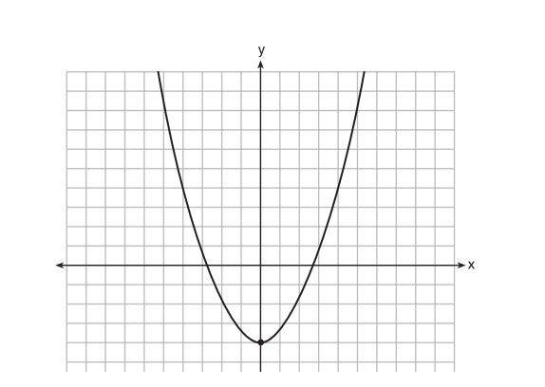

(1) ± 2 (2) ± 2 (3) ± 4 (4) ±

17. Factorize completely : 𝟑𝒙𝟐 – 𝟐7

(1) 3(x2 – 9) (2) 3(x - 9) (x + 9)

(3) 3(x – 3) (x + 3) (4) 3(x – 3) (x – 3)

18. Solve for 𝒅: 𝟑𝒅𝟐 +𝒅 − 𝟏𝟎 = 0

(1) , -2 (2) no solution (3) , -2 (4) , 2

19. A plot of land for sale has a width of x ft. and a length that is 8ft. less than its width. A farmer will only purchase the land if it measures 240 sq. ft. What value for x will cause the farmer to purchase the land?

20. The length of a rectangle is 5 in. more than twice a number. The width is 4 in. less than the same number. The perimeter of the rectangle is 44 in. Sketch a diagram of this situation and find the unknown number.

***THE FIELD GOAL KICKER***

Name : __________________________________________

A place kicker for the New York Jets is attempting a field goal with 2 seconds on the clock in a very intense game which is being played at Lucas Oil Stadium in Indianapolis, Indiana. They are trailing the Colts by a score of 16 to 14. If he can make this it will win the wild card game.

The following quadratic equation maps the flight of the football.

*h = d ( d – 60 )*

The height of the ball is represented by *h* and the horizontal distance travelled is represented by *d*. Before the ball is kicked the height of the ball is obviously zero. As *d* increases so does the height for a while. Eventually the ball starts to come back down and at this point as the horizontal distance increases the height will decrease. Complete the table below to gain a better idea of the flight of the ball.

|  |  |  |  |
| --- | --- | --- | --- |
| Height (*h*) | Distance (*d*) | Height (*h*) | Distance (*d*) |
| 0 | 0 |  | 35 |
|  | 5 |  | 40 |
|  | 10 |  | 45 |
|  | 15 |  | 50 |
|  | 20 |  | 55 |
|  | 25 |  | 60 |
|  | 30 |  | 65 |

Graph these points and sketch a smooth curve. Be sure to label your axes.



9

8

7

6

5

4

3

2

1

0

0 10 20 30 40 50 60

With three seconds on the clock the ball is on the Colts 32 yard line. Trailing by two points Folk

is sent in to win the game. The ball is snapped and Folk kicks it from the 39 yard line. Given that

the goal posts are 10 yards deep in the end zone and the cross bar is 3 yards above the ground who wins

the wild card game. You must show all the relevant working out to prove your answer.

____________________________________________________________________________________

____________________________________________________________________________________

____________________________________________________________________________________

____________________________________________________________________________________

____________________________________________________________________________________

____________________________________________________________________________________

____________________________________________________________________________________

____________________________________________________________________________________

____________________________________________________________________________________

____________________________________________________________________________________

____________________________________________________________________________________

____________________________________________________________________________________

____________________________________________________________________________________

____________________________________________________________________________________

____________________________________________________________________________________

____________________________________________________________________________________

____________________________________________________________________________________

____________________________________________________________________________________

____________________________________________________________________________________

____________________________________________________________________________________

____________________________________________________________________________________

____________________________________________________________________________________

***Teacher’s notes***

*h = d ( d – 60 ) if d = 0, h = 0*

*h = d ( d – 60 ) if d = 10, h = 5*

*h = d ( d – 60 ) if d = 20, h = 8*

*h = d ( d – 60 ) if d = 30, h = 9*

*h = d ( d – 60 ) if d =4 0, h = 8*

*h = d ( d – 60 ) if d = 50, h = 5*

*h = d ( d – 60 ) if d = 60, h = 0*

|  |  |
| --- | --- |
| 0 | 0 |
| 5 | 2.75 |
| 10 | 5 |
| 15 | 6.75 |
| 20 | 8 |
| 25 | 8.75 |
| 30 | 9 |
| 35 | 8.75 |
| 40 | 8 |
| 45 | 6.75 |
| 50 | 5 |
| 55 | 2.75 |
| 60 | 0 |

If the ball is kicked from the 39 it travels 49 yards to reach the goal post. (the posts are 10 yards deep in the end zone)

When d = 49, h = 5.39 The cross bar is 3 yards high, so the kick clears the cross bar with 2.39 yards to spare. The Jets win and move on to play New England.

You could ask them to draw the line y = 3 and find the point of intersection on the graph. This is a technique they should look at and be familiar with.

***Name: ____________________________ Date : ______________***

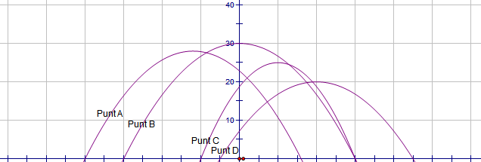

**0 10 20 30 40 50 40 30 20 10 0**

**G I A N T S P A T R I O T S**

**Steve Weatherford is the punter for the New York Giants. He made four punts during an important game against the Patriots. All four of his punts followed a parabolic pathway. His first punt was from the Giants 20 yard line and went a distance of 60 yards. His second punt was kicked from the Giants 40 yard line . His third punt went the closest to the Patriots goal line, and his fourth punt which was his second highest kick of the day, reached a height of 28 yards and landed on the Patriots 34 yard line.**

**Find the equation of each punt’s pathway. List the domain and range for each punt. Show the equations in both standard form and completing the square form. *(assume that the horizontal axis is the x-axis and the origin is along this axis on the 50 yard line.)***

**Match the first, second, third and fourth punt with the with**

**Punt A, Punt B, Punt C and Punt D on the graph above.**

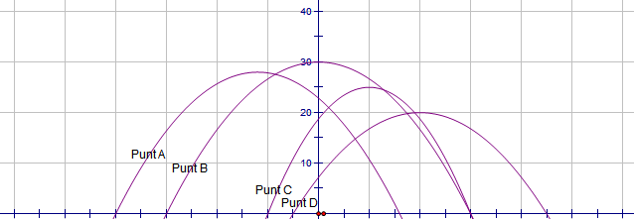

**-50 -40 -30 -20 -10 0 10 20 30 40 50**

**Give a clear explanation about how you found each equation.**

**__________________________________________________________**

**__________________________________________________________**

**__________________________________________________________**

**__________________________________________________________**

**__________________________________________________________**

**__________________________________________________________**

**__________________________________________________________**

**__________________________________________________________**

**__________________________________________________________**

**__________________________________________________________**

**A field goal kicker kicked the ball from the Patriot’s 39 yard line.**

**The ball followed the path of : *h = d ( d – 60 )***

**In this equations h, represents the height of the ball and, d, represents the horizontal distance that the ball has traveled.**

**Plot the graph for this quadratic. Show the roots and also find the vertex. Explain what these points mean and what the real life constraints are for the domain and range of the function.**

**There is one second on the clock and the Giants are two points behind. Given that the goal posts are 10 yards deep in the end zone and the cross bar is 3 yards above the ground who wins the game. You must show all the relevant working out to prove your answer.**

**The record for the longest field goal is 64 yards. Can you find an equation that would map a parabolic flight of the ball making it clear the goal post with a yard to spare and landing 4 yards behind the crossbar?**

**What was the maximum height that this field goal reached?**

**Create a similar problem for a field goal kicking scenario.**