**Subject : Algebra II**

|  |  |  |
| --- | --- | --- |
| **UNIT THREE** | | |
| **TOPIC** | **Radicals – 10 days** | |
| **ESSENTIAL QUESTIONS** | Why is the product of a conjugate pair always a rational number?  How do you know that an expression is in simplest radical form?  Why do radicals need to have like radicands?  Why are some solutions to a radical equation extraneous? | |
| **CONTENT** | **SKILLS:** | **COMMON CORE STANDARDS** |
| **Interpret the structure of expressions**  **Write expressions in equivalent forms to solve problems** | Simplify radical expressions  Perform addition, subtraction, multiplication, and division of radical expressions  Rationalize denominators involving algebraic radical expressions  Perform operations (addition, subtraction, multiplication, and division) with expressions containing irrational numbers in radical form  Rationalize a denominator with a radical expressions | **A-SSE.1** Interpret expressions that represent a quantity in terms of its context.  a. Interpret parts of an expression, such as terms, factors, and coefficients.  b. Interpret complicated expressions by viewing one or more of their parts as a single entity. For example, interpret P(1+r)n as the product of P and a factor not depending on P.  **A-SSE.3** Choose and produce an equivalent form of an expression to reveal and explain properties of the quantity represented by the expression.  c. Use the properties of exponents to transform expressions for exponential functions. For example the expression 1.15t can be rewritten as (1.151/12)12 t ≈ 1.01212t to reveal the approximate equivalent monthly interest rate if the annual rate is 15%. |
| **Mathematical Practices :**  Model with mathematics. Use appropriate tools strategically. Attend to precision. Reason abstractly and quantitatively  Look for and make use of structure.  Look for and express regularity in repeated reasoning  Make sense of problems and persevere in solving them  Construct viable arguments and critique the reasoning of others | | |
| **ASSESSMENTS**  ConferencingPre and Post Tests  Open-ended problems that involve a discovery approach to collaborative learning  Lead up problem solving tasks Performance Based Assessment Daily student work Student/group presentations | | |
| **MATERIALS & RESOURCES** | Text book : Meaningful Mathematics – Geometry Prentice Hall Mathematics Algebra I  Graphing calculators  Algebra Tiles and other manipulatives  Smart Board Demonstrations  Problem solving materials created by teachers  “Reality In Mathematics Education” Lesson Pack <http://nrich.maths.org/frontpage>  [www.Jmap.org](http://www.Jmap.org) | |

Name : ________________________________ Date : ___________________

|  |  |
| --- | --- |
| COLUMN A | COLUMN B |
| 1.) 6 + 7 - 2 | 1.) 8 - 4 + 7 |
| 2.) (7) () | 2.) (5) () |
| 3.) 3 - 2 | 3.)  -  - 6 |
| 4.)  - | 4.)  -  - |
| 5)  + | 5)  - |
| 6)  +  + | 6)  +  + |
| 7.) | 7.) |
| 8.) (2)2 | 8.) 6()2 |
| 9) (4)2 + (2)2 + ()2 | 9) (3)2 + (2)2 |
| 10.) ( - ) ( + ) | 10.) ( - ) ( + ) |

Name : _______________________ Date : ______________

**A RADICAL PUZZLE**

**H N**

 

**______________________________________________________**

**L I**

 3 - 

.

________________________________________________________________________

**E A**

 

________________________________________________________________________

**A S**

 -3 + 2 + 2 + 3

________________________________________________________________________

**R U**

(4)2 (5)2

**______________________________________________________**

**T M**

4  3  +  + 

**_________ _________ __________ _________**

**19 9 +12 60 -22**

**_________ _________**

**0 14-3**

**______ ______ ______ ______ ______ ______**

**125 - 80 -7 4  -2**

Name : _____________________________ Date : ______________

Students needed to solve the following radical equation problem.

 = 3 - x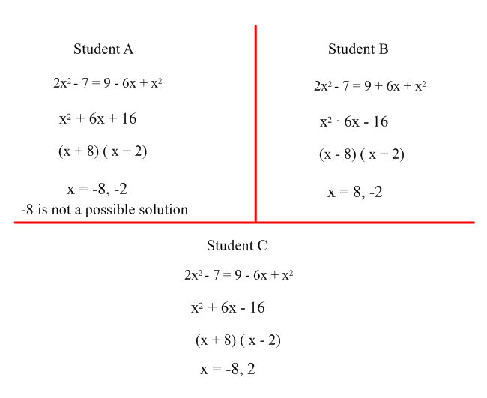

Which students is correct and what mistake did the other students make?

________________________________________________________________________________________________________________________________________________________________________________________________________________________________________________________________________________________________________________________________________________________________________________________________________________________________________________________________________

Name : ______________________ Date : _____________

1) Malik is riding his bike around part of Lake Radical from B to A. He rides along two perpendicular roads. He rides from B in a north –westerly direction to the corner. This part of the trip is miles. He turns the corner and rides south-westerly to point A which is miles. His sister decides to row her boat across the Lake Radical in a straight line from B to A. How far does she have to row in simplest radical form?

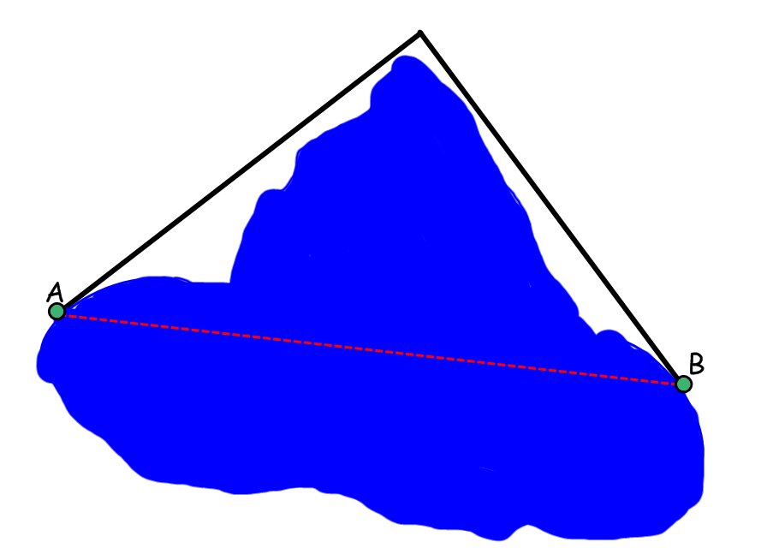

___________________________________________________________________________________

___________________________________________________________________________________

___________________________________________________________________________________

___________________________________________________________________________________

___________________________________________________________________________________

___________________________________________________________________________________

___________________________________________________________________________________

2a) You are driving your car through park land and going from point X to point Y. Imagine you drive down Sanchez St. and turn left onto Ali Ave. and then right onto Derys Dr. and finally take a left onto Linden Lane. How far in simplest radical form will you drive.

___________________________________________________________________________________

___________________________________________________________________________________

___________________________________________________________________________________

___________________________________________________________________________________

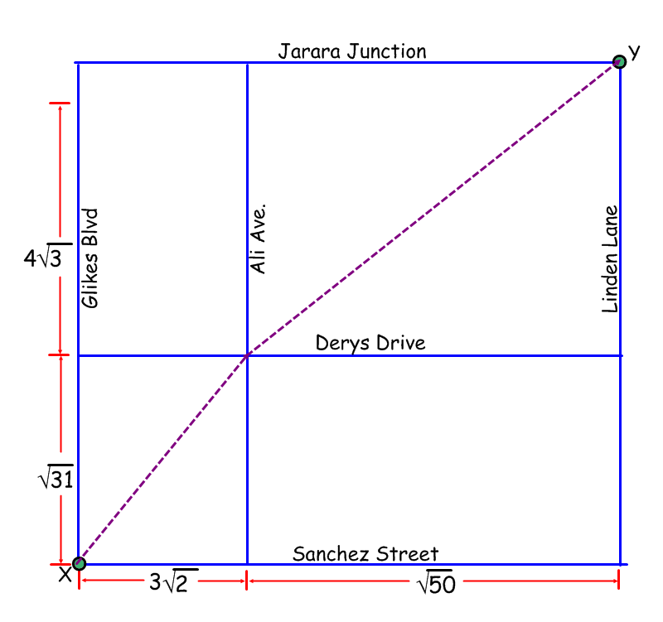

b) Now imagine you ride your bike diagonally across the part starting at point X, going to the intersection of Ali Ave. and Derys Dr. and finally onto point Y. How far will you travel giving your answer in simplest radical form. ____________________________________________________

___________________________________________________________________________________

___________________________________________________________________________________

___________________________________________________________________________________

___________________________________________________________________________________

___________________________________________________________________________________

Performance Based Assessment for Algebra II

University Neighborhood High School

Name : _____________________________________ Date : ______________

Suppose that when the Hurricane Sandy hit, your parents and you were in your family car coming back from a shopping trip for emergency supplies. You are at A on the map and need to find a route home that avoids the flooded parts of the city.

Unfortunately the car has very little fuel left; in fact, your family car can only drive for 20 more miles.

Using the map below, figure out whether your car can make it home using route ABC or route ADEC.

As an additional challenge, figure out whether you can make it to the gas station to fill up your car. Note the gas station can be reached by driving along a semi-circular road from C to F.

Exact length of Route ABC (as a radical):

__________________________________________________________________

__________________________________________________________________

__________________________________________________________________

__________________________________________________________________

__________________________________________________________________

Approximate length of Route ABC (as a decimal to the nearest ten-thousandth):

__________________________________________________________________

__________________________________________________________________

__________________________________________________________________

__________________________________________________________________

__________________________________________________________________

Exact length of Route ADEC (as a radical):

__________________________________________________________________

__________________________________________________________________

__________________________________________________________________

__________________________________________________________________

__________________________________________________________________

Approximate length of Route ADEC (as a decimal to the nearest ten-thousandth):

__________________________________________________________________

__________________________________________________________________

__________________________________________________________________

__________________________________________________________________

__________________________________________________________________

Exact length of Route CF in simplest form :

__________________________________________________________________

__________________________________________________________________

__________________________________________________________________

__________________________________________________________________

__________________________________________________________________

Write a paragraph to explain your answers.

__________________________________________________________________

__________________________________________________________________

__________________________________________________________________

__________________________________________________________________

__________________________________________________________________

__________________________________________________________________

__________________________________________________________________

__________________________________________________________________

__________________________________________________________________

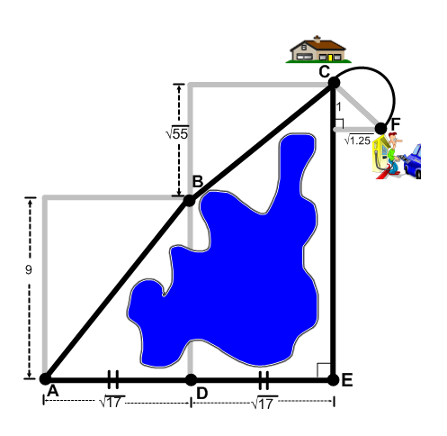

Name : ________________________ Date : ____________

**ALGEBRA II -- PRE-TEST -- RADICALS**

1) http://www.regentsprep.org/regents/math/algtrig/ATO6/powerp34.gif

(1)http://www.regentsprep.org/regents/math/algtrig/ATO6/powerp35.gif (2)http://www.regentsprep.org/regents/math/algtrig/ATO6/powerp36.gif (3)*http://www.regentsprep.org/regents/math/algtrig/ATO6/powerp37.gif*

2) http://www.regentsprep.org/regents/math/algtrig/ATO6/powerp42.gif

(1)http://www.regentsprep.org/regents/math/algtrig/ATO6/powerp43.gif (2) 5 (3) 13

3) http://www.regentsprep.org/regents/math/algtrig/ATO6/powerp44.gif

(1)http://www.regentsprep.org/regents/math/algtrig/ATO6/powerp45.gif (2)http://www.regentsprep.org/regents/math/algtrig/ATO6/powerp48.gif (3) 3

4) http://www.regentsprep.org/regents/math/algtrig/ATO6/powerp46.gif

(1)http://www.regentsprep.org/regents/math/algtrig/ATO6/powerp49.gif (2)http://www.regentsprep.org/regents/math/algtrig/ATO6/powerp50.gif (3)http://www.regentsprep.org/regents/math/algtrig/ATO6/powerp47.gif

5) http://www.regentsprep.org/regents/math/algtrig/ATO6/powerp38.gif

(1)http://www.regentsprep.org/regents/math/algtrig/ATO6/powerp39.gif (2)http://www.regentsprep.org/regents/math/algtrig/ATO6/powerp40.gif (3)http://www.regentsprep.org/regents/math/algtrig/ATO6/powerp41.gif

6) http://www.regentsprep.org/regents/math/algtrig/ATO6/powerp51.gif

(1)http://www.regentsprep.org/regents/math/algtrig/ATO6/powerp52.gif (2)*http://www.regentsprep.org/regents/math/algtrig/ATO6/powerp53.gif* (3)-7

7) http://www.regentsprep.org/regents/math/algtrig/ato3/powerp18.gif

(1)http://www.regentsprep.org/regents/math/algtrig/ato3/powerp19.gif (2)http://www.regentsprep.org/regents/math/algtrig/ato3/powerp20.gif (3)*http://www.regentsprep.org/regents/math/algtrig/ato3/powerp21.gif*

8) 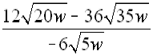

(1) http://www.regentsprep.org/regents/math/algtrig/ato3/powerp23.gif (2) http://www.regentsprep.org/regents/math/algtrig/ato3/powerp24.gif (3) *http://www.regentsprep.org/regents/math/algtrig/ato3/powerp25.gif*

9) 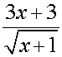

(1)m91 (2)m9b (3)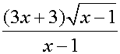

10) m10

(1) m10a (2) 19 (3) 13