Subject: Integrated Algebra Unit: One
Unit Topic and Length:

Relationships Between Quantities and Reasoning with Equations (30 Days)

Common Core Learning Standards:
N‐Q.1 Use units as a way to understand problems and to guide the solution of multi‐step
problems;
N.Q.2 Define appropriate quantities for the purpose of descriptive modeling.
N‐Q.3 Choose a level of accuracy appropriate to limitations on measurement when reporting
quantities.
A‐SSE.1 Interpret expressions that represent a quantity in terms of its context.
A‐SSE.2 Use the structure of an expression to identify ways to rewrite it. For example,
see x⁴– y⁴ as (x²)²– (y²)², thus recognizing it as a difference of squares that can be
factored as (x²– y²)(x²+ y²).
A.CED 1 Create equations and inequalities in one variable and use them to solve problems.
Include equations arising from linear and quadratic functions, and simple rational
and exponential functions.
A.CED.2 Create equations in two or more variables to represent relationships between
quantities; graph equations on coordinate axes with labels and scales.
A.CED.3 Represent constraints by equations or inequalities, and by systems of equations
and/or inequalities, and interpret solutions as viable or non-viable options in a
modeling context. For example, represent inequalities describing nutritional and cost
constraints on combinations of different foods.
A.CED.4 Rearrange formulas to highlight a quantity of interest, using the same reasoning as
in solving equations. For example, rearrange Ohm’s law V = IR to highlight
resistance R.

Big Ideas/Enduring Understandings:  Number Theory and Operations allow us to organize the world quantitatively. They give  us tools to quantify things efficiently.  Simplifying expressions and solving equations allows us to take a complex situation and make it simple. | Essential Questions:  What makes something a mathematical term?  How do we translate written information into  Mathematical terms?  What does it mean to balance an equation?  What does it mean to solve an equation?

Content:  Reason quantitatively and use units to solve problems.  Interpret the structure of expressions  Create equations that describe numbers or relationships | Skills:  Ability to choose appropriate units of measure to represent context of the problem  Ability to convert units of measure  Ability to select and use units of measure to accurately model a given real world scenario  (Example 2 pg. 15 and Question 4 pg. 3  And example 1 pg 32 and #4 pg 39)  Ability to make connections between symbolic representations and proper mathematics vocabulary (translating verbal to algebraic and algebraic to verbal) Think of a Number Lesson and Gopher Magic and the Memory Lesson  Ability to identify parts of an expression such as terms, factors, coefficients, etc.  Ability to interpret and apply rules for order of operations (Example 1 pg. 63)  Use factoring techniques such as common factors, grouping, the difference of two squares, the sum or difference of two cubes, or a combination of methods to factor completely. Algebra Charts  Simplify expressions including combining like terms, using the distributive property and other operations with polynomials.(Exercise 5&6 pg.67 and Exit Ticket pg 70)  Perimeter and Area Lesson  Ability to distinguish between linear and exponential relationships given multiple representations and then create the appropriate equation/inequality using given information  King’s Gift to his sons problem  Ability to determine unknown parameters needed to create an equation that accurately models a given situation Exit Ticket pg 55  Pic’s Rule  Ability to distinguish between a mathematical solution and a contextual solution. Is the solution feasible in real world terms?  Ability to recognize/create equivalent forms of literal equations | Days:  2  2  2  1  2  5  4  6  2  3
Assessment Evidence and Activities:
Pre and Post Tests (formative assessment and assessments for evidence of growth)
Quizzes
Questioning and Observations
Do Nows and Exit Slips
Class work and Homework
Possible Support Strategies:
Use of manipulatives
Word Walls and Individual Glossaries
Journals
Back Tracking Technique demonstrated for solving equations
Formative Assessment:
The assessments listed above will be used to identify students’ strengths and weaknesses.
There will be constant adjustments and fine tuning of the curriculum delivery based on this analysis. Sharing student work, sharing best practice and planning next steps will be an integral part of common planning meetings.
Final Performance Based Task:
Problem solving activities will be a feature of the unit of work and will be embedded in the unit plan. The final Performance Based Task will feature students analyzing Regents Equation Solving Problems and justifying solutions as well as determining the reasoning behind the inclusion of distracters. This will culminate with them devising their own multiple choice question for class mates to attempt. They must include an explanation of all parts of their answer choices. This will demonstrate a conceptual understanding of both order of operations and solution justification.
Extension:
Differentiated column sheets for order of operations and evaluating like terms.
Table logic for adding and subtracting integers and polynomial expressions.
Differentiated column sheets for solving equations.
Learning Plan & Activities:
The learning plan will incorporate work shop style lessons which will allow for student centered learning. Group work will be incorporated into various concepts with a focus on students learning collaboratively. There will be an emphasis on technique to enable students to solve skills based questions. This will be supported with problem solving exercises for all content to give students a conceptual understanding of the material.
Resources:
Text book : Prentice Hall Mathematics Algebra I
Graphing calculators
Algebra Tiles
Smart Board Demonstrations
Problem solving materials created by teachers

Name:___________________________ Date:_____________ Warm Up Tasks
Mini-Lesson
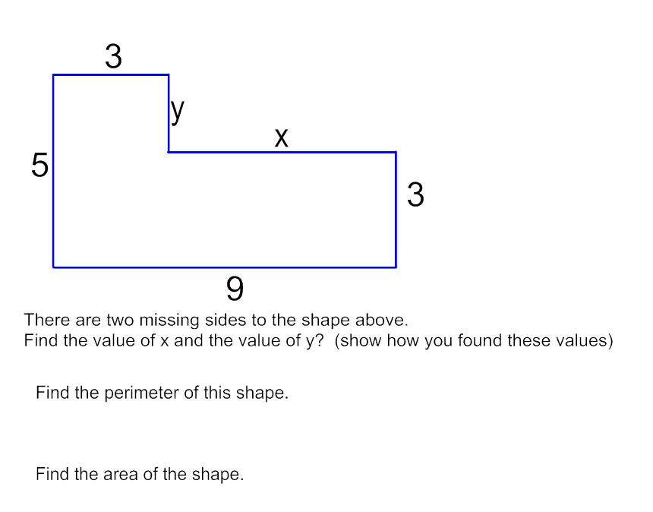
========================================================
OUR END GOAL:
Guiding Questions:
- What shapes do we see?
- What information is missing?
- What operation can help you find the missing information?
- How do we calculate perimeter?
- How do we calculate area?
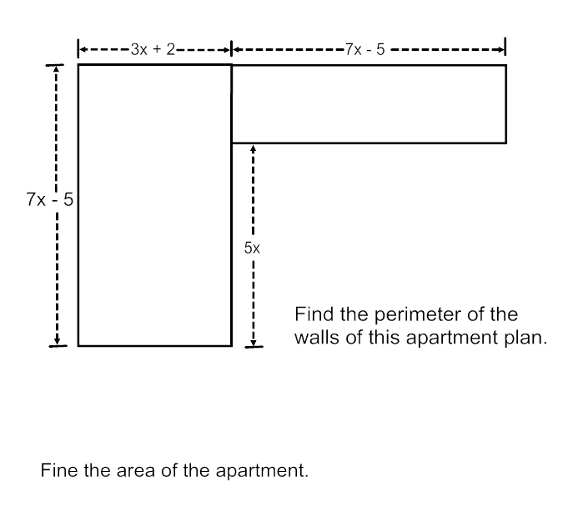
Guided Practice (1-4)
x + 4
- Find the perimeter of the rectangle to the right.
3x + 6
- Find the area of the rectangle below.
?
2x
2x + 2
2x + 2
4x + 1
2x + 1
x
2x + 2
- Find the missing sides (?) of the shape to the right.
-------------------- ? -------------------

- Find the missing sides (?) of the shape below.
x + 1

2x + 5
?
?
x +3
-----------------3x + 7 -------------------
- Find the perimeter and area of the shapes below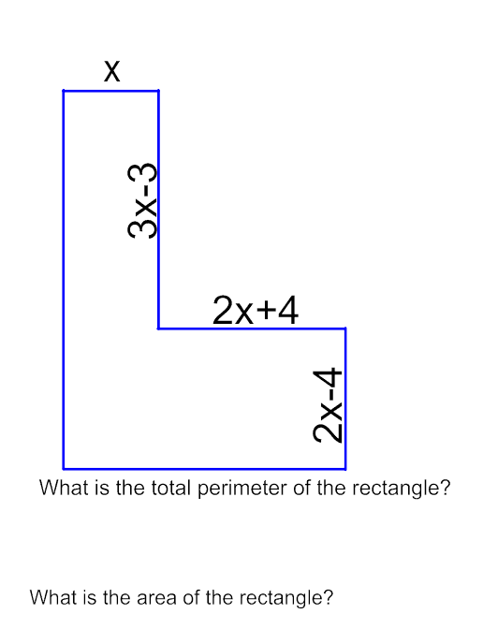
Find the area of this apartment plan.

HW: Go back to the question labeled “Our End Goal” and find the perimeter and area.

Name:__________________________________ Check Up Quiz 2
Simplify the following:
- (2x² + 3x - 1) + (4x² - 2x + 4)

- (3x² + x + 2) - (5x² + 2x - 2)

- 2x + 3(x² + 2x + 1)

- Factor the following expression:
x² + 10x + 24
Name the property expressed in each equation
- (xy)z = x(yz) 6. x + (y + 1) = (y + 1) + x 7. 2x(x – 1)=2x² – 2

__________________ _____________________ __________________

Name:__________________________________ Check Up Quiz 2

Simplify the following:
- (2x² + 3x - 1) + (4x² - 2x + 4)

- (3x² + x + 2) - (5x² + 2x - 2)

- 2x + 3(x² + 2x + 1)

- Factor the following expression:
x² + 10x + 24
Name the property expressed in each equation
- (xy)z = x(yz) 6. x + (y + 1) = (y + 1) + x 7. 2x(x – 1)=2x² – 2
__________________ _____________________ __________________
Polynomials by Design
End of Unit Assessment
Directions made for _________________:
You’ve been assigned task A. Use our work from yesterday to complete the table of measurements- When you are done and have checked your work, move on to task B. This second task will be completed for homework tonight. Before you leave today, you must finish and turn in task A.

Polynomials by Design
End of Unit Assessment
Directions made for _________________:
You’ve been assigned task B. Use our work from yesterday to complete the table of measurements- When you are done and have checked your work, move on to task C. This second task will be completed for homework tonight. Before you leave today, you must finish and turn in task B.

Polynomials by Design
End of Unit Assessment
Directions made for _________________:
You’ve been assigned task C. Use our work from yesterday to complete the table of measurements- When you are done and have checked your work, move on to task D. This second task will be completed for homework tonight. Before you leave today, you must finish and turn in task C.

Name : ________________________________ Date : ___________ Task A
Directions: Determine the missing values from the table below. Be sure to show all of your work!!
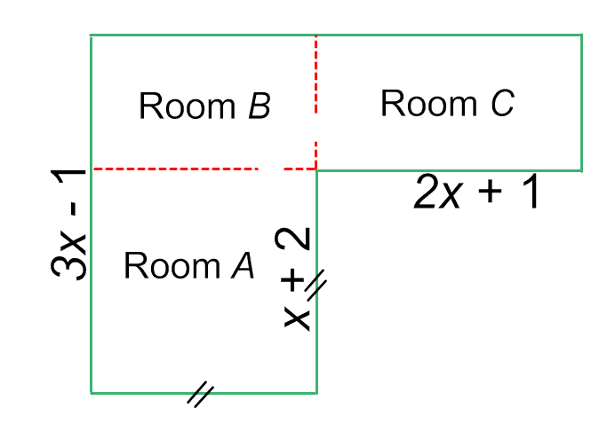
Note:
// means they have the same measurement!
Complete the table below.
Room | Dimensions  Length Width |  | Area of Room
A |  | x + 2
B

C | 2x + 1 |  | 4x² – 4x – 3
 | Total Area of House
What strategies did you use to complete this task? ______________________________________________________________________________________________________________________________________________________________________________________________________

Name : ________________________________ Date : ___________ Task C
Directions: Determine the missing values from the table below. Be sure to show all of your work!!
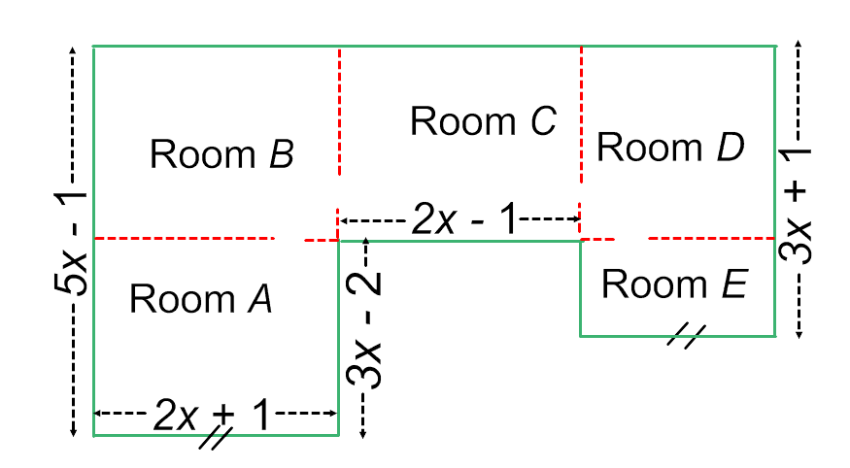Complete the table below.
Note:
// means they have the same measurement!
Room | Dimensions  Length Width |  | Area of Room
A

B

C

D

E

 | Total Area of House
What strategies did you use to complete this task? ______________________________________________________________________________________________________________________________________________________________________________________________________
Name : ________________________________ Date : ___________ Task B
Directions: Determine the missing values from the table below. Be sure to show all of your work!!
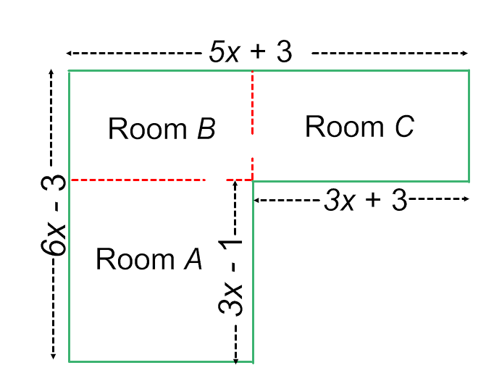Complete the table below.
Room | Dimensions  Length Width |  | Area of Room
A

B

C

 | Total Area of House
What strategies did you use to complete this task? ______________________________________________________________________________________________________________________________________________________________________________________________________
Name : ________________________________ Date : ___________ Task D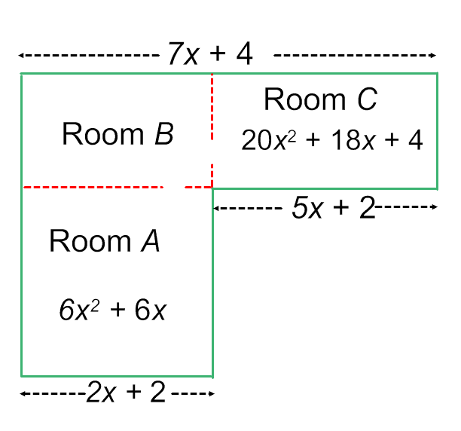Complete the table below.
Directions: Determine the missing values from the table below. Be sure to show all of your work!!
Room | Dimensions  Length Width |  | Area of Room
A

B

C

 | Total Area of House
What strategies did you use to complete this task? ______________________________________________________________________________________________________________________________________________________________________________________________________
Name : ________________________________ Date : ___________
Reflection
Directions: Review the task that has just been turned back to you and complete the following questions independently
- How did you begin your task? Why?
____________________________________________________________________________________________________________________________________________

- What did you find success with?
____________________________________________________________________________________________________________________________________________

- What did you struggle with?
____________________________________________________________________________________________________________________________________________

Presentation (2 minutes)
Be sure to address the following talking points in your presentation:
- What task did you complete first?
- How did you begin your task and why?
- What were you successful with?
- What did you struggle with?

Group Work
Look at Tasks 1-4 with your partner(s). Decide which task you would like to complete. Spend the remainder of class today completeing that task.

Name : ________________________________ Date : ___________ Task 1
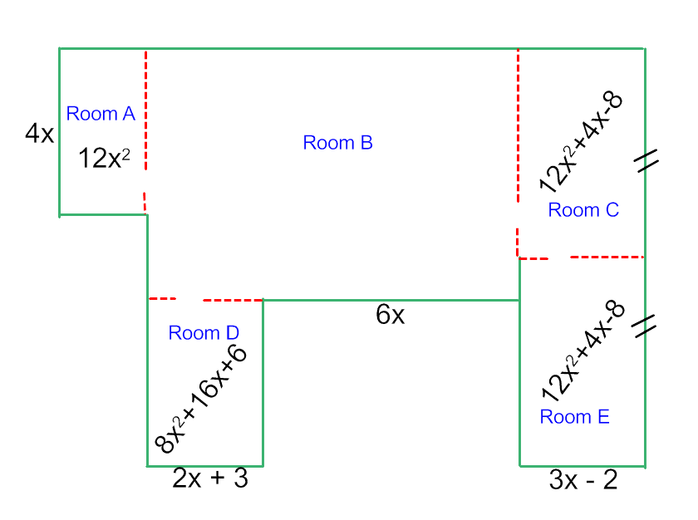
Complete the table below.
Room | Dimensions  Length Width |  | Area of Room
A

B

C

D

E

 | Total Area of House
Name : ________________________________ Date : ___________ Task 2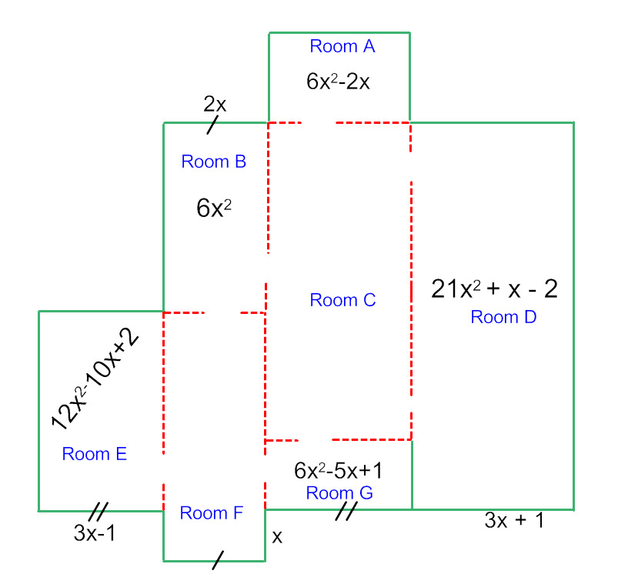
Complete the table below.
Room | Dimensions  Length Width |  | Area of Room
A
B
C
D
E
F
G
 | Total Area of House
Name : ________________________________ Date : ___________ Task 3
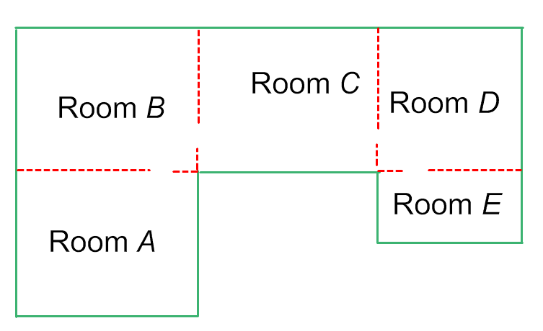

Make up your own problem. Put in the minimum amount of information to be able to complete the table that goes with this floor plan.
Room | Dimensions  Length Width |  | Area of Room
A

B

C

D

E

 | Total Area of House
Name : ________________________________ Date : ___________ Task 4 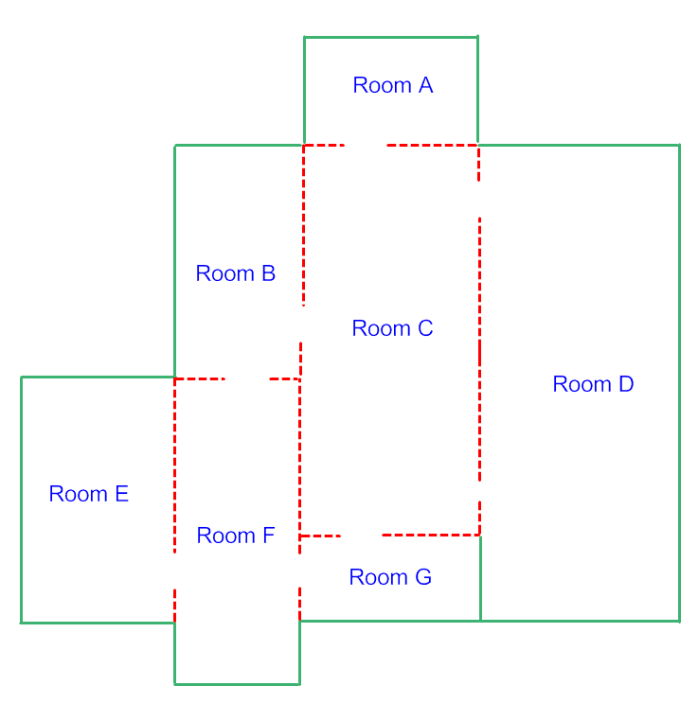
Make up your own problem. Put in the minimum amount of information to be able to complete the table that goes with this floor plan.
Room | Dimensions  Length Width |  | Area of Room
A
B
C
D
E
F
G
 | Total Area of House

