How to Log onto iRead, System 44, Read180

Students receiving Title 1 support through software (iRead, System44, and Read180) can all access from the same portal by clicking on the link below.

https://idp-awsprod1.education.scholastic.com/idp/

Students can also find a “shortcut” icon on the Level Green website as shown below.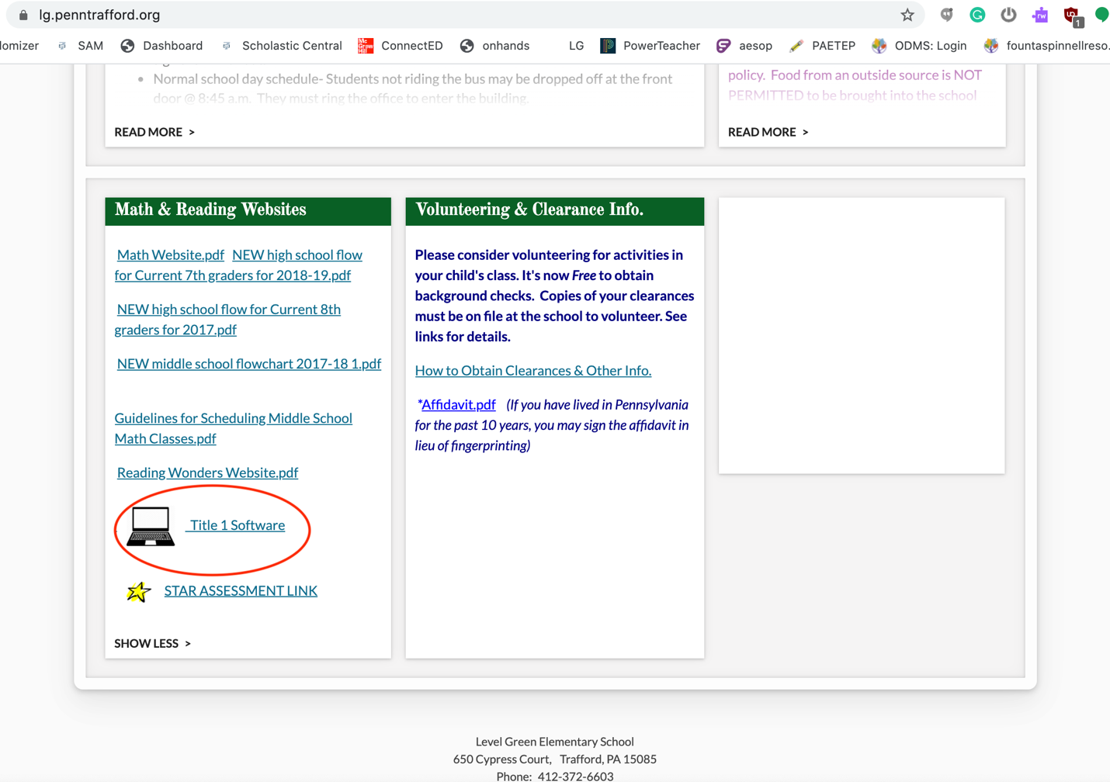

Usernames are most often first initial and last name: Example- soliver
Passwords are always the student’s id: Example- 908448

The goal is to use the software 20 minutes daily to boost reading skills. Any problems or concerns please contact the Reading Specialist, Sara Oliver, by email olivers@penntrafford.org. Data reports will be shared with the classroom teacher and parents by request.

