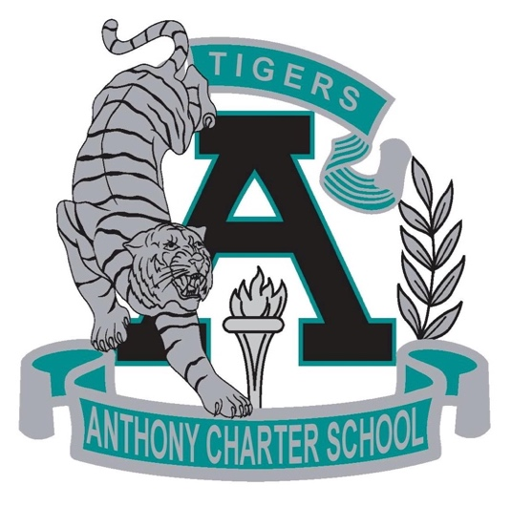

Public Notice
(Notificamiento Publico)

Anthony Charter School
Governing Council
(Junta del Cuerpo Escolar)
Monday, June 12th, 2017
(Lunes, Junio 12, 2017)
TIME: 6:15 pm
Location:
780 Landers
Anthony NM 88021

