IMPORTANT CONCEPTS YOUR STUDENT SHOULD KNOW AND ACTIVITIES TO DO AT HOME
ELA Important Concepts Addressed in this Unit
Title of book: Owen Foote, Money Man (2 weeks)  Title of book: Fudge-a-Mania (2 weeks)  - I can ask and answer questions to to show understanding of a text, using the text.  - I can describe characters in a story and explain how their interactions contribute to the sequence of events.  - I can demonstrate command of the conventions of standard English capitalization, punctuation, and spelling when writing.  - I can read with accuracy and fluency.  - I can apply apply grade-level phonics and word analysis skills and in decoding words.  - I can demonstrate how to use common and proper nouns.  - I can write narratives to develop real or imagined experiences or events.  - I can use information gained from illustrations (e.g. map, photographs) and the words in a text to demonstrate understanding of the text.  - I can determine the meaning of words and phrases as they are used in a text, distinguishing literal from nonliteral language.  - I can engage effectively in a range of collaborative discussions (one-on-one, in groups, and teacher-led) with diverse partners on grade 3 topics and texts, building on others’ ideas and expressing their own clearly. |  |  | Title of book: The Constitution of the United States (Nonfiction: 2 weeks)  Title of book: The Congress of the United States  (Nonfiction: 2 weeks)  Title of book: Soil (Nonfiction: 1 week)  - I can determine or clarify the meaning of unknown and multiple-meaning words and phrases.  - I can use root words as a clue to the meaning of unknown words with the same root.  - I can read and comprehend informational texts independently and proficiently.  - I can use text features and search tools to locate relevant information on a given topic.  - I can use information gained from illustrations and words in a text to demonstrate an understanding of the text.  - I can ask and answer questions to demonstrate an understanding of a text.  - I can describe the relationship between a series of historical events using language that pertains to time, sequence, and cause/effect.
Key Words To Know |  |  | How You Can Help Your Student
Title of book: Owen Foote, Money Man  demonstration, reaction, disappointed, persuade, collaborate, profit; cautious, consultant, pride, figurative language  Writing- Narrative, Opinion, Informative  Title of book: Fudge-a-Mania  anticipation, relax, complication, disaster, mania, jealousy, embarrassed, resolution, impress, anticipation, relax, complication, disaster, misunderstanding  Writing- Narrative, Opinion  Title of book: The Constitution of the United States  government, federal government, collaborate, obstacles, protected, compromise, delegates, organize, branches, amend  Writing- Narrative, Opinion, Informative  Title of book: The Congress of the United States  democracy, congress, Legislative, President, Representative, power, bill, contrast, accuse, arrest, decide, monument, memorial, capital, right, privilege, US citizens, expert, highlights, feature  Writing- Narrative, Opinion, Informative  Title of book: Soil  ingredients, nutrients, bacteria, diagram, sand, silt, loam, clay, conserve, erosion, fertilize  Writing- Informative |  |  | Interactive Learning Games: Playing games is a wonderful way to practice skills at home in a fun environment.  Google Classroom  www.educationgalaxy.com  www.freereadingprogram.com  Sample Questions:  Owen and Katie could not _____________ Lydia to think the toilet process was cool.  - collaborate b. persuade c. cautious  Describe three ways that Owen and Katie are different. Please use complete sentences.  ________________________________________  ________________________________________  ________________________________________

IMPORTANT CONCEPTS YOUR STUDENT SHOULD KNOW AND ACTIVITIES TO DO AT HOME
Social Studies Important Concepts Addressed in this Unit
Title of unit: Government  - I can describe the elements of representative democracy/republic in the United States.  - I can describe the three branches of national government: executive, legislative, and judicial.  - I can describe the three branches of state government: executive, legislative, and judicial.  - I can state the main responsibility of each branch: executive, legislature, judicial.  - I can explain the importance of Americans sharing certain central democratic beliefs and principles, both personal and civic.  - I can explain the necessity of respecting the rights of others and promoting the common good.  - I can explain the necessity of obeying reasonable laws/rules voluntarily, and explain why it is important for citizens in a democratic society to participate in public life.  Key Words  Government Unit:  representative democracy branches national/ federal government executive legislative judicia Senator president Congress population executive legislative judicial governor courts |  |  | Title of unit: Geography  - I can locate the major topographical features on a physical map of the United States.  - I can locate and describe the equator, prime meridian, and lines of latitude and longitude on a globe.  Key Words  Geography:  Topographical features Locate United States of America Describe Equator Prime Meridian Latitude Longitude Globe
Sample Questions: |  |  | How You Can Help Your Student
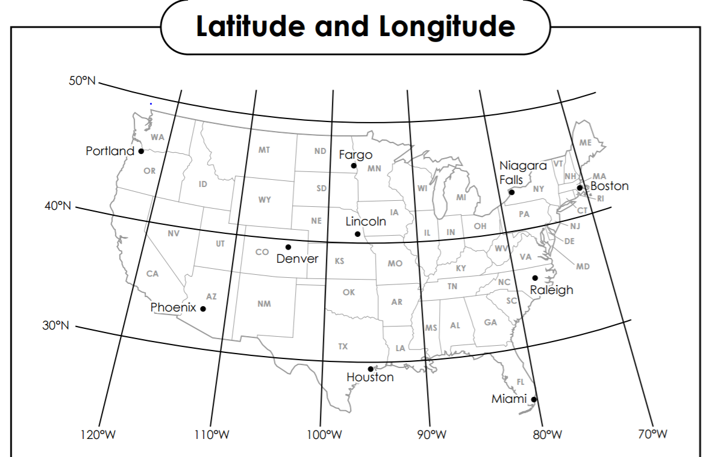  What state is located at 30⁰N and 100⁰W?  - CA  - MO  - TX  - WY  _______________________________________________________________________________  The United States government is a democracy. This means that they have __________________.  a. A form of government where a king rules  b. A form of government where the people have a say  c. A form of government run by the police  D. A form of government in which the leader uses power to take control |  |  | Complete homework nighty.  Make notecards or play games using the study guide.  www.educationgalaxy.com  Google Classroom

