Rosetta Stone and Chromebook Picture Display Fix

Some Chromebooks are showing the following when students are logging into Rosetta Stone – many boxes with an “X” in them instead of text:
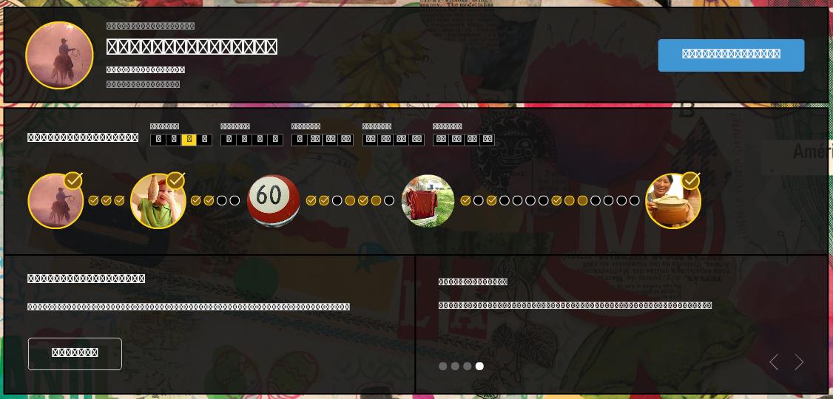
Please try the following steps to fix this issue. From any Chromebook that is displaying this screen:
- On the desktop, click in the system tray. | 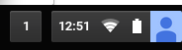
- Select “Settings”
- Click on “About Chrome OS” | 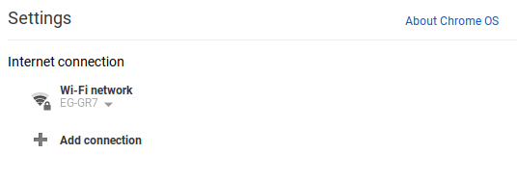
- Click “Check for and apply updates”
- If there is an applicable update for your Chromebook, it will begin downloading the update and displaying a percentage completion.
- When the Chromebook reaches 100% and is ready to apply the update, click the button that says “Nearly up-to-date! Restart your device to finish updating.” – There will also be a small arrow in the system tray indicating that the Chromebook needs to restart. | 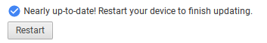  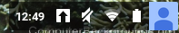
- The Chromebook will reboot – have the student log back into their CMP profile.

- Return to the update screen (Steps 1-3) and select “Check for and apply updates”. If there are more updates, the Chromebook will again begin downloading them. If the Chromebook is fully up-to-date, you will get a message that the Chromebook is up to date. | 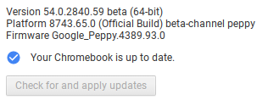
- Have the student log into Rosetta Stone. They should now be able to see the lesson names and their progress on each lesson.

