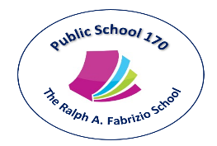 Tony Wu, Principal
Kristi Pollock, AP
Holli Sainz, AP
Maria Strongilis, AP
Therese Mulkerrins, Dean
619 72nd Street Brooklyn, NY 11209 Tel. (718) 491 8400 Fax (718) 491-8405 www.PS170.com

Family Literacy Night
Tech Talk
Grades 3 - 5

Please join us to discuss what our children are doing online and how to teach them to be smart, safe, and respectful digital citizens. You’ll learn about:

• The importance of knowing the sites and apps your child uses
• How kids are using mobile devices like smartphones and tablets
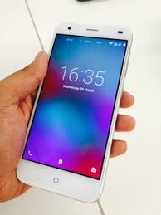
• Social networking sites and how to help your child use them wisely
• What to do if your child encounters online bullying
• Objectionable content, how to block it, and what to do if your child views it
• The importance of teaching your child to find a healthy balance with technology use
• Your role in keeping the conversation going about responsible Internet use

Thursday, November 8, 2018
6:30 – 7:30 pm
Library room 471
Light refreshments

Workshop presented byMrs. Cynthia Aweeky, Librarian

Mrs. Abigail Figueroa, Parent Coordinator

