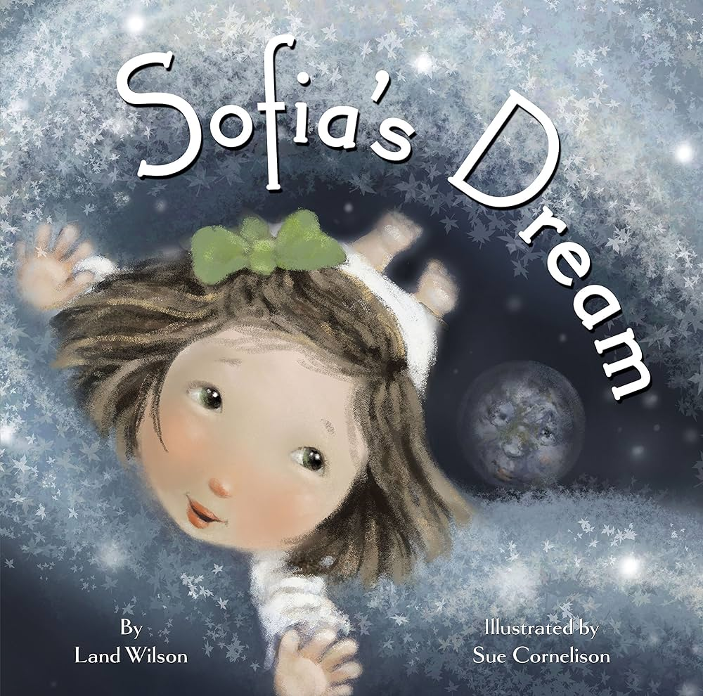

P.S. 212’s Book of the Month for the month of April is “Sofia’s Dream.” The theme is “Citizenship.”

In this story, little Sofia befriends the Moon and sets off on a dreamy adventure to visit her friend. She sees our planet from the Moon's point of view and is inspired to do whatever she can to protect our Earth. When she wakes, Sofia encourages others to do the same.

Parents, please click the link to listen to the story with your child:
https://www.youtube.com/watch?v=WjmB3gR6eaI

All the best,

Mrs. S. Dror
Assistant Principal

