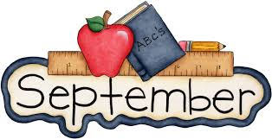
1st Grade September Goals:
Math: Your child will solve addition and subtraction problems up to ten (10).

Reading: Your child will be able to identify the main idea of a story with supporting details.

Writing: Your child will be able to write a fictional narrative using a variety of resources.

Science: Your child will explain what living things need to survive in their environment.

Social Studies: Your child will explore why families are important and how do they influence who we are.

