DAY | DATE | OPPONENT | LOCATION | TIME
Tuesday | August 22 | Brookeland | There | 5:00pm
Tuesday | August 29 | Broaddus | Here | 5:00pm
Tuesday | Sept 5 | Zavalla | Here | 5:00pm
Thurs-Sat | Sept. 7-9 | Centerville Tournament | There | TBA
Thursday | Sept 14 | Big Sandy | Here | 5:00pm
Thursday | Sept 21 | Chireno | Here | 5:00pm
Thursday | Sept 28 | Martinsille | There | 5:00pm
Tuesday | Oct 3 | Wells | There | 5:00pm
Thurs-Saturday | Oct. 5-7 | End of Year Tournamnet | There | TBA
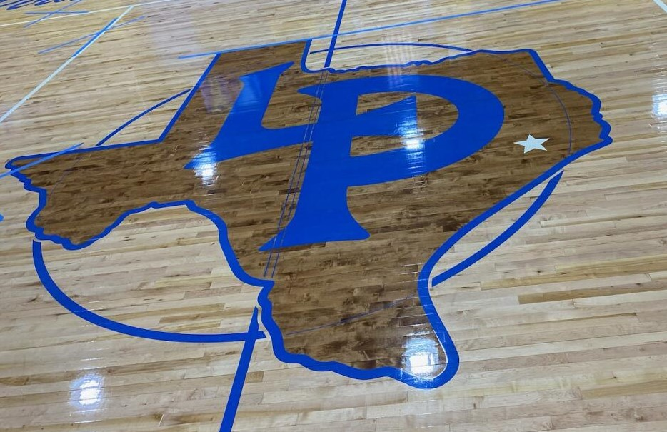
LEGGETT PIRATES MIDDLE SCHOOL BASKETBALL SCHEDULE 2023
Head Boys Coach/ Atheltic Director: Ra’Shod Jefferson
Head Girls Coach: Terri Barlow
Principal: Amanda Lawson
Superintedent: Jana Lowe
“The strength of the team is in each individual member…the strength of each member is the team.”
-Phil Jackson

