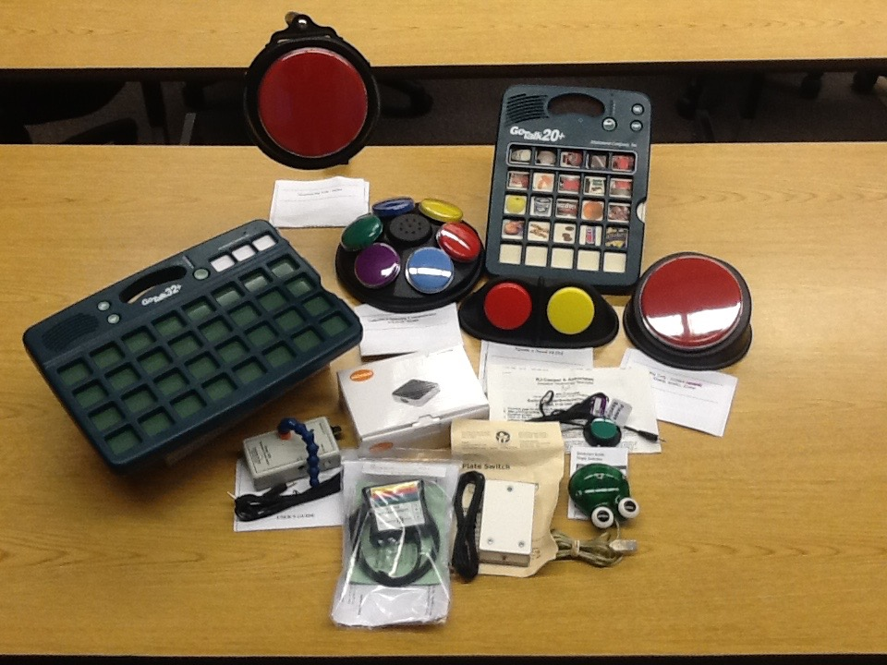

AAC for Communication

Go Talk – 32+
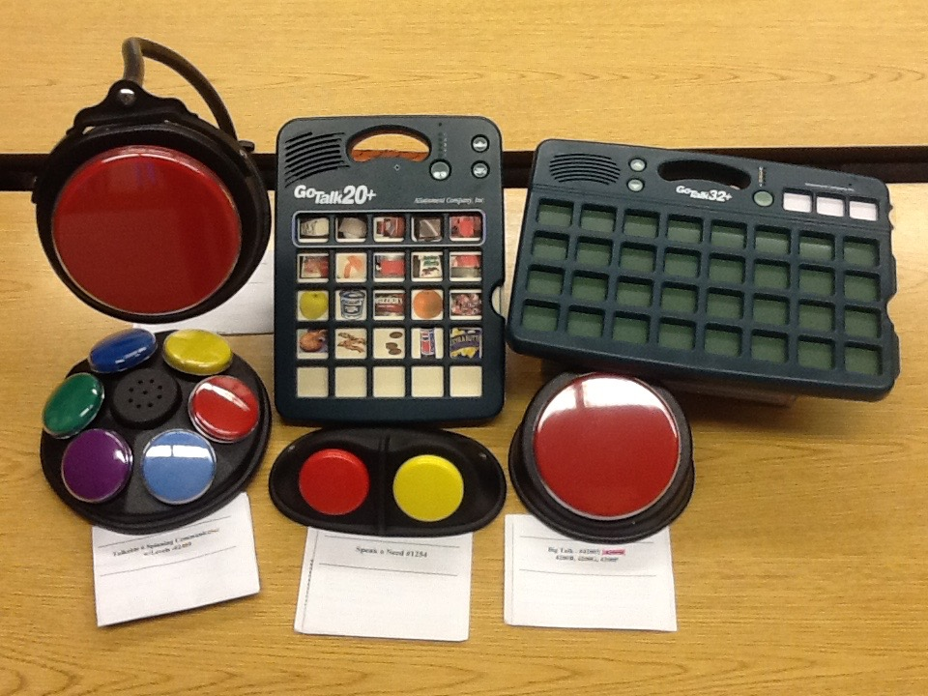

Go Talk – 20+

Big Mac switch & Mount

Big Talk

Speak and Need

Talkable Spinning Communicator

Frog Switch
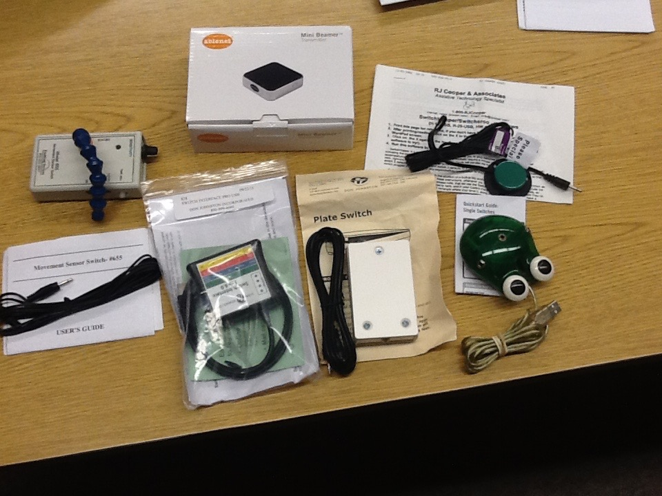

Plate Switch

Mini-Beamer

Movement Sensor Switch

Mini Switch (PC)

