Name:_________________________________________ Newton’s 3rd Law of Motion Practice
For each picture, tell the reaction force and draw the force model (arrow) Use different colors. Then, answer the questions that follow.
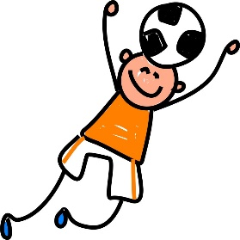  This Photo by Unknown Author is licensed under CC BY-NND  Action: Ball hitting head.  Reaction:___________________  ___________________________  Who is hitting with the most force? | 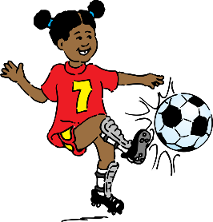  This Photo by Unknown Author is licensed under CC BY-NND  Action: Foot kicking the ball.  Reaction:___________________  __________________________  Who is hitting with the most force? | 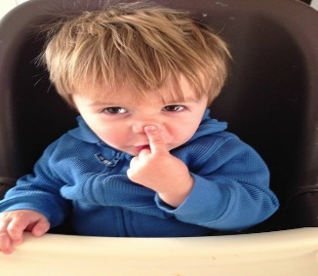  This Photo by Unknown Author is licensed under CC BY-SA-NC  This Photo by Unknown Author is licensed under CC BY-NND  Action: Finger touching nose.  Reaction:___________________  __________________________  Who is hitting with the most force?
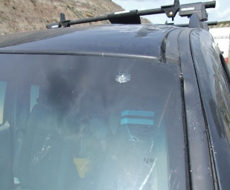  This Photo by Unknown Author is licensed under CC BY-NC  This Photo by Unknown Author is licensed under CC BY-NND  Action: Bug hitting windshield.  Reaction:____________________  ___________________________  Who is hitting with the most force? | 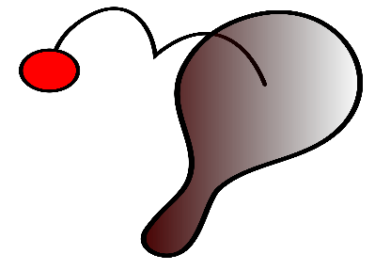  This Photo by Unknown Author is licensed under CC BY-SA  This Photo by Unknown Author is licensed under CC BY-NND  Action: Bug hitting windshield.  Reaction:____________________  ___________________________  Who is hitting with the most force? | Come up with your own.  Action: Bug hitting windshield.  Reaction:____________________  ___________________________  Who is hitting with the most force?
If a baseball was hit with a bat with a force of 500 N, how much force did the ball exert?  - Less than 500N  - More than 500N  - 500 N  Explain: | A phone is thrown against the wall at 150N, how much force will the wall exert back?  - Less than 150N  - More than 150N  - 150 N  Explain: | What is Newton’s Third Law of motion?

