Level 1 Vocational Interview
Student

Student: Date:

School: PS811Q Marathon School OSIS#

DOB: Class: Teacher:

- What classes do you like best in school?

- What do you do in your free time at home?
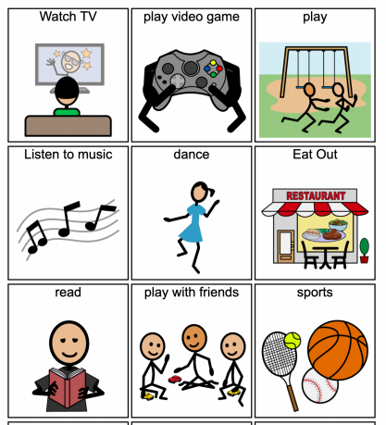

- Who do you live with?

- Do you like to work alone or in a group?
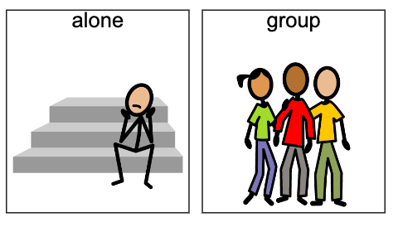

- What jobs might you want to do when you complete high school?
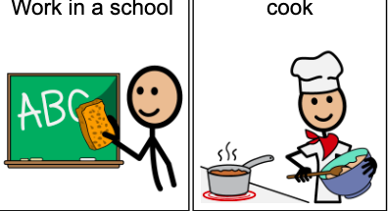
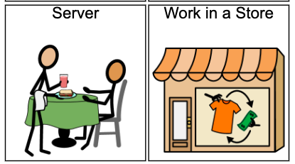
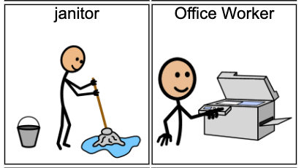

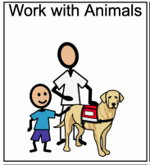
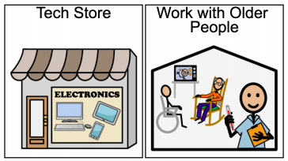

- Do you have chores to do at home?

If so, what chores do you do at home?
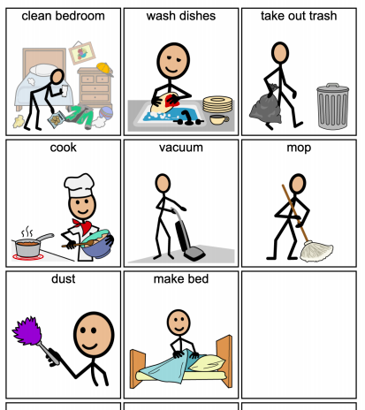

- How do you learn best?
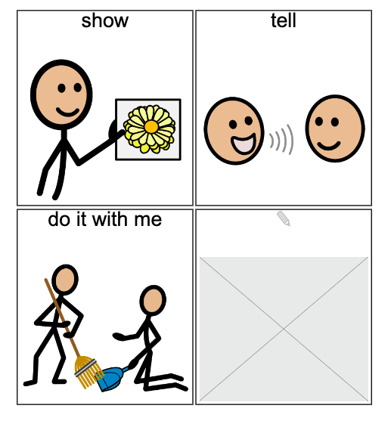

- What behaviors are you working on?
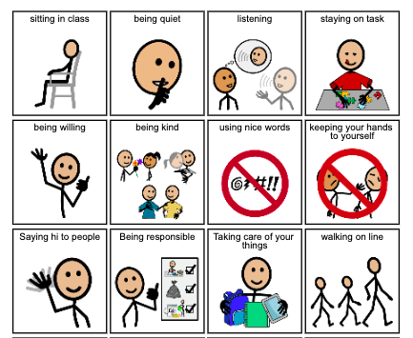

- Where do you want to live when you complete high school?
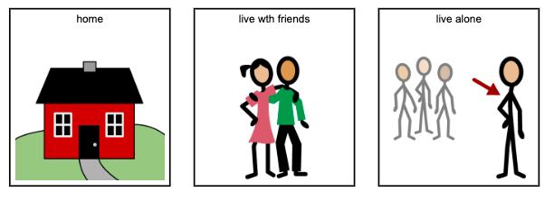

- Do you feel good about yourself? (Are you a good person? A good friend? A good son/daughter/brother/sister, etc.)
