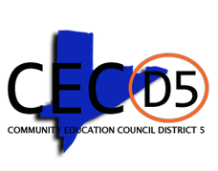

Special Meeting
Wednesday, August 11, 2021
6:30 PM

IS 286/Auditorium 1st Floor
Urban Assembly Academy for Future Leaders
509 W. 129th Street
NEW YORK, NY 10027

All attendees must complete a health screening please find link below.

https://healthscreening.schools.nyc/

Come share your experiences and lend your voice to this important conversation!

For More Information Call (212) 222-1395 ext. 2321
Your Child, Your School, Your Voice

