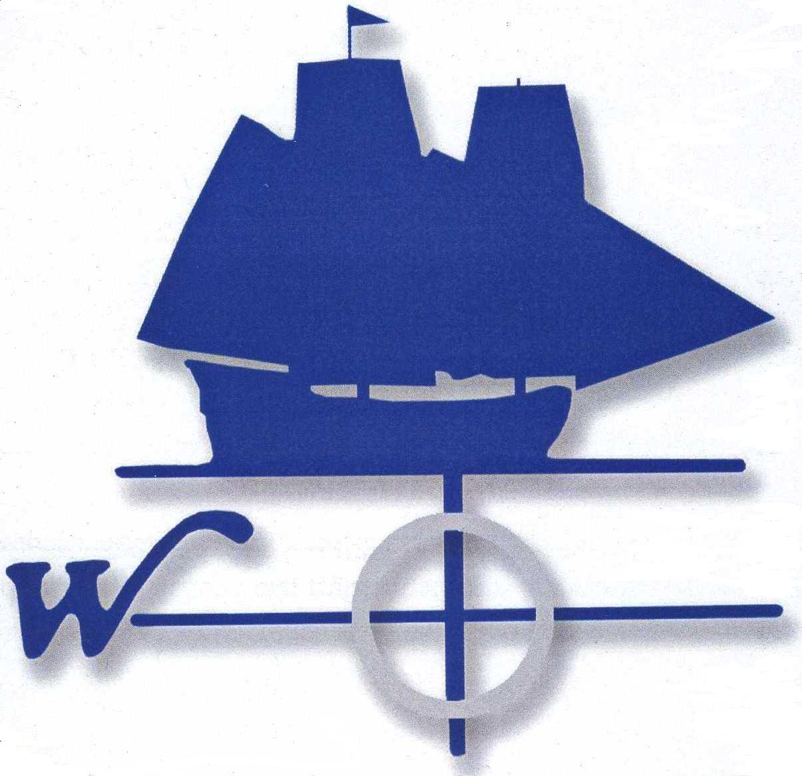

**May 24, 2010**

TABLE OF CONTENTS

SECTION PAGE

Introduction to Transition 3

Vision Statement 5

Transition Plan 7th Grade 6

Transition Plan 8th Grade 9

Transition Plan 9th Grade 14

Transition Plan 10th Grade 18

Transition Plan 11th Grade 21

Transition Plan 12th Grade 24

Appendix I- Students Guide to Understanding 27

Special Education Rights (70 pages)

Appendix II-MAPS 98

Appendix III – Student Participation at the PPT 99

Appendix IV- An Educational Journey from 210

Self-Discovery to Advocacy (111 pages)

Appendix V- Modifications and Accommodations 212

Appendix VI- Building a Bridge (92 pages) 304

**Introduction**

**Definition of Transition Services:**

Transition services means a **coordinated set of activities** for a child with a disability that is “designed to be within a **results-oriented process**, that is focused on improving the academic and functional achievement of the child with a disability **to facilitate the** **child’s movement from school to post-school activities,** including postsecondary education, vocational education, integrated employment (including supported employment), The **coordinated set of activities** must:

1. Be based on the individual student’s needs, taking into account the student’s strengths, preferences, and interests; and
2. Include:

• Instruction;

• Related services;

• Community experiences;

• The development of employment and other post-school adult living objectives;

and

• If appropriate, acquisition of daily living skills and provision of a functional vocational evaluation.

1. Provide transition services for children with disabilities. This may be **special education**, if provided as specially designed instruction, or a **related service**, if required to assist a child with a disability to benefit from special education. (34 CFR § 300.43)

**IDEA 2004** requires that appropriate measurable postsecondary goals and objectives be based on age-appropriate assessments related to **postsecondary education** or **training**, **employment**, and, where appropriate, **independent living skills**. continuing and adult education, adult services, independent living, or community participation.” (34 CFR § 300.43 (a))

***A student’s goals and objectives in this area are designed based on the student’s answers to the following questions:***

* What is the student’s long term goal in the area of **Employment** or **Postsecondary Education**?
* What is the student’s long term goal in the area of **Independent Living**?
* What is the student’s long term goal in the area of **Community Participation**?

**Vision statement**

The mission of the Westbrook Public Schools is to assist all students with disabilities to realize their fullest potential by providing them with the academic and vocational skills needed to become active citizens in their community.

**Mission statement**

The mission of the Westbrook Public Schools, in partnership with families, students, agencies and community resources, will develop a comprehensive transition services that will prepare students to reach their fullest potential, and transition to higher education, employment, independence and an active community life:

* Provide students with opportunities and experiences to help them define and be prepared for their future career and educational goals;
* Meeting the students; unique needs; and
* Teach students self-advocacy skills so they may become confident

TRANSITION PLANNING

For

7th Grade Students at Westbrook



**SEVENTH GRADE**

IDEA 2004 requires transition planning to take place during a student’s PPT meeting when he/she reaches the age of 15. However, a few years ago transition planning was required to start earlier. In fact, the Connecticut Interagency Transition Task Force (2004) states, “quality transition planning is achieved when the process is initiated at an early age (age 13 or younger).” Therefore, best practices would lead us to begin at age 13.

The student’s 7th grade year is the ideal time to start the transition planning process. The transition planning goals and objectives that are developed at a 7th grade student’s Annual Review meeting will be implemented during his/her 8th grade year.

To help students prepare for high school life, the following goal is proposed:

**Goal 1:The student will increase his/her understanding of the PPT process and increase his/her participation in his educational program as evidenced by the following:**

Obj: Student will demonstrate an understanding of his/her rights in

special education by completing the “A Student’s Guide to Understanding Your Rights in Special Education” (Appendix I).

Obj: Student will meet with his/her case manager to increase his/her

understanding of the various components of his/her IEP

Obj: Student will participate in at least one PPT meeting and/or

conference during his/her 8th grade year

**Goal 2: Student will increase his/her understanding of his/her**

**disability**

Obj: Student will increase his/her understanding of his/her learning

style by taking the CITE learning inventory.

Obj: Student will identify 3 various ways the his/her disability impacts

him/her in different settings

Obj: Student will a minimum of 3 identify strategies that are helpful to him/her in compensating for the area of disability

**Goal 3: Student will demonstrate readiness to transition to high**

**school as evidenced by the following**:

Obj: Student will increase his/her familiarity with the high school

building by visiting/touring the building a minimum of one time

Obj: Student will identify his/her areas of interest as he/she selects

programs and courses for high school.

Obj: The student will identify a minimum of one extracurricular activities of interest to him/her that are available in the high school.

***Again, it is important to note that the goals and objectives developed***

***during the student’s 7th grade year will be implemented the following***

***academic year.***

TRANSITION PLANNING

For

8th Grade Students at Westbrook



**EIGHTH GRADE**

Eighth grade marks the beginning of active transition planning for most students with disabilities. Their goals, which were proposed during their 7th grade, are implemented in September of their 8th grade year.

As previously discussed, the overarching transitional goal for an 8th grade student is to increase his/her understanding of and participation in the PPT process. According to the Connecticut’s Transition Training Manual and Resource Directory (2004), a student must learn specific skills and receive training to participate fully in their PPT meeting. They include the following:

* Students must know it is their right to attend their PPT meetings
* Students need to understand the PPT process and their role in the process
* Students must have the confidence and skills to share their ideas and concerns about the future
* Students should be prepared to make suggestions about the activities and services to be included in their IEP
* Students must commit to taking ownership and following through on the objectives assigned to them.

In order to accomplish the above, a series of activities will take place that include the following:

* Special education students will meet with their case manager and/or guidance counselor for an introduction on how to use their Naviance account.
* Students will review the contents of “A Student’s Guide to Understanding Your Rights in Special Education” (Appendix I) with their special education instructor and/or case manager.

Futures Planning

Students who have more complex disabilities that effect education (e.g. those with intellectual disabilities, profound language disabilities, autism, etc.) will likely need more comprehensive and creative planning than their less disabled peers. To assist in the planning process, a MAPS facilitation will be conducted for all 8th grade students with significant disabilities (Appendix II). Information generated from the participants, including the student, family members, invited friends, and school staff, will drive the development of the student’s IEP in years to come. (A copy of each student’s MAPS discussion will be kept in their portfolio).

Planning and Placement Team Meetings

By the end of the school year, all 8th grade students will have an Annual or Triennial Review PPT meeting. This is the first meeting of their educational career that students will be strongly encouraged to attend by their case manager. Their role in this meeting will have already been reviewed in the first month of school when they receive and review their copy of A Student’s Rights in Special Education.

PPT Invitation

* The student is invited to the PPT meeting, and his/her name is listed on the invitation.
* The Invitation indicates that transition planning will take place in addition to other reasons (e.g. Annual Review).
* The invitation will be attached to a letter to parents and students that indicates why student participation in the PPT meeting is important (Appendix III).

PPT Meeting

Minutes will reflect that the team discussed the student’s possible post secondary outcomes (education/training and employment). The team will also discuss exit criteria from special education services. The team must carefully consider whether a student will likely remain in special education until graduation or age 21. Some students may require one extra year. Others may be ready to exit in high school upon demonstrating their ability to succeed without special education support.

Proposed Transition Goal

The transition goal that is developed during the student’s 8th grade year will be implemented during his/her freshman year of high school.

Transition Goals will focus on the student’s move from middle to high school.

Education/Training goals

**Goal 1: The student will continue to increase his/her involvement in his/her educational program as evidenced by the following:**

Obj: The student will express his/her academic interests and preferences as he/she selects high school courses that meet high school graduation requirements

Obj: The student will identify and meet with key staff members who will serve as resources to him/her in the high school setting (e.g. guidance counselor, school counselor, special education instructor, case manager, etc.)

Obj: The student will participate in his/her Annual Review PPT meeting.

Obj: The student will complete and review a transition planning questionnaire that will help him/her define a vision of the future.

**Goal 2: The student will demonstrate self-advocacy skills in order to communicate academic and behavioral needs.**

Obj: The student will receive and review a copy of an Educational Journey from Self Discovery to Advocacy.

Obj: Student will develop a self-advocacy plan as described in the Educational Journey from Self Discovery to Advocacy.

Obj: Student will identify any accommodations and/or modifications that assist him/her in school.

Obj: Student will identify when/where/and to whom he/she should disclose information related to his/her disability

TRANSITION PLANNING

For

9th Grade Students at Westbrook



**NINTH GRADE**

As previously mentioned, the goal of the student’s 9th grade year is for him/her to achieve a successful transition to the high school setting. The student will accomplish this by meeting with his/her school counselor and case manager, and becoming familiar with school policies and activities, as well as course offerings and graduation requirements. In addition, the student will begin to build his/her self-advocacy skills. He/she will also continue to increase his/her participation in the PPT process.

The following will occur in the Fall semester:

* Students will receive a copy of their Westbrook student handbooks and review school policies and procedures
* Students will meet with their school counselor to discuss course offerings and graduation requirements
* Students will receive a copy of “An Educational Journey from Self Discovery to Advocacy” (Appendix IV).
* Students will meet with an assigned special education teacher and/or school counselor to review the contents of An Educational Journey
* Students will attend an informational session offered in the Resource Room (or similar) that identifies available extracurricular activities.
* Students will identify extracurricular activities that might be of interest to them, and obtain information about when and where these activities meet.
* Students will meet with their case managers, tutors, and guidance counselor.
* Students will take Game Play Survey and Career Interest Profile on Naviance.
* The case manger that students have in 9th grade will work with them through the students four years in high school.

The following will occur during the Spring semester:

* Students will develop a self-advocacy plan.
* Students will take the Game Play and Career Interest Profile survey’s on Naviance.
* Students will identify accommodations and modifications that assist them in the school setting (Appendix V).
* Students will identify appropriate parties to disclose information related to their disabilities
* Students will begin to learn about and understand the importance of record keeping utilizing their Naviance accounts.

Annual Review PPT

* The student is invited to the PPT. His/her name is printed on the invitation
* A letter indicating the importance of student participation in his/her PPT meeting will be enclosed with the PPT invitation
* PPT invitation indicates that transition planning will take place
* During the PPT meeting, a new transition goal will be proposed for the student’s sophomore year:

Post-secondary education/training

**Goal: The student will develop increased understanding of post-secondary opportunities that are available to him/her**

obj: Student will practice needed postsecondary education strategies by learning (time management skills/test preparation skills/ note-taking techniques/stress reduction techniques/or test anxiety reduction activities)

obj: The student will increase his/her awareness of community resources and leisure activities that are available to him/her now, and following graduation

Employment goal

**Goal: The student will complete a series of activities in order to prepare for the transition to competitive or supported employment.**

obj: The student will begin a resume.

obj: The student will complete a career interest survey (ex. O*Net).

obj: The student will increase knowledge of general labor laws re: the employment of minors (e.g. work papers, hrs of work, minimum wage and jobs permitted for minors.)

Again, the PPT will discuss any post-secondary outcomes that may apply

The PPT will review exit criteria (e.g. ability to succeed without special education support, 21, graduation, etc.)

The PPT will project a timeline for the student to complete their program (e.g. graduate on time, additional years of high school, etc.).

TRANSITION PLANNING

For

10th Grade Students at Westbrook



**TENTH GRADE**

In a student’s 10th grade year he/she will begin to discover post-secondary opportunities that are available to him/her. These include possible training programs, jobs, educational programs, and other opportunities. Once the student knows his/her options, they can be narrowed down into those of high interest to the student. This becomes the goal for the following year.

During the course of the school year the following will occur:

Students will investigate possible post-secondary educational options by using the internet, attending school presentations, reviewing want ads, and meeting with their guidance counselor and utilizing the career section of Naviance.

Students will investigate possibly community/leisure activities by using the internet, reading local newspapers, Park and Recreation brochures, and adult education offerings

Annual Review PPT

* The student is invited to the PPT. His/her name is printed on the invitation
* Complete the O*Net survey.
* A letter indicating the importance of student participation in his/her PPT meeting will be enclosed with the PPT invitation
* PPT invitation indicates that transition planning will take place

During the PPT meeting, a new transition goal will be proposed for the following school year (junior year).

Post-secondary/training goal

**Goal: The student will develop an increased awareness of post-secondary opportunities that are of interest to him/her.**

obj: Using the Naviance program, the students will be introduced to career clusters and find the areas of interest to him/her.

obj: The student will participate in at least one extracurricular activity during the school year (school or community sponsored) in order to develop nonacademic aspects of learning.

Employment goal

**Goal: The student will complete a series of activities in order to prepare huim/her to transition to competitive or supported employment.**

obj: The student will identify and research at least 3 areas of possible vocational interests (based on informal vocational assessments– both go in his transition portfolio).

obj: The student will participate in a mock job interview.

TRANSITION PLANNING

For

11th Grade Students at Westbrook



ELEVENTH GRADE

In a student’s 11th grade year transition planning becomes increasingly individualized based on his/her preferences and interests. Toward that end, the following will occur:

* Students will take a vocational interest questionnaire (ex. ASVAB)
* Students will investigate post-secondary education programs with their guidance counselor.
* Student will be encouraged to participate in at least one community activity, either in the school building (e.g. extracurricular activity) or in the community setting during their 1st semester.
* Student’s will have at least one job shadowing experience 2nd semester.

Annual Review PPT

The student is invited to the PPT. His/her name is printed on the invitation

A letter indicating the importance of student participation in his/her PPT meeting will be enclosed with the PPT invitation

PPT invitation indicates that transition planning will take place

During the PPT meeting, a new transition goal will be proposed for the student’s senior year.

There will be a review of the credits the student has earned towards graduation.

Education/training goal:

**Goal: The student will develop a comprehensive and individualized plan to work toward his/her post-secondary goals based on his/her preferences and interests that include the following:**

Obj: Student will submit a resume and postsecondary options to their case manager by October of Grade 12.

Obj: Students will write a personal essay in the fall of Grade12.

Obj: The student will research deadline dates for applications to post-secondary education/training on a minimum of 2 places.

Employment goal:

**Goal: The student will complete a series of activities in order to prepare for the transition to competitive (or supportive) employment:**

Obj: Student will update their personal resume.

Obj: Using the internet, the student will locate three jobs in their area of interest.

Obj: Students will learn and demonstrate the skills necessary to effectively interview for employment.

TRANSITION PLANNING

For

12th Grade Students at Westbrook



TWELFTH GRADE

As the student enters their final year of public schooling, he/she will be thinking about and planning for the future more than ever before. It is a time for intensive decision-making. To assist in this process, the following will occur:

* Selected students will be referred to agencies, such as the Bureau of Rehabilitation Services, for vocational assistance. The student and his/her parents will be notified of the referral by the district.
* Student will meet with agency representatives to help determine whether or not the student wishes to work with the agency
* For students who work with one or more agency, a Coordination of Services meeting will take place to determine roles, priorities, and activities.
* A Summary of Performance will be filled out by the student’s case manager, and reviewed with him/her.
* Students will receive information on how to obtain services in college (ex. From the disability counselor, writing lab, learning lab, ect.)
* Students will participate in job visits, situational assessments, career fairs, and related activities.
* A field trip will be offered to One Stop Center (US Dept. of Labor) in New London. Students will write a summary about their experience.
* Students will review and complete the activities in “Building a Bridge” (Appendix VI).

Annual Review PPT

The student is invited to the PPT. His/her name is printed on the invitation

A letter indicating the importance of student participation in his/her PPT meeting will be enclosed with the PPT invitation

PPT invitation indicates that transition planning will take place

Students who are age 17 are informed of the transfer of rights in special education.

TRANSITION PLANNING

For

18-21 years old

MCj02341280000[1]

18 to 21 YEAR OLD PROGRAM

Students at this level are no longer required to participate in the usual high school day. This program focuses on developing student’s independent living, employment and community participation skills. Students spend time at the high school in the morning working with certified teachers on their independent living, social and employment skills with their non-disabled peers. After lunch the students will participate in community experiences involving three days of employment, one day of independent living skills, and one day of community participation.

* Students will be placed at job sites based on transition assessments which focus on their individual needs and taking into account the students strengths, preferences, and interests as defined by the law.
* Students will participate in or facilitate their PPT meetings.
* The appropriate state agency (i.e. DDS, BRS, DHMAS, BESB) will be invited to the meeting.
* Adult programming for students to attend after graduation will be invited.

***Example of a typical day of a student in the 18 to 21 year old program***

|  |  |  |  |  |  |
| --- | --- | --- | --- | --- | --- |
|  | **Monday** | **Tuesday** | **Wednesday** | **Thursday** | **Friday** |
| **Period 1** | Independent living skills (reverse inclusion) | Independent living skills (reverse inclusion) | Independent living skills (reverse inclusion) | Independent living skills (reverse inclusion) | Independent living skills (reverse inclusion) |
| **Period 2** | elective | elective | elective | elective | elective |
| **Period 3** | Employment, social and daily living skills taught in a reverse inclusions class. | Employment, social and daily living skills taught in a reverse inclusions class. | Employment, social and daily living skills taught in a reverse inclusions class. | Employment, social and daily living skills taught in a reverse inclusions class. | Employment, social and daily living skills taught in a reverse inclusions class. |
| **Period 4** | Lunch | Lunch | Lunch | Lunch | Lunch |
| **Period 5** | Work site | Independent living in the community (1 hour at rec center gym/then students go to places such as grocery store, post office, and town hall. | Work site | Community experiences (Students volunteer at places such as senior center, library and town hall. Students also spend time learning travel training skills by using the bus and train) | Work site |
| **Period 6** |

**Transition to Adult Agencies**

Students with intellectual disabilities and on the spectrum may qualify for additional adult services. The transition from students under IDEA to ADA can be a confusing one. Students with disabilities from ages 3-21 of age are entitled to the services under IDEA. Adult services for students 18-21 years of age and up are given out based on eligibility.

When students turn 18 years old:

* Parents may file for guardianship or conservatorship of their child. To file parents need to see the local probate judge at town hall and complete a one page form. This application cannot be completed until the day the student turns 18 years old.
* Students may apply for social security with disability.
* Students may apply for Medicaid (Note: It is easier to receive Medicaid if a student is receiving social security with disabilities benefits. In addition, DDS will require students to have Medicaid before entering adult programming)