York Preparatory Academy Patriot Band
Band Enrollment Information

Student Name_________________________________Home Room Teacher_____________________________

*PLEASE CONFIRM

______Yes, my child is interested in participating in the YPA Band Program.
______Maybe, my child is considering joining the YPA Band Program.
______No thank you, my child is not interested in joining the YPA Band Program

Please fill out the following information if you checked “yes.”

GUARDIAN(S)_________________________________________________________________________________

ADDRESS___________________________________________________________________________________

HOME #__________________________MOBILE #1________________________MOBILE #2____________________

EMAIL 1_____________________________________ EMAIL 2________________________________________

Did the student attend YPA last year?__________. If not, what school did they attend?______________

- Each student will get the opportunity to see, hear, and hold each instrument.
- If the student wishes to play the trumpet, trombone, tuba, or flute, he/she will get the opportunity to try-out a mouthpiece before making their decision.
- Students who wish to play percussion will be asked to demonstrate their kinesthetic (hand movement) and auditory (listening) skills before making their decision. Please remember this section has a maximum of 7 students.

CHOOSE TWO OF THE FOLLOWING INSTRUMENTS:

FIRST CHOICE:________________________ SECOND CHOICE:________________________

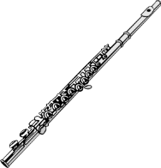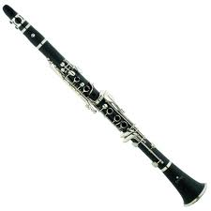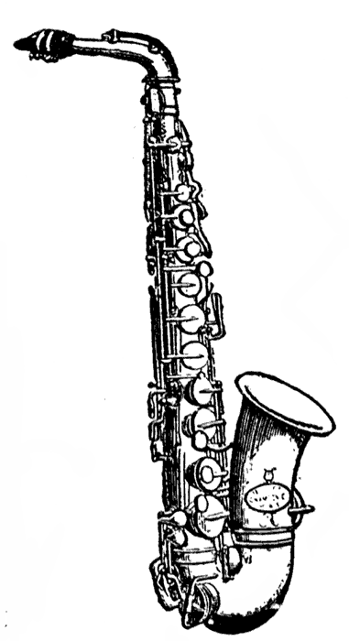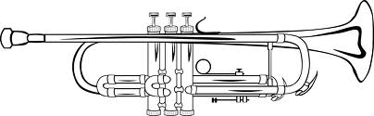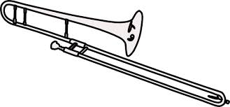
FLUTE CLARINET ALTO SAXOPHONE TRUMPET TROMBONE
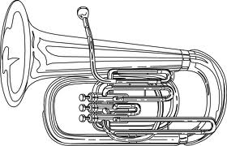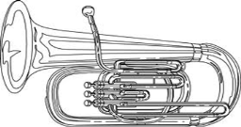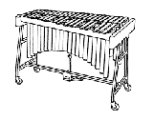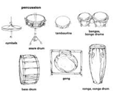
TUBA BARITONE MALLETS PERCUSSION

