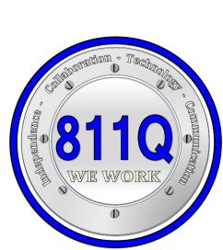
P 811Q
MARATHON SCHOOL
61-25 Marathon Parkway
Little Neck, New York, 11362
718-224-8060 Fax 718-224-5914
www.811Q.weebly.com
Independence-Collaboration-Technology-Communication

Nicole Avila
Principal Assistant Principals
Elementary Offsites: PS 69, P 147, P 822 Johnnie Bradford III
Intermediate Offsites: PS/MS 147IS 227 Yvette Miguez
High School Offsites: Bayside HS, Francis Lewis HS, QHST Katis Romig

District 75 Community-Based Instruction
Parent Consent

Dear __________________________________________________

A critical component of all programs in District 75 is community-based instruction (CBI). These instructional activities give students the opportunity to learn and practice important skills in community settings. Your son/daughter

__________________________________________will participate in many experiences outside the classroom under the supervision of a teacher, paraprofessional and/or related service provider. The activities are directly related to the goals and objectives of your child’s IEP. Your child’s educational program at P811Q will include instruction in the following type of locations in both the home and school communities:
___ Community Service Locations (e.g., post office, public library, firehouse)
___ Recreational Locations (e.g., neighborhood walks, schoolyard, park, YMCA)
___ Community Agency Locations (e.g., AHRC, ACRMD, FEGS, Urban Center)
___ Educational Locations (e.g., universities, colleges, public schools)
___ Stores/Retail Locations (e.g., grocery store, shoe store, drug store)
___ Health Care Locations (e.g., hospitals, nursing homes)
___ Business Locations (e.g., telephone company, hotel, power company)

Transportation
___school bus or van ___subway ___public bus ___walk

Student Supports (money, special clothing, materials that may be needed by the student)

If you have any questions about any of this information, please call the school at ______________________and ask for __________________________________________________________________________________________

I give my permission for ______________________________________of class ___________________________to participate in the Community-Based Instruction program as it has been described above.

Signature of Parent or Guardian: ______________________________ Date: ____________________________

