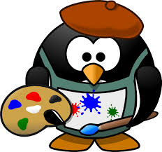
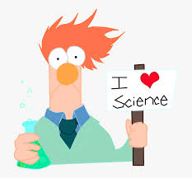

Art and Science Expo Re-imagined
Hello all, hope you are having a great beginning to the school year. Since things are so different this year, the Art and Science Expo will be too. We can’t have gatherings and volunteers are not permitted in the school, so we will be having monthly virtual sessions this year and a mini project.

On the second week of every month from October – March, there will be videos posted on the McCullough website with a guest expert in either Art or Science. The videos will contain Science experiments or Art activities from a different expert every month. They will be posted under Art and Science Expo.

If there are any materials needed, we will post them along with the videos.

Instead of the Expo projects this year, we will be doing Art and/or Science related Trioramas. A Triorama is a 3D Diorama made out of card stock. All the students participating in the Triorama activity will be entered in a raffle for a prize. The Trioramas are due in March.

October videos are from the Andy Warhol Museum

1) Pop-up Soup Can Cards – materials needed are tape or glue, scissors, paper, and 2 templates. Templates provided on McCullough website.

2) Potato Stamps – materials needed are potatoes, paint, brushes, paper, marker, and knife(parental guidance may be needed for cutting, can use a butter knife.)

3) Simple Book Making – materials needed are paper, scissors, and yarn.

Keep checking THT, the PTO Facebook page, and the McCullough website for upcoming videos and more information on the Triorama project for March. Have fun!

