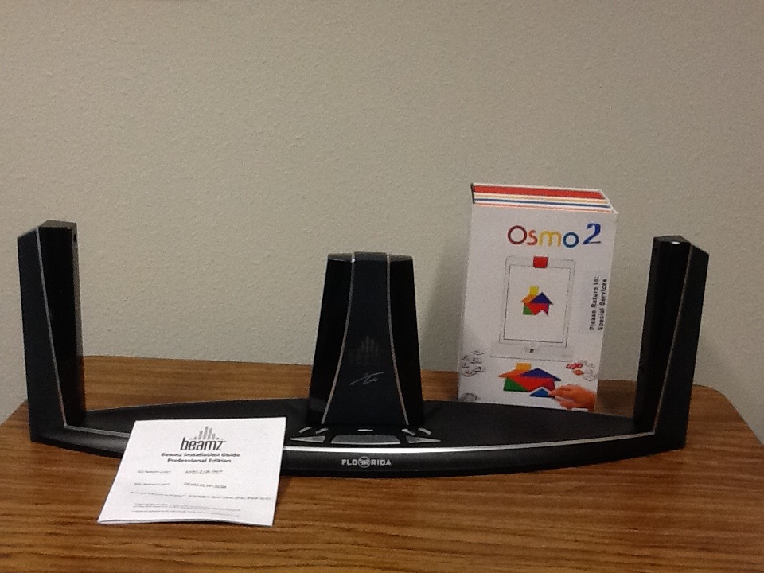

Supplemental Education Devices

- Osmos

- Beamz

