Oxidation-Reduction (Redox)

An oxidation-reduction or redox reaction is a reaction that involves the transfer of electrons between chemical species (the atoms, ions, or molecules involved in the reaction). Some examples of common redox reactions are shown below.

CH₄(g) + 2 O₂(g) → CO₂(g) + 2 H₂O(g) (combustion of methane)

2 Cu(s) + O₂(g) → 2 CuO(s) (oxidation of copper)

During a redox reaction, some species undergo oxidation, or the loss of electrons, while others undergo reduction, or the gain of electrons.

For example, consider the reaction between iron and oxygen to form rust:

4 Fe(s) + 3 O₂(g) → 2 Fe₂O₃(s) (rusting of iron)

In this reaction, Fe loses electrons to form Fe³⁺ ions
and O₂ gains electrons to form O²⁻ ions.

In other words, iron is oxidized, and oxygen is reduced.

To help you memorize this, remember the pneumonic device, OIL RIG

Oxidation Reduction
Is Is
Losing electrons Gaining electrons

Note that when a species gets oxidized, its oxidation number goes up and
when a species gets reduced, its oxidation number goes down.

But what is an oxidation number?

Rules for Oxidation numbers
An atom’s oxidation number (or oxidation state) is the imaginary charge that the atom would have if all of the bonds to the atom were completely ionic. Oxidation numbers can be assigned to the atoms in a reaction using the following guidelines:
- An atom of a free element has an oxidation number of 0. For example, each atom in O₂ has an oxidation number of 0. The same is true for each in H₂​, each S atom in S₈, each C atom in C and so on.
- A monatomic ion has an oxidation number equal to its charge. For example, the oxidation number of Cu²⁺ is +2. And the oxidation number of Br⁻ is -1.
- When combined with other elements, alkali metals (Group 1) always have an oxidation number of +1, while alkaline earth metals (Group 2) always have an oxidation number of +2.
- Fluorine has an oxidation number of -1in all compounds.
- Hydrogen has an oxidation number of +1 in most compounds. The major exception is when hydrogen is combined with metals, as in NaH, or CaH₂. In these cases, the oxidation number of hydrogen is -1.
- Oxygen has an oxidation number of -2 in most compounds. The major exception is in peroxides (compounds containing O₂²⁻, where oxygen has an oxidation number of -1. Examples of common peroxides include H₂O₂ and Na₂O₂.
- The other halogens (Cl, Br and I) have an oxidation number of -1, in compounds, unless combined with oxygen or fluorine. For example, the oxidation number of Cl in the ion ClO₄⁻ is +7 (since O has an oxidation number of -2, and the overall charge on the polyatomic ion is -1. Explanation: Each O is -2. 4 x -2 = -8. Therefore, Cl needs to be +7 because +7 -8 = -1 (-1 is the charge on ClO₄⁻)
- The sum of the oxidation numbers for all atoms in a neutral compound is equal to zero, while the sum for all atoms in a polyatomic ion is equal to the charge on the ion.

Example 1: Assigning oxidation numbers
What is the oxidation number of each atom in:
(a) SF₆
(b) H₃PO₄
(c) IO₃⁻

S⁺⁶F⁻¹₆ (+6 + 6(-1) = 0)

H⁺¹₃P⁺⁵O⁻²₄ (3(+1) + (+5) + 4(-2) = 0)

I⁺⁵O⁻²₃⁻ ((+5) + 3(-2) = -1)

Recognizing redox reactions
How do we actually use oxidation numbers to identify redox reactions? To find out, let’s revisit the reaction between iron and oxygen, this time assigning oxidation numbers to each atom in the equation:

4 Fe⁰(s) + 3 O₂⁰(g) → 2 Fe⁺³₂O⁻²₃(s) (rusting of iron)

Iron changes from an oxidation number of 0 to an oxidation number of +3. Oxygen changes from an oxidation number of 0 to an oxidation number of -2.
We can conclude that oxidation involves an increase in oxidation number, while reduction involves a decrease in oxidation number.

Oxidizing Agents and Reducing Agents
An oxidizing agent is a substance that causes oxidation by accepting electrons; therefore, it gets reduced. A reducing agent is a substance that causes reduction by losing electrons; therefore, it gets oxidized.

Writing and Balancing Redox Reactions
In the ion-electron method (also called the half-reaction method), the redox equation is separated into two half-equations - one for oxidation and one for reduction. Each of these half-reactions is balanced separately and then combined to give the balanced redox equation.

HOW TO WRITE AND BALANCE A REDOX EQUATION

We will learn to balance a redox reaction using the following reaction as an example:

HCl + KMnO4 H2O + KCl + MnCl2 + Cl2

Step 1) Find the Oxidation Numbers for each element.

H+1Cl-1 + K+1Mn+7O-24 ------> H+12O-2 + K+1Cl-1 + Mn+2Cl-12 + Cl02

Step 2) Find out which element is being oxidized and which element is being reduced; then
start to write out the 1/2 rxns for each.

Oxidation: Cl-1 Cl02

Reduction: Mn+7 Mn+2

Step 3) Then Balance both the Number of atoms and the Charge...

Oxidation: 2 Cl-1 Cl02 + 2 e-1

Reduction: 5 e-1 + Mn+7 Mn+2

Step 4) Balance out the electrons so that the number of electrons gained = the number lost.

Oxidation: (2 Cl-1 Cl02 + 2 e-1) x 5 = 10 Cl-1 ------> 5 Cl02 + 10 e-1

Reduction: (5 e-1 + Mn+7 Mn+2) x 2 = 10e-1 + 2 Mn+7 ------> 2 Mn+2

Step 5) Now add the two reactions together like a math problem, canceling out the electrons.

Oxidation: 10 Cl-1 5 Cl02 + 10 e-1

Reduction: 10e-1 + 2 Mn+7 2 Mn+2
-----------------------------------------------------------

10 Cl-1 + 2 Mn+7 2 Mn+2 + 5 Cl02

Step 6) Reinsert the coefficients into the original equation.

H+1Cl-1 + K+1Mn+7O-24 H+12O-2 + K+1Cl-1 + Mn+2Cl-12 + Cl02

becomes.....

10 HCl + 2 KMnO4 H2O + KCl + 2 MnCl2 + 5 Cl2

Step 7) Now check to make sure everything is balanced, and if not, the try to rebalance it.

Since the K’s were not balanced, The KCl is multiplied by 2.

10 HCl + 2 KMnO4 H2O + 2 KCl + 2 MnCl2 + 5 Cl2

Now to balance the Cl’s (since there are 16 on the right, we need 16 on the left.)

16 HCl + 2 KMnO4 H2O + 2 KCl + 2 MnCl2 + 5 Cl2

Finally, to balnce the H’s (and also the O’s) 8 H₂O’s are needed.

16 HCl + 2 KMnO4 8 H2O + 2 KCl + 2 MnCl2 + 5 Cl2

Teacher: Mr. Baruch Unit: Redox
Subject: Chemistry
Name: _________________________ Date: ___________________

Redox

1. What is oxidation? Give an example of this process.

2. What is reduction? Give an example of this process.

3. What is meant by a “redox reaction”?

4. In the following reactions, identify which elements are being oxidized, and which are being reduced. Show the oxidation numbers of the oxidized and reduced elements:

a. 2 K (s) + H2SO4 (aq) ----> K2SO4 (aq) + H2 (g)

b. H2 (g) + CuO (s) -----> Cu (s) + H2O (l)

5. For the equations above, write the electronic equations for the elements oxidized and reduced in each.

Teacher: Mr. Baruch Unit: Redox
Subject: Chemistry

Name: _________________________ Date: ___________________

Balancing Half Reactions Worksheet

Use the half-reaction method to balance each of the following equations. Show each half reaction.

1. Li + H2O ----> LiOH + H2

2. Al + HCl ------> AlCl3 + H2

3. H2S + HNO3 -----> H2SO4 + NO2 + H2O

4. Cu + HNO3 -----> Cu(NO3)2 + NO + H2O

5. KClO3 ------> KCl + O2

ELECTROCHEMICAL CELL

A device that produces useable electric energy
from a spontaneous chemical rxn; a battery.
Zn⁰_{(s)} Zn2+ + 2e- Cu2+ + 2e- Cu⁰_{(s)}
oxidation reduction
Anode Cathode
- is negative - is positive
- is where oxidation occurs - is where reduction occurs
- e- flow from anode - e- flow to the cathode
- e- generated by the - e- accumulated and used
oxidation 1/2 rxn to make reduction happen

ELECTROLYTIC CELL

A device that drives a non-spontaneous chemical rxn by using an external electrical source. (It uses a battery)
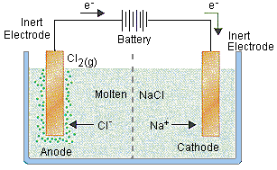
2 Cl- Cl2(g) + 2e- 2 Na+ +2e- 2 Na⁰_{(s)}
Anode Cathode
- is positive - is negative
- oxidation occurs at anode - reduction occurs at cathode
- neg. ions attracted to anode; - positive ions attracted to
- electrons produced here. cathode, battery supplies
electrons to cathode.

ELECTROPLATING

Electric current used to deposit a layer of of metal, such as silver, on the object to be plated.
Same system as the electrolytic cell.
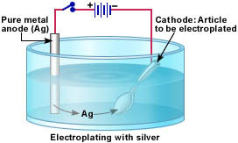
Ag Ag+ + 1e- Ag+ + 1e- Ag
Anode Cathode
- is positive - is negative
- oxidation occurs at anode - reduction occurs at cathode
- positive ions provided - positive ions attracted to
by anode cathode
- electroplating occurs at cathode

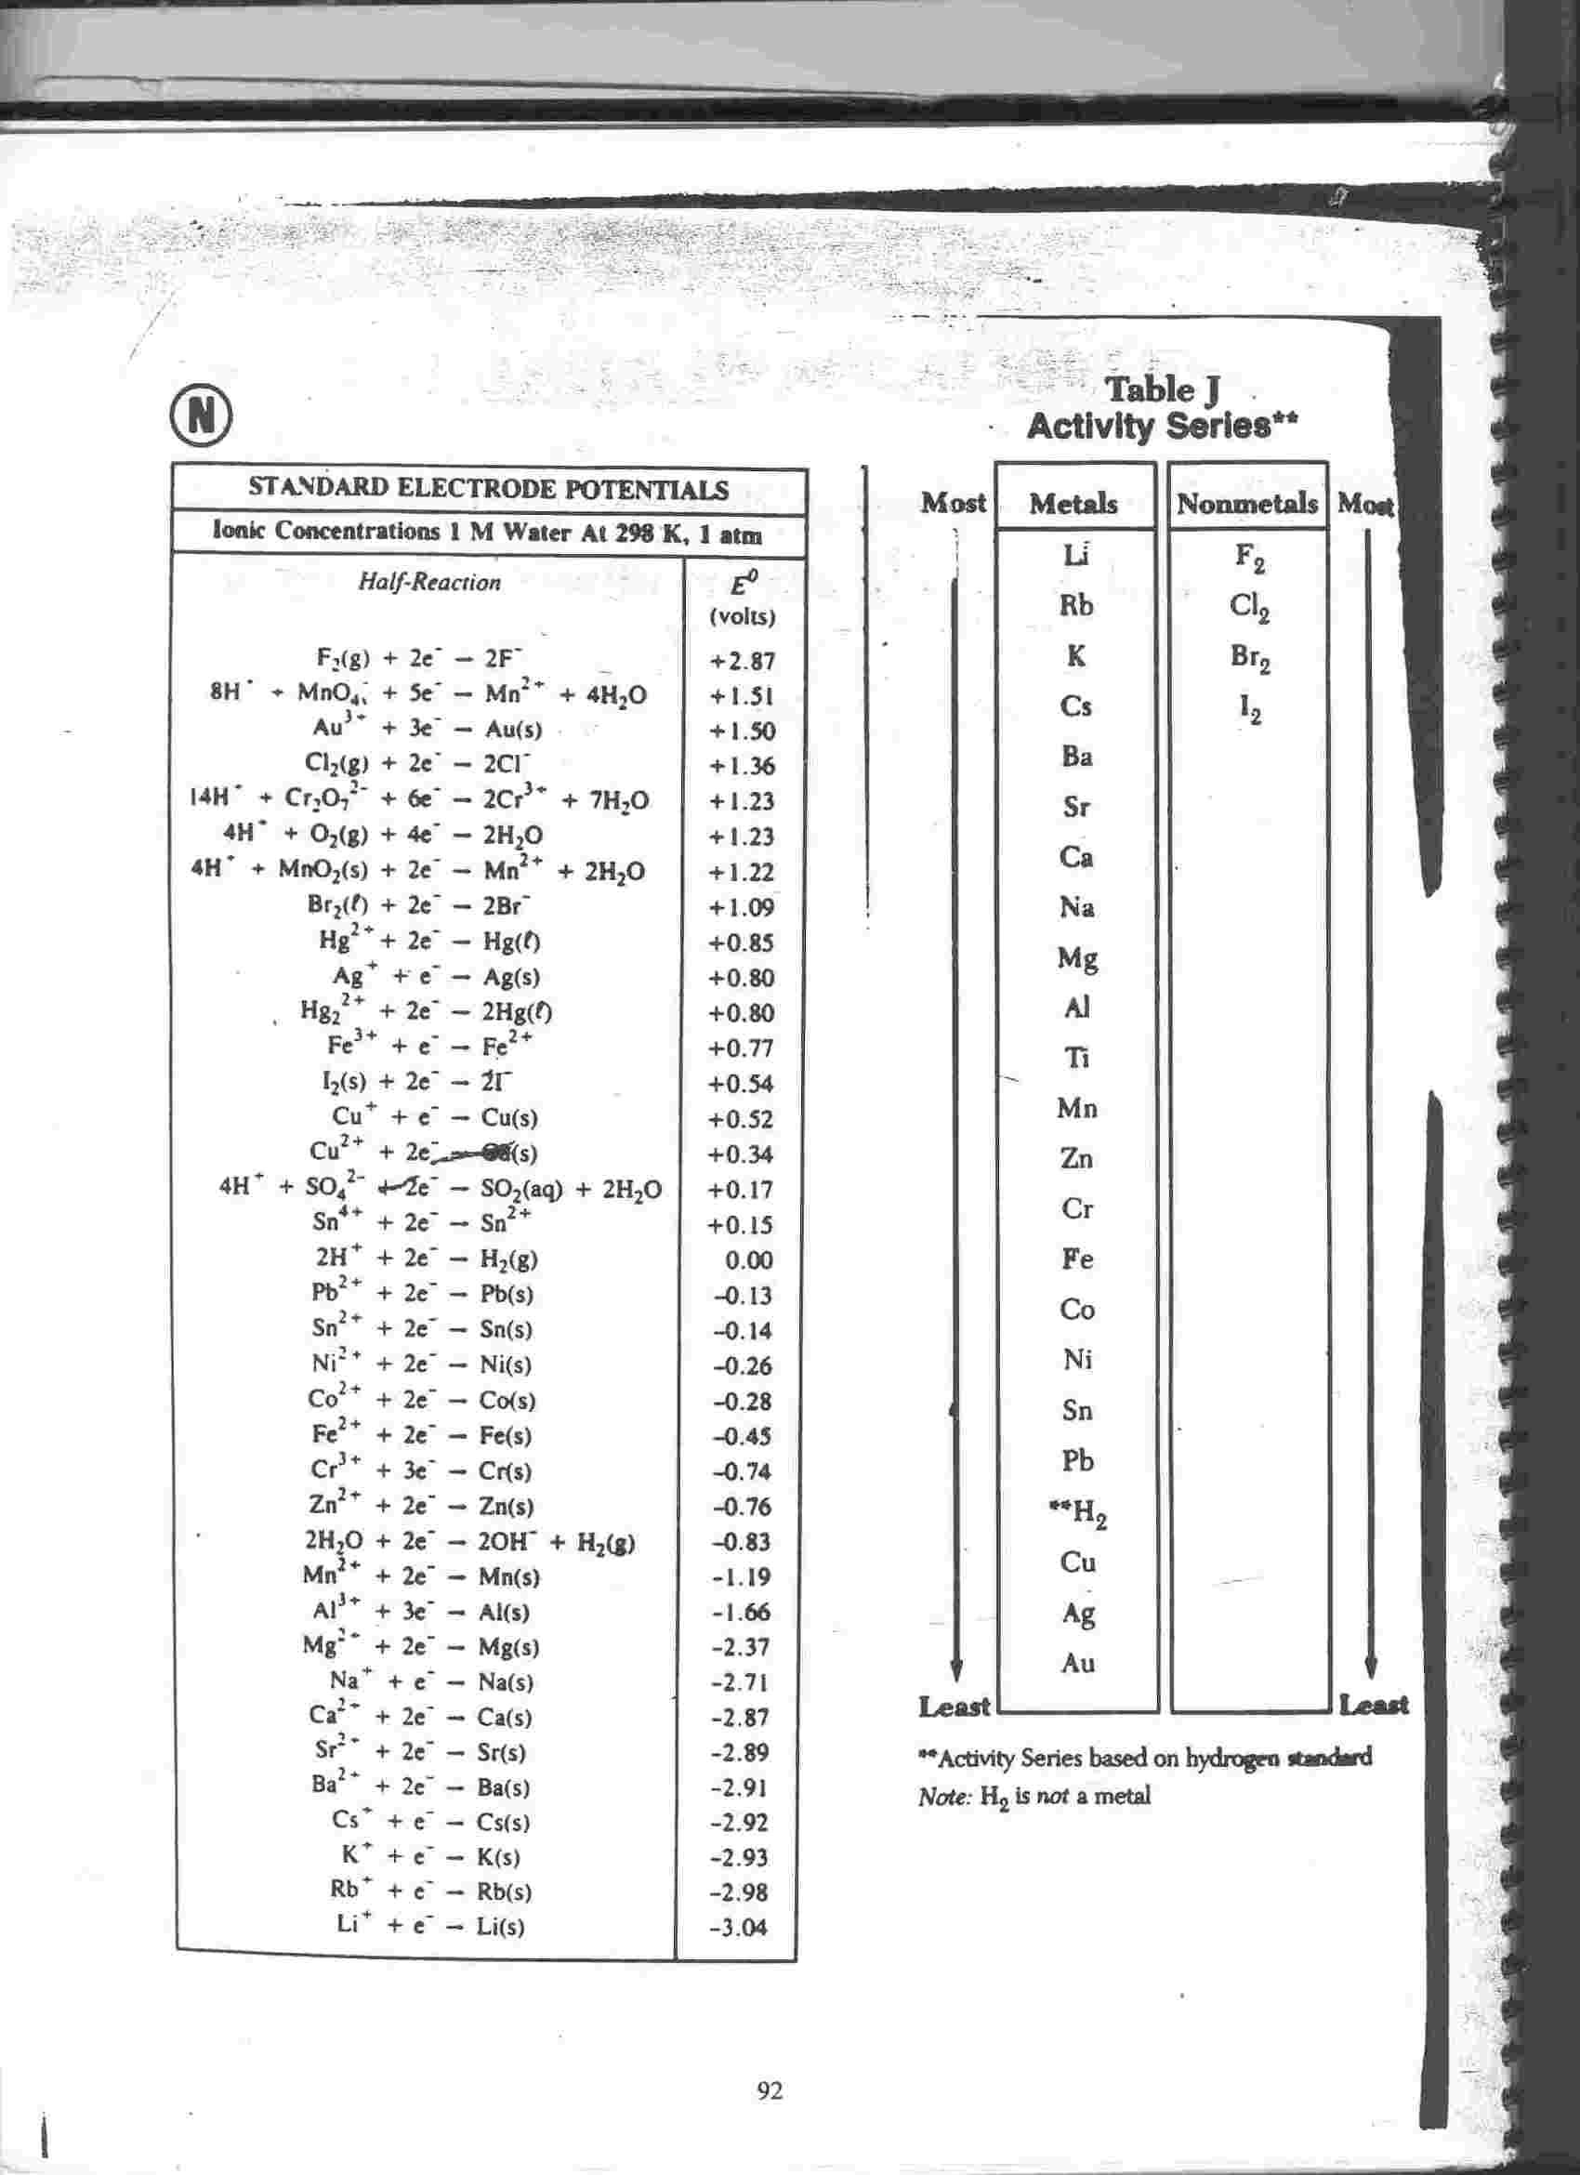
Name: _________________________ Date: ___________________

Electrochemistry

1. Write the word anode or cathode next to each line.

a. The electrode at which oxidation occurs. _________________

b.The electrode at which reduction occurs. _________________

c.The negative electrode in an electrochemical cell. _________________

d.The negative electrode in an electrolytic cell. _________________

e.In an electrolytic cell, the electrode that attracts Cl- ions . _________________

f.The part of an electroplating system that is provided by a fork. _________________

g.The part of an electroplating system that generates Ag+ ions. _________________

2. Define the term reducing agent.

3. Define the term oxidizing agent.

4. The most active reducing agent among the elements is:
a. iodine b. cesium c. fluorine d. lithium

Explain why: ____________________________________________________________

5. The most active oxidizing agent among the elements is:
a. iodine b. cesium c. fluorine d. lithium

Explain why: ____________________________________________________________

6. How do anodes and cathodes differ in electrochemical cells vs. electrolytic cells?

OVER
7. Write out the net ionic (or skeletal redox) equation for an electrochemical cell that has
MgCl2 in one 1/2 cell, and SnCl2 in the other 1/2 cell.

8. Draw the full electrochemical cell diagram for question #7 on the back of this sheet.

Class: Chemistry

Name: _________________________ Date: _________________

Electrochemical Cell Worksheet

You are given two beakers. In Beaker #1 is a solution of lead nitrate ( Pb(NO₃)₂ ) and a piece of solid lead metal. In Beaker #2 is a solution of nickel nitrate ( Ni(NO₃)₂ ) and a piece of solid nickel metal. The two pieces of metal are connected by wires to each other through a voltmeter which reads electrode potential (E_{cell}) in volts. Finally, a salt bridge is placed between the two beakers. The salt bridge contains a solution of potassium nitrate.

1. Draw a diagram of the picture mentioned above.
- Which beaker ( half-cell) is undergoing oxidation and which is undergoing
reduction?
3. Write the 1/2 reactions for oxidation and reduction of these two half-cells.
4. What does the Ecell equal for this reaction?
5. Which electrode is the anode and which is the cathode?
6. Which electrode is positive and which is negative?
7. In which direction are the electrons flowing (from what to what)?
- Why will this reaction occur spontaneously?
- What is the function of the salt bridge?
- What will happen to the Nickel metal over time, and what will happen to the Lead metal over time?
- Which of the two solutions will have more metal ions in it over time and which will have less over time?

