Name: _________________________________________ Date: ___________________

- Student Activity -
Calorimetry and the Law of Conservation of Energy

It is because we know that energy is conserved that we can use a calorimeter to measure the total heat gained or lost in a system. In other words, heat lost by one body must be gained by another. We will use this law to determine the specific heat capacity of an unknown metal, and from that, the identity of that metal.
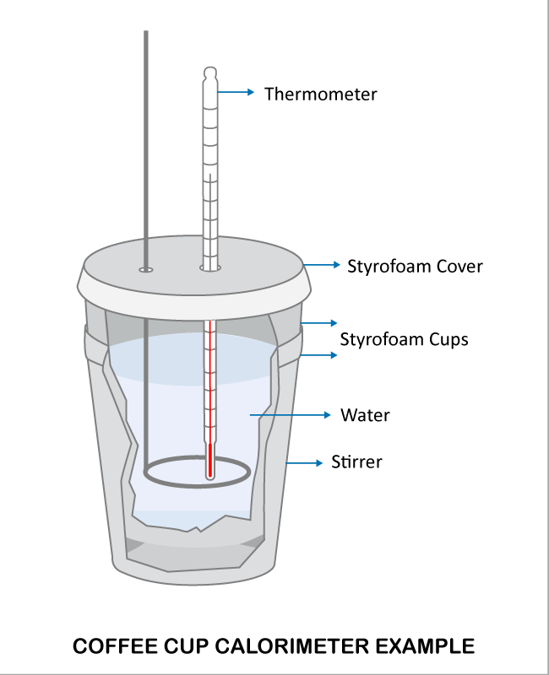
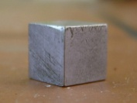
Unknown metal

1st Activity
A Styrofoam cup had been filled with 50.00 grams of water that had been heated to 50.00ºC. At that exact moment, a 30.00 gram piece of an unknown metal was gently placed into the cup of water. The metal was originally at 20.00ºC. The heat from the water had slowly raised the temperature of the metal, while at the same time, the temperature of the water had decreased. Eventually the temperature of both the metal and the water equilibrated to a final temperature of 43.80ºC. Fill in the data table on the next page. Determine the specific heat capacity of an unknown metal, and from that, the identity of that metal.

Data Table - Calorimetry Data for an Unknown Metal and Water
Fill in the data table below.
Mass of water (g)
Mass of unknown metal (g)
Initial temperature of metal (ºC)
Initial temperature of water (ºC)
Final temperature of both (ºC)
Specific heat capacity of water | 4.184 J/gºC

The following relationships will be used in this activity:

- heat lost by the original mass of specific heat the change in
water in the = of water in the x capacity of x temperature calorimeter calorimeter water of water
In symbols, this word formula becomes:
q = m x C x ΔT

The specific heat capacity of a substance is the quantity of heat energy needed to raise the temperature of one gram of the substance by 1° Celsius. The specific heat capacity of water is 4.184 joules per gram per degree Celsius (4.184J/g°C).

- heat given off by the water = heat absorbed by the metal (Law of conservation of energy)

q_{lost} = q_{gained}

Using the data and formulas from the previous page…
1. Calculate the heat lost by the water.

2. Based on the Law of Conservation of Energy, what was the heat gained by the metal?

3. Calculate the specific heat capacity of your unknown metal.

4. Using the chart below, identify your unknown metal.
Substance | Specific heat capacity in J/gºC
Aluminum | 0.900
Beryllium | 1.82
Cadmium | 0.232
Lead | 0.128
Nickel | 0.444
Silver | 0.233
Tin | 0.213
Tungsten | 0.133
Uranium | 0.115
Zinc | 0.387
Unknown metal ______________
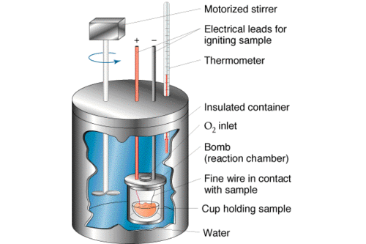

2nd Activity
Food calorimetry allows us to determine the number of calories per gram of food. In this next activity, a piece of food is burned and the released energy is used to heat a known quantity of water. The temperature change (∆T) of the water is then used to determine the amount of energy in the food. A bomb calorimeter had been filled with 100.00 grams of water at 20.0ºC. A 1.00 gram piece of a candy bar was placed into the inner chamber and then ignited. The candy bar burned and the heat given off from the combustion caused the temperature of the water to increase to 65.0ºC.

Fill in the data table below.

Data Table - Calorimetry Data for a Candy Bar
Fill in the data table below.
Mass of water (g)
Mass of candy bar (g)
Initial temperature of water (ºC)
Final temperature of water (ºC)
Specific heat capacity of water | 4.184 J/gºC

1. Calculate the heat gained by the water.

2. Based on the Law of Conservation of Energy, what was the heat content of the1.00 gram piece of the candy bar in joules/gram?

3. If the full size of the original candy bar was 50.00 grams, how many joules of heat are contained in a full size candy bar?

4. Since heat is recorded in calories instead of joules on packages of food, calculate the calories of heat contained in a full size candy bar, given that 1 calories = 4.184 joules.

5. Food Calories are not the same as scientific calories. In fact one food Calorie is actually the same as one scientific kcal. Therefore, how many Calories would be listed on the package of this candy bar?

