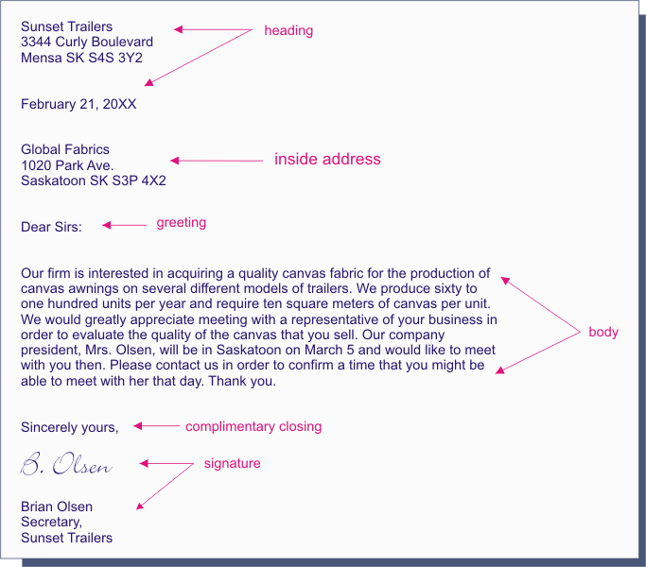

[Your Name]   
[Address]  
[Address]  
[Phone]

[CERTIFIED MAIL]

[Date today]

[Recipient’s Name]  
**[Company Name]**  
[Address]  
[Address]

**Re: [To what this letter refers]**

Dear [Recipient’s Name]:

The main characteristic of modified block business letters is that everything is flush with the left margin, except as shown. Modified block letters are a little less formal than full block letters and only the body is block and left justified. The complimentary closing will be started at the center point.

If your letter is only one page, type the complimentary close and optional components as shown below. Otherwise, type them on the last page of your letter.

Sincerely,

[Signature]  
Your Name Typed  
*Title*

[Identification Initials]  
Enclosures: [Number]

cc: [Name for Copy]

To: Recipients Name  
From: Your Name  
Date: (automatically generated)

Subject:

Dear Recipient:

____________________________________________________________________________________________________________________________________________________________________________ .

* Point 1
* Point 2
* Point 3

____________________________________________________________________________________________________________________________________________.

Complimentary Closing,

Your Name  
*Title*

Company Name  
Address Line 1  
Address Line2

Phone NUmber