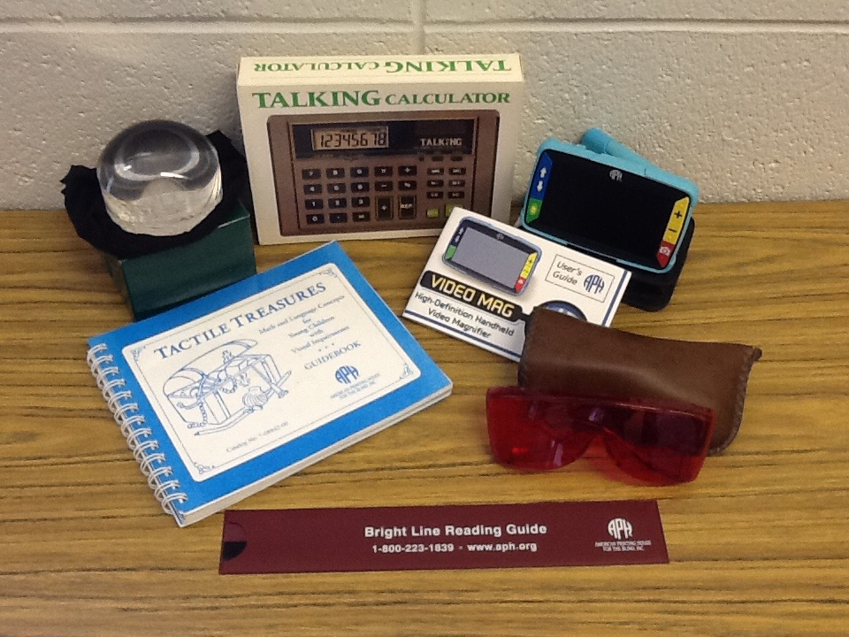

Items for Low Vision

- Tactile Treasures – Math and Language Concepts for Young Children with Visual Impairments

- Talking Calculator

- Bright Line Reading Guide

- Glasses

- Bubble magnifier

