Fever, 1793
Reading Schedule and Activity

On this date… | Read and have completed Reading Diary Entry for…
Monday, October 17 | Chapters 1-4
Thursday, October 20 | Chapters 5-7
Monday, October 24 | Chapters 8-10
Thursday, October 27 | Chapters 11-15
Monday, October 31 | Chapters 16-19
Thursday, November 3 | Chapters 20-22
Monday, November 7 | Chapters 23-25
Thursday, November 10 | Chapters 26-Epilogue

Reading Diary Requirements
- For each Reading Diary entry (see grouping of chapters above)…
  - Use one side of one half sheet
  - List each character that was introduced in those chapters and write something we learn about them (description or how they relate to the story).
  - Write a brief summary (2-4 sentences that retell the important events in those chapters).
  - Write down any thoughts you had as you read the chapters, including…
    - Questions you had
    - Words or descriptions that kept reoccurring
    - Emotions you felt

Project Due Date: Monday, November 14 (details on back)

Complete Reading Diary Due Date: Wednesday, November 16

Test Date: Wednesday, November 16
Fever, 1793 Project – Book Cover

- Create your own book cover for your novel
- As shown, a book cover should include:
  - Title, Author, and Cover art
  - Summary
  - Main Character List
  - Book Recommendation - Convince someone that he/she should read this book. Use specific examples from the book to show what lessons he/she might learn from it.

Book Cover Example
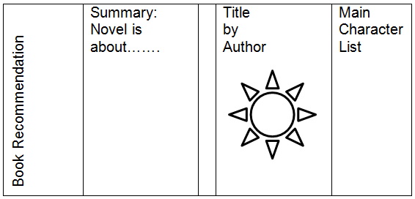

Book Cover Rubric
- Title, Author, Cover Art (20)
  - Original Cover Art
  - Creativity
- Summary (40)
  - 150+ words
  - Complete and thorough (includes all major plot elements)
  - No Spelling and Punctuation errors
- Main Character List (20)
  - Complete and Thorough
  - Demonstrates understanding of the novel
- Book Recommendation (20)
  - 75+ words
  - Includes examples from the book
  - Demonstrates understanding of the novel

