PowerSchool
Online Registration Instructions

The following instructions will help you sign into the PowerSchool for student’s website and being the Online Registration process.

Go to the Westbrook High School website: https://whs.westbrookctschools.org/

Under the Student Resources tab, click on Login Portal and PowerSchool for Parents and Students

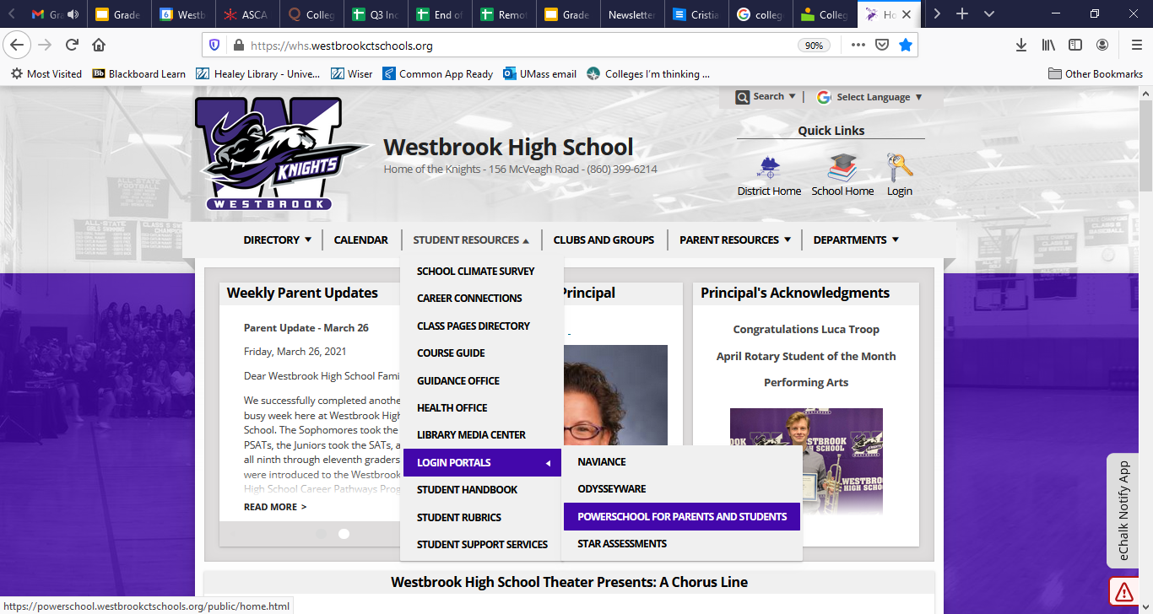
Click on PowerSchool for Parents and Students

Use your PowerSchool username and password to log-in. If you have trouble signing in, please contact Lori Wallace at lori.wallace@westbrookctschools.org

After signing in, you will see a Navigation Screen on the left. Select Class Registration to begin the course registration process.

Each Welcome Page is designed for your grade during the 2021-2022 school year.

- To select a Pathway, click on the pencil next to Career Pathway to select one of three available career clusters. Please refer to the Westbrook High School Career Pathways Program of Study for more information about class offerings for each pathway.

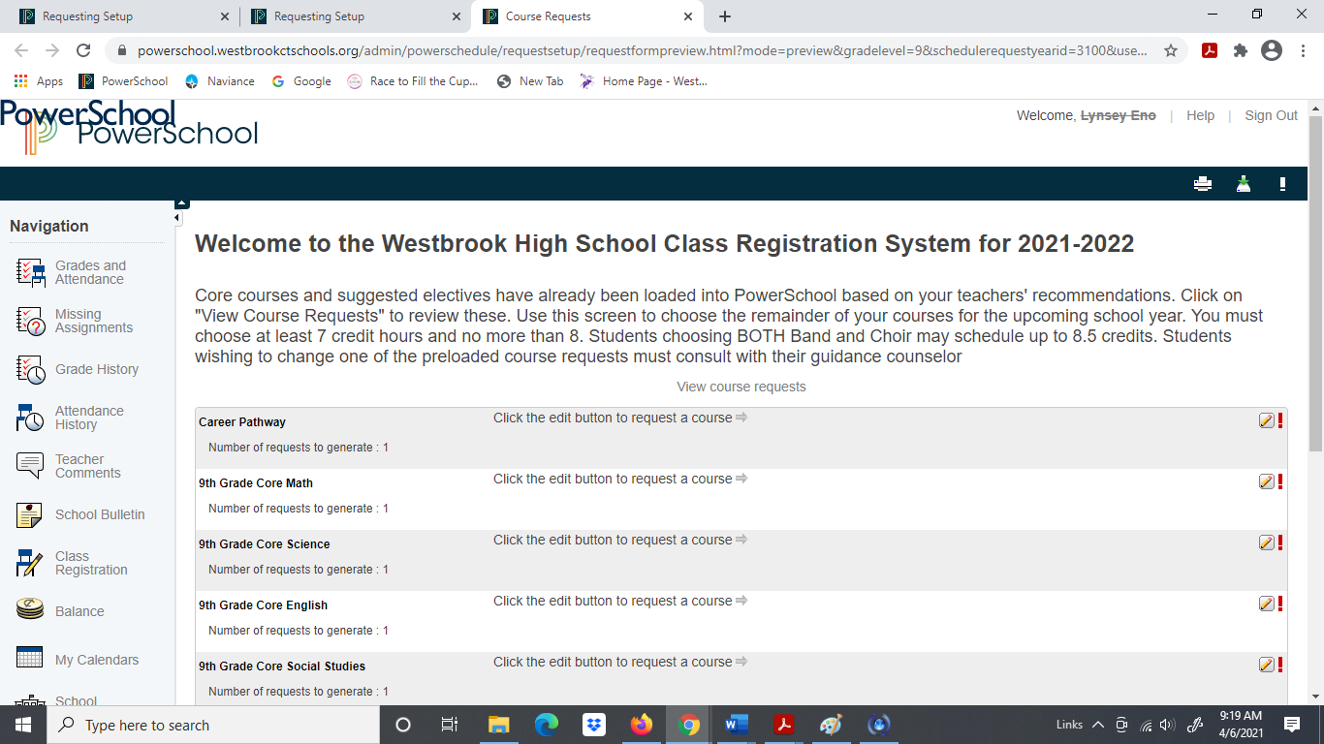
Click on Career Pathway

Beginning in the fall of 2021 students will select 1 of 3 career clusters: Advanced Technologies and Sciences, Arts, Business and Communications, and Health, Human, and Public Services Pathway.
Click on a Career Cluster
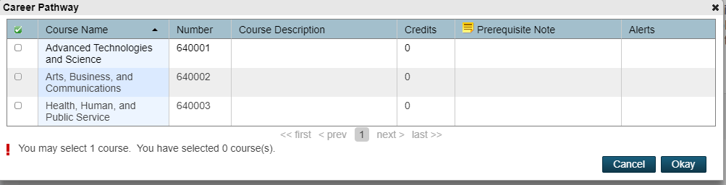

Select a career cluster and click Okay.

- On the Class Registration Screen, you will select a Core Math, Science, English, and Social Studies courses by using the course screens which appear when you click on the Pencil in each category. Please be sure to select the appropriate course(s) in each category.

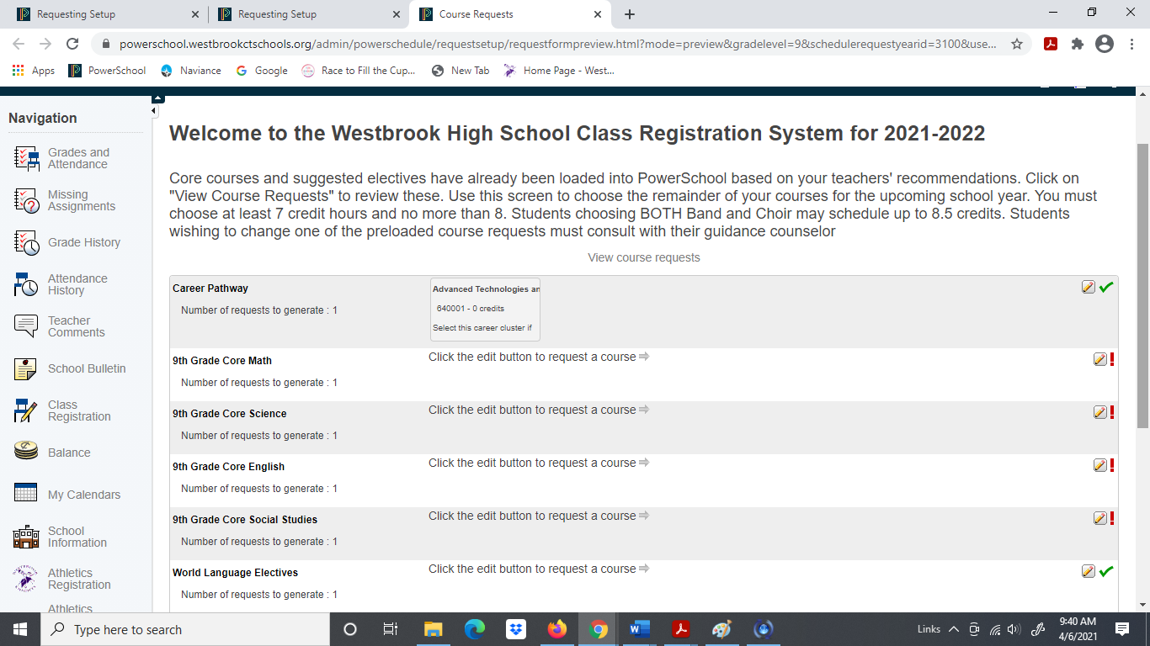

- When the course screen appears, select the desired class by clicking the appropriate box. **Please be sure to register for the class(es) you were recommended for**. After double checking the class you selected is correct, click Okay. You should follow the same process for each category: Core Math, Core Science, Core English, Core Social Studies, and Electives.

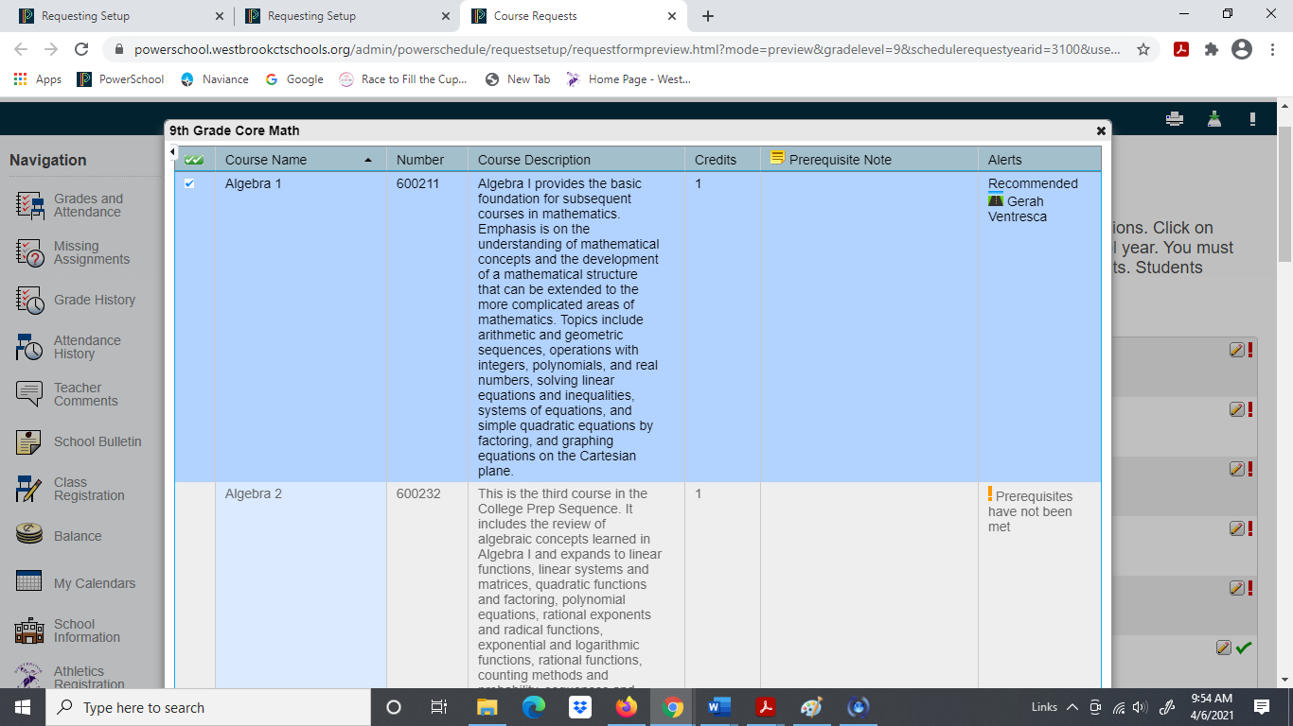

- When selecting your electives, please notice there are numerous pages of elective screens and the electives are in alphabetical order. You may have to go through numerous screens to find the elective you are looking for.

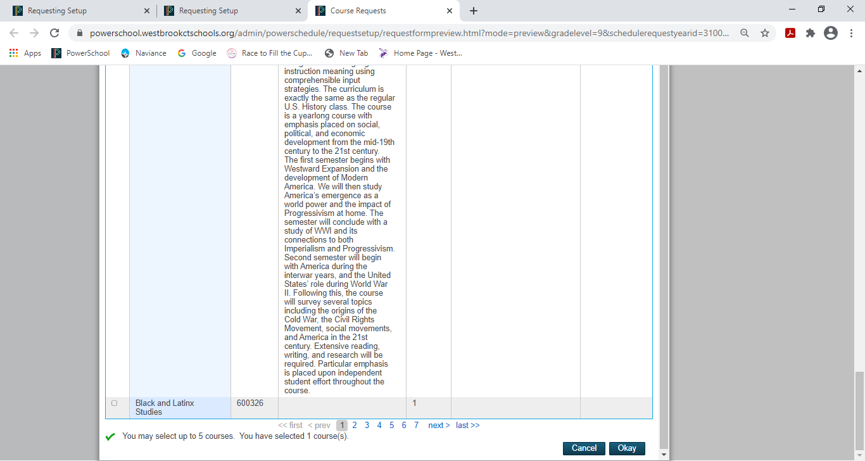

When you have selected a minimum of 7 credits or a maximum of 8.5 credits for the 2021-2022 school year, scroll down to the bottom of the Registration Page and click the Submit Button.

Please address any questions you have about particular classes with your high school counselor Mrs. Britton (A-K) jbritton@westbrookctschools.org and Ms. Cunningham (L-Z) scunningham@westbrookctschools.org.

