Influenza Information

Please by aware that the Westbrook Public Schools have a population of students and staff who are at high risk for developing flu related complications. The flu can be deadly for the old, young, and people with compromised immune systems. On the behalf of our high risk population, I ask for people to be responsible and do not enter the school with flu-like symptoms.

Schools are a prime location for the flu virus to spread. It is hard to prevent kids from getting the flu this time of year for various reasons. The flu virus is spread by respiratory droplets from coughing, sneezing, and talking. Droplets can spread up to six feet away and land in the mouths or noses or people who are nearby. It can also be spread by touching a surface or object that has the flu virus on it and then touching their mouth or nose.

- Children are three times more likely to get sick with the flu
- Children can pass the flu virus to others for a period of more than seven days after the symptoms start
- On average, one-third of family members in families with school age children are infected with the flu each year.

The flu is different than a cold. Both a cold and flu are respiratory illnesses, however they are caused by different viruses and have different symptoms. The flu normally comes on suddenly.

An easy way to recognize the flu symptoms are to remember the FLU FACTS.
(Fever, Aches, Chills, Tiredness, and Sudden onset)
Sometimes vomiting and diarrhea is seen with children.

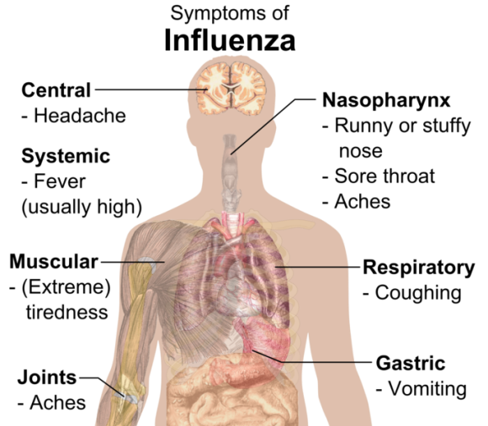

Symptoms of Influenza: Central – Headache, Systemic – Fever (usually high), Muscular (extreme tiredness), Joints – Aches, Nasopharynnx – Runny or stuffy nose – Sore throat – Aches, Respiratory – Coughing, Gastric – Vomiting

Complications of the flu virus can include bacterial pneumonia, ear infections, sinus infections, dehydration, and worsening of chronic medical conditions, such as congestive heart failure, asthma, or diabetes.

Key points to remember:
Teach your children to wash their hands often with soap and water. You can set a good example by doing this yourself. Good hand hygiene is the first line of defense against the flu. Hand sanitizer is acceptable if your hands are not visibly dirty.
Teach your children not to share personal items like drinks, food or unwashed utensils, and to cover their coughs and sneezes with tissues. If they don't have a tissue, they should cough or sneeze into their upper sleeve, not their hands.
Know the signs and symptoms of the flu. Symptoms of the flu include fever (100 degrees or greater), cough, sore throat, a runny or stuffy nose, body aches, headache, and feeling very tired. Some people may also vomit or have diarrhea.
Don't send children to school if they are sick. Any children who are sick at school will be sent home. Keeping your child home when sick will allow them to rest and also allows you to monitor their health closely. Keeping your sick child home is the responsible thing to do. It protects fellow students and school staff, especially those who are at higher risk of severe illness from the flu.
Remember- if you are sick, please STAY HOME! Please be vigilant of others and aware of the serious risk to students and staff when coming to school with flu-like symptoms. Thank you in advance for doing your part in keeping our schools healthy! If you have any questions or concerns please let me know.

