Name: ____________ Date:

STUDENT ACTIVITY - Chemical Equilibrium
Introduction
- Chemical equilibrium occurs when opposing reactions are proceeding at equal rates.
- The rate at which the products are formed from the reactants equals the rate at which the
reactants are formed from the products.
- As a result, concentrations cease to change, making the reaction appear to be stopped.
- How fast a reaction reaches this equilibrium state is a matter of kinetics.
- An equilibrium state results when a reaction is reversible.
k_{f}
k_{r}

aA + bB cC + dD

- At equilibrium the concentrations of reactants and products is still changing, however,
the rate of the forward reaction (k_{f}) is equal to the rate of the reverse reaction (k_{r}) in what is called a dynamic equilibrium such that no change in their concentrations is observed. Thus, for equilibrium to occur, neither reactants nor products can escape from the system.
- The law of mass action states the ratio of forward and reverse processes is described by
the equilibrium constant, K_{c ,} which can be calculated using a knowledge of the
equilibrium concentrations of reactants and products.
- The equilibrium constant expression depends only on the stoichiometry of the reaction.

Objectives and Success Criteria
- Mastering the application of the ICE table methodology to equilibrium problems.
- Accurate solutions to problems involving reactant and product concentrations and
equilibrium constants.

MODEL 1: The ICE Table

Example:
Initially 1.50 moles of N₂(g) and 3.50 moles of H₂₍g) were added to a 1 L container at 700 °C. As
a result of the reaction:
N₂(g) + 3 H₂₍g) 2 NH₃(g)

the equilibrium concentration of NH₃(g) became 0.540 M. What is the value of the equilibrium
constant for this reaction at the given temperature of 700 °C?

N₂(g) + 3 H₂₍g) 2 NH₃(g)
I. Write the Initial concentrations of
reactants and products. 1.50 M 3.50 M 0 M

C. Write the Change in concentration due −x −3x +2x
to reaction using the given reaction
stoichiometric coefficients.
________________________________________
E. Write the reactant and product 1.50 -x 3.50 -3x 2x
concentrations at Equilibrium.

Since we know that the equilibrium concentration of NH₃(g) became 0.540 M, we can substitute that number for 2x. Solving for x, we get x = 0.270 M. We can substitute these new numbers into the ICE Box chart.

N₂(g) + 3 H₂₍g) 2 NH₃(g)
I. 1.50 M 3.50 M 0 M
C. − 0.270 − 0.810 + 0.540 ____________________________________________
E. 1.23 M 2.69 M 0.540 M
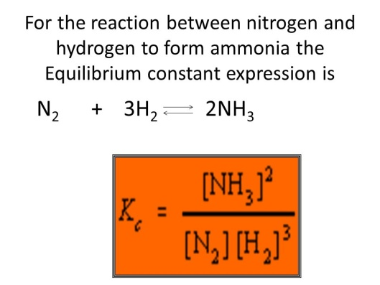

We can now solve for the equilibrium constant K_{c} using the equilibrium equation:

equation. 1

K_{c} = [0.540]²_____ = 0.0122
[1.23] x [2.69]³
Key Questions
(i) In the above reaction we can monitor the change in concentration of reactants over time
and we can plot the data as follows:

Label below
C
O
N
C
E
N
T
R
A
T
I
O
N
(M)

3 -
__________

2 -
__________

1 1 - __________

a b c d
time

1. Using the worked example from Model 1, label each data plot as either [H₂], [N₂] or [NH₃].

2. Why does one data plot show an initial positive slope whereas the other two data plots show
initial negative slopes?

________________________________________________________________________

________________________________________________________________________

3. Why does the uppermost plot have a steeper initial slope than the middle plot.

________________________________________________________________________

4. At which time a, b, c or d is an equilibrium state first reached? ________

5. The equilibrium constant for this reaction was calculated to be 0.0122. What is Kc for
the reverse reaction? (Show work below).

6. Initially, 1.0 mol of NO(g) and 1 mol of Cl₂(g) were added to a 1 L container. As a result
of the reaction the equilibrium concentration of NOCl(g) became 0.96 M. Using the ICE Box
methodology, determine the value of the equilibrium constant K_{c} for this reaction:

2 NO(g) + Cl₂₍g) 2 NOCl(g)

I. _______M _______M _______M

C. ________ ________ ________
__________________________________________________

E. _______M _______M _______M

Solve for K_{c}

7. If a 10.00 L flask at 500 K is filled with a 0.30 mole of hydrogen and 0.30 mole of iodine.
What are the equilibrium concentrations of all three gases?

The equilibrium constant K_{c} = 45.0.

The relevant reaction is: H₂(g) + I₂₍g) 2 HI(g)

:

[H₂] = ________M [I₂] = ________M [HI] = ________M

8. Gaseous carbon dioxide is partially decomposed according to the equation below.
An initial pressure of 1.00 atm of CO₂ is placed in a closed container at 2500 K, and 2.10 %
of the molecules decompose. Determine the equilibrium constant K_{p} at this temperature.

(K_{p} is solved the same way as K_{c}, except you will use pressure values instead of molarities).

2CO₂(g) 2 CO(g) + O₂₍g)

K_{p} = ____________

