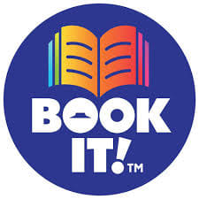

BOOK IT! 2020-2021 kicks off October 1st!

BOOK IT! is a free reading motivation program created by Pizza Hut. When your student meets their monthly reading goal, they receive a free Personal Pan Pizza®, a prize and praise from Pizza Hut.

You will receive an email from: Pizza Hut BOOK IT! Program
The subject of the email is: Book It Student Approval Pending
Just select YES if you’d like your child to participate!

All students in all grades at McCullough are eligible to participate this year.

Reading logs and pizza certificates will be all online.

Refer questions to:

Sarah Schadler schadlers@penntrafford.org
or
Amy Schulte amyschulte1616@gmail.com

