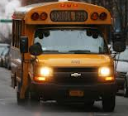
Class Bus Sheet
Staff:

Student | Bus | Location | Staff

