What is a Visual Activity Schedule?
A visual activity schedule is a series of pictures or drawings to sequence activities or events in a child’s day. A visual activity schedule will help to create structure, ease the transition between activities and alleviate anxiety as your child will know what to anticipate next.
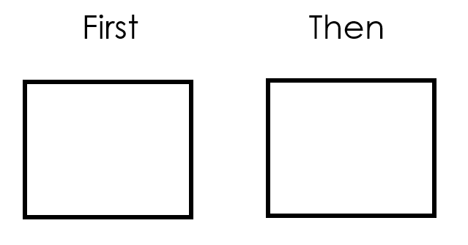
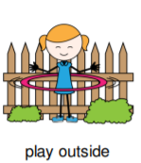
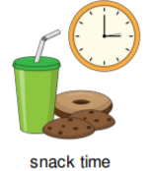
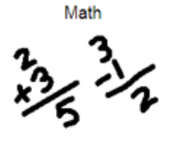

How can I create one at home?
A visual activity schedule can be presented using an iPad or computer, dry erase board or pen and paper. After gathering materials, decide how to break down the activities and the manner in which you will symbolize each activity. For example, for early learners it may be best to use a photograph, illustration or real objects. For others, simple stick figures and line drawings would suffice.
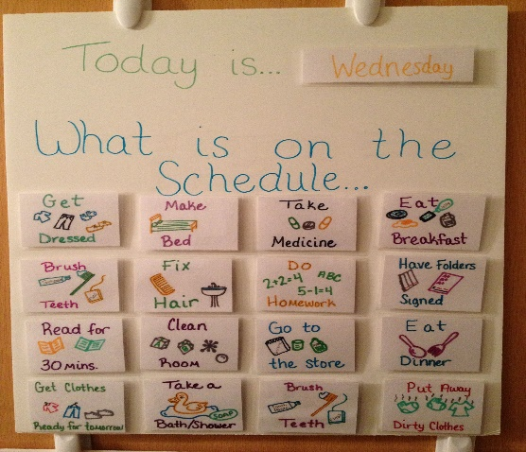
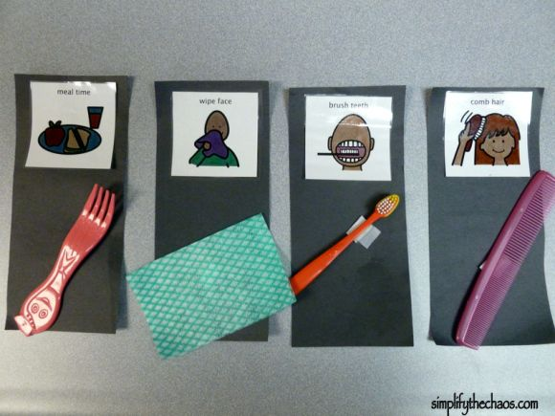
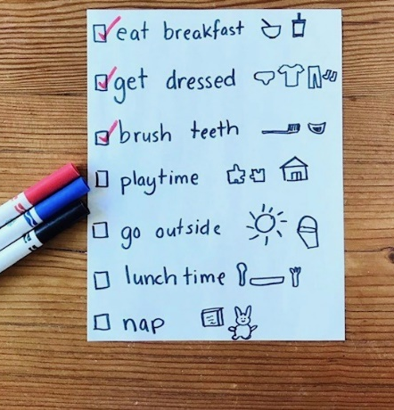

How do I teach it?
- When you want to teach or review the schedule you can say “Let’s check our schedule. First we have _____, then _____, next______ and finally______”. It is helpful to point to each item as you say them aloud.
- For many children, it is helpful to include them in the creating of the schedule. Providing you child a choice of activities or the order of some activities will help to increase motivation and adherence to the schedule.
- It may be helpful to decide with your child the form in which you will indicate the completion of the activity. This can be done by placing a check mark next to the activity, crossing it off, or by turning the pictures over. As you complete the activities you can say “Great work ______! All done_____, now it’s time for ______.”
Some Helpful Tips:

- Keep the schedule in a conspicuous place preferably in close proximity to your child.
- Involve your child in the monitoring of their schedule by having them point to the pictures or say the next activity.
- Sometimes things change! Be sure to include your child in any changes to the schedule by allowing them to rearrange the activities.
- Praise your child for following the schedule and offer a motivating reinforcement for completing the entire schedule.

