Category | 1 | 2 | 3 | 4 | Weight | Total
Creativity | Demonstrates marginal curiosity and offers a generic perspective on topic | Demonstrates some curiosity and offers a different perspective on topic | Demonstrates a solid level of curiosity and offers a unique perspective on topic | Demonstrates a high level of curiosity and offers a unique perspective on topic | 4
Organization | Report had no apparent organization | Report was difficult to follow | Report was mostly clear and somewhat logically sequenced | Report on topic was clear and logically sequenced | 4
Research and Citation | Has no sources listed | Has sources listed but not in MLA format | Has sources listed, some errors in MLA format | Has sources listed in appropriate MLA format | 2
Visual Elements | Included no visual elements, audience was not engaged in the presentation | Included a few visual elements, audience was engaged for some of the presentation | Included some visual elements, audience was engaged for most of the presentation | Included appropriate visual elements, audience stayed engaged throughout presentation | 3
Presentation Skills | Difficult to understand, read from presentation | Spoke somewhat clearly, read from most of presentation | Spoke fairly clearly, face audience most of the time | Spoke clearly, used an understandable pace, faced the audience | 2
Genius Hour Journal | Genius Hour Journal is incomplete | Genius Hour Journal was complete, had no dates | Genius Hour Journal was complete with some dates | Genius Hour Journal was complete and dated | Bonus
Category | 1 | 2 | 3 | 4 | Weight | Total
Creativity | Demonstrates marginal curiosity and offers a generic perspective on topic | Demonstrates some curiosity and offers a different perspective on topic | Demonstrates a solid level of curiosity and offers a unique perspective on topic | Demonstrates a high level of curiosity and offers a unique perspective on topic | 4
Organization | Report had no apparent organization | Report was difficult to follow | Report was mostly clear and somewhat logically sequenced | Report on topic was clear and logically sequenced | 4
Research and Citation | Has no sources listed | Has sources listed but not in MLA format | Has sources listed, some errors in MLA format | Has sources listed in appropriate MLA format | 2
Visual Elements | Included no visual elements, audience was not engaged in the presentation | Included a few visual elements, audience was engaged for some of the presentation | Included some visual elements, audience was engaged for most of the presentation | Included appropriate visual elements, audience stayed engaged throughout presentation | 3
Presentation Skills | Difficult to understand, read from presentation | Spoke somewhat clearly, read from most of presentation | Spoke fairly clearly, face audience most of the time | Spoke clearly, used an understandable pace, faced the audience | 2
Genius Hour Journal | Genius Hour Journal was incomplete | Genius Hour Journal was complete, had no dates | Genius Hour Journal was complete with some dates | Genius Hour Journal was complete and dated | Bonus
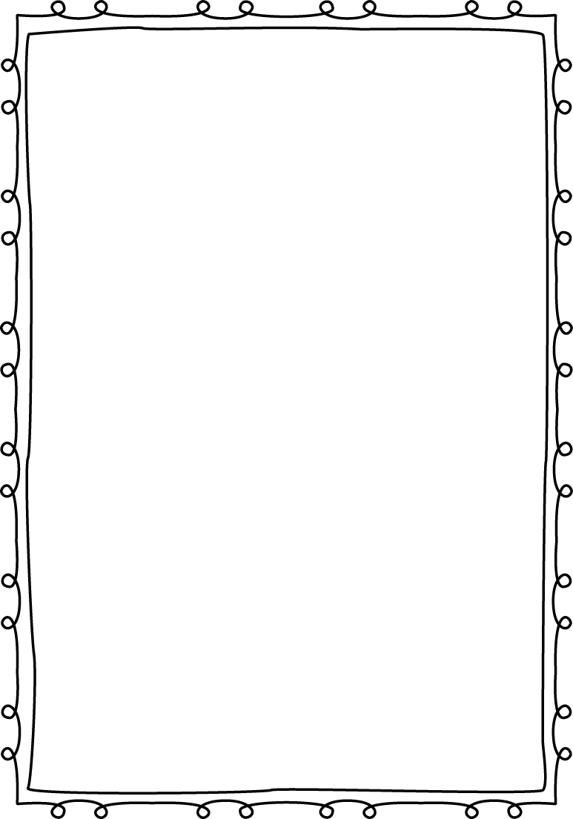
Name: Grade:
Genius Hour Rubric

Name: Grade:
Genius Hour Rubric

