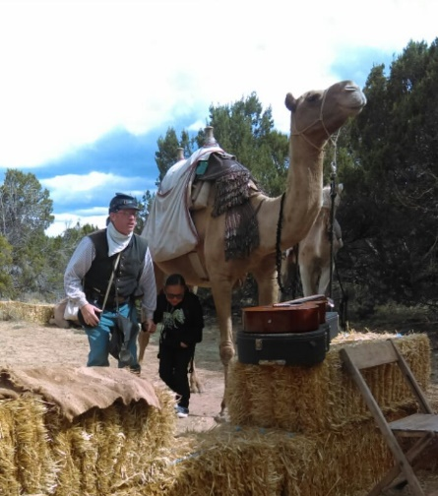

News from the 2nd Graders
Over the past two months, our 2nd graders have had a great start to the 2016-2017 school year at Catherine A. Miller Elementary. We have all been working hard in our core subject areas as well as in other fundamental academic areas. Our three target areas this year are English Language Arts (which includes writing, spelling, phonics, and grammar), Reading, and Mathematics. Additionally, students are being introduced to specific concepts in Science and Social Studies through our core content area units. Aside from learning in our main classrooms, students have the opportunity to attend a variety of other classes on a weekly basis which include: Physical Education, Technology/Computers, Library, Music, and Navajo Language and Culture.
We have been targeting several specific areas over the past two months in our three core subject areas. Our English Language Arts and Reading blocks have been targeting a variety of topics which have included two main areas: family units and animals (both fictional and non-fictional). Our topic of family units incorporated additional lessons in Social Studies which focused on cultures, traditions, and family unit responsibilities from around the world. Additionally, our topic of animals incorporated both Science and Social Studies lessons which focused on animal survival, animal adaptations, and animal habitats which are found in different regions around the world. In our Mathematics blocks, we have worked on a variety of skills including basic one-digit addition and subtraction skills, number identification and counting from 0 – 100, skip counting by 2s, 5s, and 10s, and two-digit addition using place value. For each of our target areas, students have been producing a variety of student work pieces which have been on display in our second grade classrooms, reviewed at Parent/Teacher Conferences, maintained in student’s classroom portfolios, and sent home with students on a regular basis.
Over the next month, our 2nd graders will continue to focus on animal discoveries in English Language Arts and Reading. This focus will include an extension of our previous learnings on animal habitats. It will also present new information on baby animals and animals found in poetry. In Mathematics, we will begin studying two-digit subtraction and place value to 1,000. We will continue to revisit and review topics we have already studied in our core content areas over the past two months. Additionally, we will begin incorporating the new Step Up to Writing curriculum on a daily/weekly basis in our classrooms. This program will present new writing opportunities for our 2nd grade students as well as present new information in all content areas.
Our team is excited about the current progress our 2nd graders are showing and we are looking forward to the upcoming months of continued learning for our students. If you have any questions or concerns about your child’s academic performance, please contact your child’s teacher to set up a conference.
Sincerely,
The Second Grade Team
Ms. Weida Mrs. Forbes Ms. Khoury Ms. Acosta
4th grade news
This year is off to a good start for our 4th graders. We had a fantastic field trip to El Morro National Monument on September 12th, and got to see live camels and learn about the history of the U.S. Camel Corps and some of the interesting history of this area. Our next field trip will be in the spring, but nothing has been decided yet on that one.
Students in the 4th grade are expected to be reading chapter books, and should be reading every night for at least 20 min. to increase their reading comprehension and fluency. This also helps them to build background knowledge and will help with all areas of reading, writing, and math as well. Our students have been working on being able to use details and examples in a text when answering questions. In writing, our students are expected to write at least 3 full paragraphs. During this first quarter, we are working on writing personal narratives. Their next writing assignment topic will be to write about a person whom they admire.
In Math, our 4th graders are starting to learn how to multiply 2-digit, 3-digit, and 4-digit numbers by one digit. What would REALLY help us a lot is for them to KNOW their multiplication facts much better. If parents could help each night going over their math facts 5-10 min. every night, that would be a great help to them being more successful in their math assessments. Because our students have to take assessments on computers, we are trying to increase their skills with typing. Any extra time they could spend practicing at home using their keyboarding skills would be awesome.
Hello Families! I am Susan Shell, the Instructional Coach, Building Test Coordinator, and the Head Teacher at Catherine A. Miller where I welcome my numerous duties and responsibilities with great enthusiasm each day. This is my 39th year as an Educator and my experience has included educating children from Kindergarten through the Fifth Grade, and facilitating after school and summer school programs throughout my career.
As the Building Test Coordinator I assist the teachers to insure proper implementation of testing procedures, and make sure we have a positive testing environment for our students . Students will be taking their first formative assessment on the computer in the areas of Reading, Language Arts, and Math. Testing information such as schedules will be going home soon. As the Instructional Coach, I work closely with teachers to support student achievement and provide teachers with the necessary instructional tools to create success for all students. I thoroughly enjoy working with the teachers and students at our school. Please visit with me anytime if you have any questions or concerns. We look forward to having positive outcomes this year for all of our outstanding students!
5th Grade
Hello Parents and Guardians,
It is our pleasure to introduce ourselves as your child's 5th grade team. We have Mrs. Ramos, Ms. Tahe, and Ms. Prough. We hope your child is having a great school year so far. We are looking forward to an exciting year! It is our goal to provide all students with an educationally challenging, yet fun, experience in the classroom. We have high expectations for your child and will do all that we can to help your child achieve those expectations. As the parent/guardian, you are also a very important part of your child’s success.
Math and Reading are both essential to your child’s success in school. With that in mind, we would ask that you have your child read a minimum of 20 minutes per day. Your child will also have math homework Monday-Thursday. Please ask your child every day if she/he has homework, and if so, please make sure your child completes the assignment. Finally, please also make sure that your child practices multiplication facts regularly so he/she can become proficient.
Concerning testing, we will be taking one of our big tests next week, the TLI test. We also need your help to make sure your child is ready for the test. Please make sure your child gets enough rest and arrives at school on time (if they are dropped off).
One of our most important goals this year is to keep the lines of communication open with you so if ever you have any questions or concerns, please do not hesitate to contact your child’s teacher.
Thank you,
Mrs. Ramos, Ms. Tahe, and Ms. Prough

CHAMPS

