|  |  |  |
| --- | --- | --- |
| **Scoop** | | |
| **Objective:** Find cards that make 10 and scoop them up. Whoever finds the most 10's wins. | |
| **Grades:** K–2  2-4 players  **Materials:** Deck of cards with face cards and jokers removed. |  |
| **Set up**. Lay out 20 cards face up in four rows of five. Set the remaining cards in a pile to draw from.  **How to play**   1. Take turns. On your turn: Search for cards that make 10 (such as 5, 4, and 1). If you find any, scoop them up and set them next to you. 2. Draw cards from the deck to replace any you scooped. 3. Play until no one can make a 10. The player with the most groups of 10 wins. | |

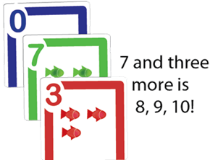

|  |  |  |
| --- | --- | --- |
| **Pile Up 100** | | |
| **Objective:** Be the first to reach 100, in piles of 10 or 20 at a time. | |
| **Grades:** K–2  2-4 players  **Materials:** Deck of cards with face cards and jokers removed. |  |
| **Set up**. Each player sets out 5 cards face up. Set the remaining cards in a pile to draw from.  **How to play**   1. Take Turns. On your turn: Draw a card and add it to your layout. 2. Look for cards in your layout that total 10 or 20 (such as 8, 7, and 5). Remove those cards from your layout and set them next to you, then the next person goes. 3. If you can't make 10 or 20 on your turn, the next person goes. 4. The first player to reach 100 wins. | |

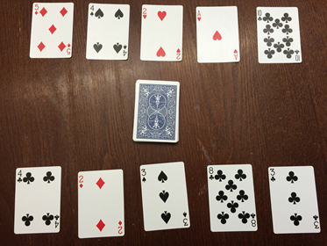

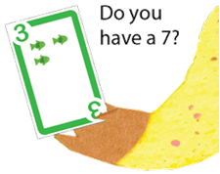

**Make 10**

**Objective:** Get two cards that make 10 (similar to the game “Go Fish”) **Grades:** K-2

2-4 Players

**Materials:** Deck of cards. Remove all 10’s and face cards and jokers.

**Set Up:** Deal five cards to each player. Pile the rest face down. If you have two that make 10, put them down next to you and draw another card.

**How to Play:**

1. If you have any pairs of cards that total 10, put them down next to you and replace them with cards from the draw pile.
2. Take turns. On your turn, ask a player for a card that goes with a card in your hand that would make 10.
3. If you get a card that makes 10, put down the pair. Take one card from the deck. Your turn is over.
4. If you do not get a card that makes 10, take the top card from the deck, your turn is over.
5. If the card you take from the deck makes 10 with a card in your hand, put the pair down and take another card.
6. If there are no cards left in your hand but still cards in the deck, you take two cards.
7. The game is over when there are no more cards.
8. At the end of the game, count up all of your cards.

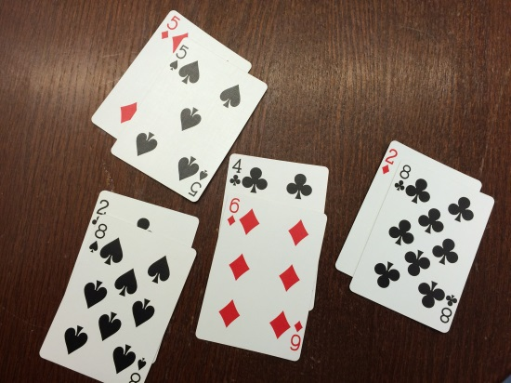

**Objective:** To practice counting on from a number without starting at the number 1.

**Counting Up**

**Grades:** K-2

**1-**4 players

**Materials:** Deck of cards with face cards and jokers removed.

**Set Up:** Place cards face down between the players.

**How to Play:**

1. Player draws a card and counts on ten numbers from the card drawn. Take turns, or have player continue to practice with a new card.

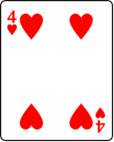 “4…5, 6, 7, 8, 9, 10, 11, 12, 13”

1. Challenge: Pick two cards and make a double digit number. Count on ten numbers from that number.

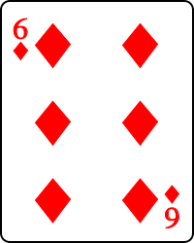 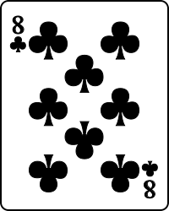

Count from 68…..68,69,70,71,72,73,74,75,76 OR  
Count from 86 ….86,87,88,89,90,91,92,93,94,95,96

1. Alternative: Pick a card…count by 10’s on from that card. (Try making a double digit number and count on by 10’s.)

 “4, 14, 24, 34, 44, 54, 64, 74, 84, 94”

**Subtraction High Card, “War”**

**Objective:** Find the difference between two cards. The player with the greater difference wins.

**Grades:** K-2

**2-**4 players

**Materials:** Deck of cards with face cards and jokers removed…or assign a value to face cards (11, 12, 13).

**Set Up:** Shuffle cards. Deal an equal number of cards to each player until the deck runs out. Each player keeps his/her cards in a stack.

**How to Play:**

1. Each player turns two cards face up, reads the number sentence and finds the difference. For example, if a player draws a 5 and a 4, s/he says “5 minus 4 is 1”. If the opponent draws a 7 and a 2, then his/her number sentence is “7minus 2 is 5”.
2. The player with the greater difference wins the hand and keeps all four cards.
3. If each player has a number sentence with the same difference, then it's “war!”
4. Each player puts three cards face down and places an additional two cards, face up, to find the difference. The player with the greater difference wins.
5. Set up the timer and play the game for 10 to 15 minutes. When the bell goes off, each player counts his/her cards. The player with the most cards wins. If one player runs out of cards beforetime is up, then the other player wins.

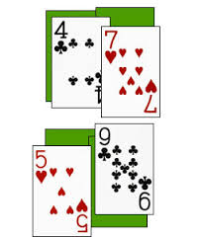 “7 minus 4 is 3”….”9 minus 5 is 4”

“4 is greater than 3, I win!”

**Objective:** Find the difference between a two-digit and a one-digit number. The player with the greater difference wins all the cards in the hand.

**Multi-Digit Subtraction Number Battle, “War”**

**Grades:** 1-2

**2-**4 players

**Materials:** Deck of cards with 10’s, face cards and jokers removed.

**Set Up:** Shuffle cards. Deal an equal number of cards to each player until the deck runs out. Each player keeps his/her cards in a stack.

**How to Play:**

1. Each player turns three cards face up and creates a two-digit number and subtracts the value of the third card. Players may move the 3 cards around to create any 2-digit minus 1-digit expression.
2. Players finds the difference for their expression. For example, if a player draws an 8, 5 and a 4, s/he says “85 minus 4 is 81”. If the opponent draws a 6, 7 and a 2, then his/her number sentence is “76minus 2 is 74”.
3. The player with the greater difference wins the hand and keeps all six cards.
4. If each player has a number sentence with the same difference, then it's “war!”
5. Each player puts three cards face down and places an additional three cards, face up, to find the difference. The player with the greater difference wins.
6. Set up the timer and play the game for 10 to 15 minutes. When the bell goes off, each player counts his/her cards. The player with the most cards wins. If one player runs out of cards beforetime is up, then the other player wins.

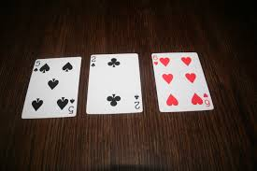

If dealt a 5, 2, and 6 a player may create the expression 65-2.

**Objective:** Find the sum of two cards. The player with the greater sum wins.

**Addition High Card, “War”**

**Grades:** K-2

**2-**4 players

**Materials:** Deck of cards with face cards and jokers removed…or assign a value to face cards (11, 12, 13).

**Set Up:** Shuffle cards. Deal an equal number of cards to each player until the deck runs out. Each player keeps his/her cards in a stack.

**How to Play:**

1. Each player turns two cards face up, reads the number sentence and finds the sum. For example, if a player draws a 5 and a 3, s/he says “5 and 3 is 8”. If the opponent draws a 7 and a 2, then his/her number sentence is “7 and 2 is nine”.
2. The player with the greater sum wins the hand and keeps all four cards.
3. If each player has a number sentence with the same sum, then it's “war!”
4. Each player puts three cards face down and places an additional two cards, face up, to find the sum. The player with the greater sum wins.
5. Set up the timer and play the game for 10 to 15 minutes. When the bell goes off, each player counts his/her cards. The player with the most cards wins. If one player runs out of cards beforetime is up, then the other player wins.

 “7 and 4 is 11”….”9 and 5 is 13”

“13 is greater than 11, I win!”

**Eleven’s Card Game**

**Objective:** Find cards that add to make 11.

**Grades:** K-2

1-4 players

**Materials:** Deck of cards with face cards and jokers removed.

**Set Up:** Shuffle cards. Place cards, face up, in 3 rows of 3. Place the remaining cards face down in a draw pile.

**How to Play:**

1. One player can play alone or players can work together and take turns.
2. Player looks for sums that add up to 11. Pick up these cards.
3. Replace empty spaces with new cards from the deck.
4. Try to use all the cards in the deck. If you successfully use all the cards from the deck, you win!

**Variation:** Look for other sums (12, 13, 14…) You may need to look for 3 cards that make larger sums.

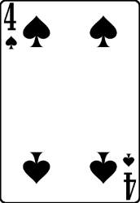 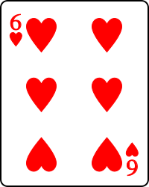 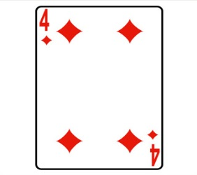

Can you find cards that add to 11?

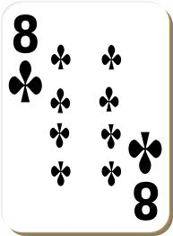 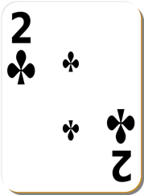 

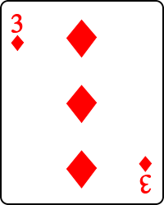 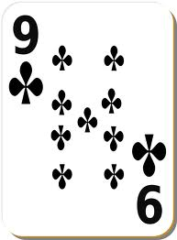 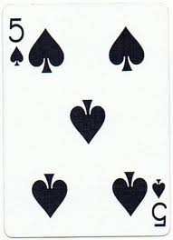

**Make 20: An Addition Game**

**Objective:** To create sums as close to 20 as you can, without going over 20.

**Grades: K-2**

2-4 Players

**Materials:** Deck of cards with face cards and jokers removed; paper and pencil **Set Up:** Shuffle cards. Deal each player 5 cards. Place the remaining cards face down in a draw pile.

**How to Play:**

1. Each player selects three of their cards and adds them together to create a sum as close to 20 as possible, without going over 20.
2. After players have made their selections, they place their cards face up in front of them and tell their opponent(s) their sum.
3. The player with the sum closest to 20, without going over 20, wins a point. In the case of a tie, each player is awared a point. (Keep score on the paper.)
4. Deal out three more cards to each player so they begin each hand with five cards.
5. Play continues for 10 rounds. The player with the most points after the last round wins the game. (If more cards are needed, shuffle the used cards into the pile to deal).

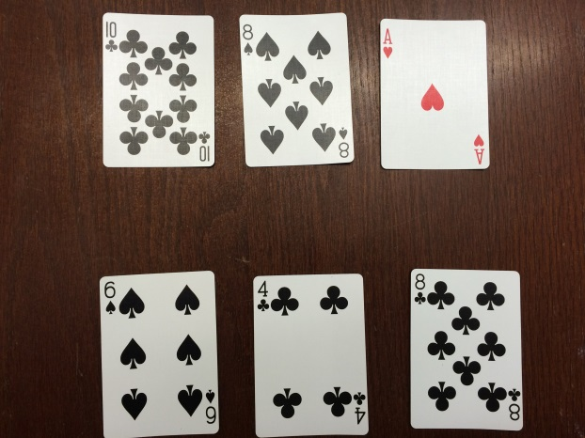

**”10 and 8 and 1 is 19”**

**“6 and 4 and 8 is 18”**

**19 is closer to 20 than 18, player 1 wins.**

**Make 25 with 5**

**Objective:** To have 5 cards in your hand with a sum of 25.

**Grades: K-2**

2-4 Players

**Materials:** Deck of cards with face cards and jokers removed; paper and pencil **Set Up:** Shuffle cards. Deal each player 5 cards. Place the remaining cards face down in a draw pile, with the top card turned over and placed next to the draw pile.

**How to Play:**

1. Each player begins with 5 cards to hold in his/her hand.
2. Players take turns picking up the top card of the draw pile or the top card on the discard pile next to it.
3. After picking a card, the player then chooses to discard one card from his/her hand and place it face up on top of the discard pile.
4. The first player to create a hand with 5 cards that have a sum of 25 calls out “Twenty-five” and is the winner of that round.
5. A point is awarded to the player for each hand s/he wins.
6. The first player to reach 5 points wins the game.

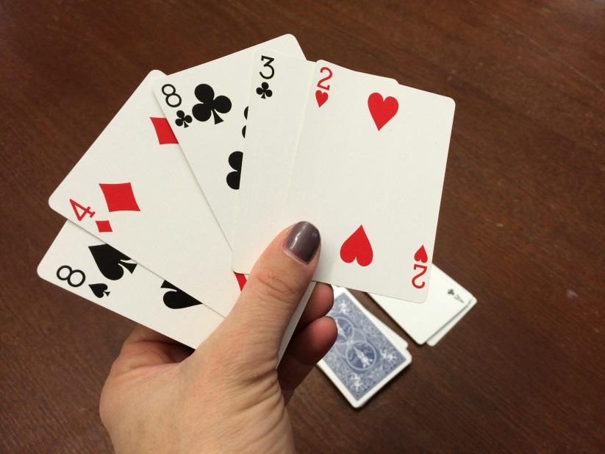

**Card Sort**

**Objective:** To sort cards by creating groups with a similar attribute.

**Grades: K-2**

1 or more players

**Materials:** Deck of cards.

**How to Play:**

1. Student thinks of a rule to sorts the deck of cards according to that rule.
2. Students can sort by color.

Students can sort by suit.

Students can sort by number.

Students can sort by odd/even (may want to remove face cards or assign value of 11, 12, 13)

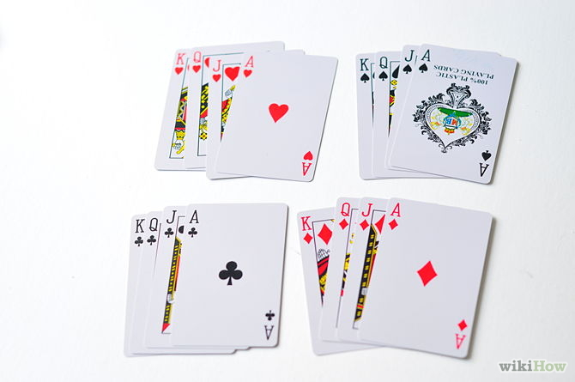

**Cards sorted by suit.**

**Addition Salute**

**Objective:** To use clues to figure out the hidden addend.

**Grades: K-2**

3 Players

**Materials:** Deck of cards with face cards and jokers removed.

**Set Up:** Shuffle cards. One person acts as a “Captain” to deal the cards.

**How to Play:**

1. The Captain deals one card to each player, face down. Players do not look at the card.
2. Captain counts to three and players place the card on their foreheads, facing out, and say “Salute”.
3. The captain finds the sum of the two cards.
4. The players have to look at their opponent’s card that they can see and think about the sum to figure out the hidden card they are holding up.
5. The player to guess the number on his/her card first wins both cards.
6. Continue to play. You can take turns being the captain.

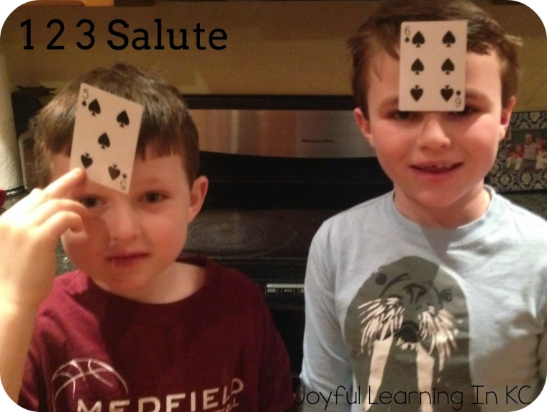

**Captain:** “The sum of your cards is 11”

**Player 1:** “ I have 5” (He knows this because he can see the 6 on his opponent’s head and knows 11-6=5”

**Addition Memory**

**Objective:** To find combinations to practice math facts. Choose to make combinations of 6, 7, 8, 9 or 10.

**Grades: K-2**

2-4 Players

**Materials:** Deck of cards with face cards and jokers removed. Also, remove all cards that are equal to and higher than the featured number for the math game. For example, if the goal is to practice addition facts for the number six, the game will be played with ones (aces ) through fives.

**Set Up:** Shuffle cards. Turn all the cards face down in a grid pattern.

**How to Play:**

1. Players take turns.
2. Players decide on the math facts they will practice, e.g. facts for 6.
3. Player one turns over two cards so they are face up and looks for a combination that would “make 6”. (In this example you would be looking for a 1 &5, 2& 4 or 3 &3.)
4. If the player finds a combination of “6” s/he keeps the cards and leaves those spaces blank. The next player takes a turn.
5. If the player does not reveal a combination of “6”, s/he turns the cards back over in the exact place they were found and the next player takes a turn.
6. Continue playing until all the cards in the deck have been matched into pairs.
7. The player with the most pairs wins the game.

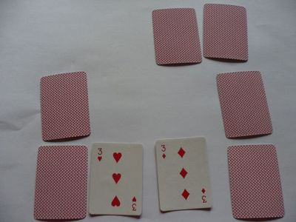 “3 plus 3 is 6”

**Objective:** Create the highest 3-digit number given 3 cards. The player with the greater number wins.

**Place Value Number Battle, “War”**

**Grades:** K-2

**2-**4 players

**Materials:** Deck of cards with 10’s, face cards and jokers removed.

**Set Up:** Shuffle cards. Deal an equal number of cards to each player until the deck runs out. Each player keeps his/her cards in a stack.

**How to Play:**

1. Each player turns three cards face up and creates the largest 3-digit number possible. Players may move the cards and place them in any position (hundreds, tens, ones) they wish.
2. The player with the highest 3-digit number wins the hand and keeps all six cards next to him/her.
3. If players create a number that is equal, it is “war!”
4. Each player puts three cards face down and places an additional three cards, face up, to find a new 3-digit number. The player with the greatest number wins.
5. When players are finished with the cards in their deck, the player with the most cards wins.

Variation: Try playing with 4 cards and creating a 4-digit number.

Try to create the smallest number possible…the player with the least value wins.

 “644”

  “821” “821 is greater than 644.”

**Objective:** Create two, 2-digit numbers that have a sum as close to 100 as possible, without going over.

**Make 100: An Addition Game**

**Grades:** 1-3

2-4 players

**Materials**: Deck of cards with 10’s, jokers and face cards removed; paper and pencils (for scratch paper)

**Set Up:**  Shuffle the deck of cards. Deal each player 6 cards. Place the remaining cards, face down, in a pile between the players.

**How to Play:**

1. Each player selects four of their cards (from the 6 they have been dealt) and creates two 2-digit numbers from them. The goal is to create two numbers that have a sum as close to 100 as possible, without going over. (For example, a player may choose to use the cards 4, 6, 8, and 1, creating the problem 14 + 86 = 100.)
2. After players have made their selections, they place their cards face up in front of them, arranging them so other players can see which two numbers they have created.
3. The player with the sum closest to 100, without going over, wins a point. In the case of a tie, a point is awarded to each team.
4. For the next hand, players are dealt four new cards.
5. Play continues for 5 rounds. The player with the most points after the last round wins the game.

**Variations:**

* Change the number of cards dealt (4 cards dealt gives no choices, 8 cards gives more choices)
* Try to create two 2-digit numbers that have the lowest sum.
* Create 3-digit numbers, and set the goal to 1,000

 

“48 and 46 is 94…close to 100.”

**I Spy Sums**

**Objective:** Find sums and search for combinations that equal a given sum.

**Grades:** K-2

2-4 players

**Materials**: Deck of cards with jokers and face cards removed

**Set Up:**  Shuffle the deck of cards. Place 21 cards out, face up, in a 7x3 array.

**How to Play:**

1. One player challenges the other player to find two cards nest to each other, either vertically or horizontally, that have a given sum. The player will say, “I spy two cards with a sum of *9*.”
2. The other player then looks for two cards with the sum of “9” and picks this pair up. If there are any other pairs with a sum of “9” that the player sees, s/he may pick these up too.
3. If the player misses any pairs that add to “9”, then the first player may claim them.
4. Players swap roles for the next turn. Fill in any spaces with cards from the deck so a 7x3 array remains. When there are no more cards to fill in the spaces, just move cards to form a new array and continue play.
5. Play continues until the cards are cleared.
6. The winner is the player with the most cards at the end of the game.

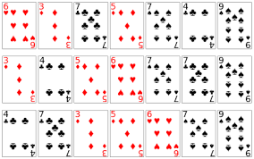 “I spy two cards with a sum of 11.”

**Addition Quick Draw**

**Objective:** Be the first player to find the sum of two cards.

**Grades:** K-2

2 players

**Materials**: Deck of cards with jokers and face cards removed

**Set Up:**  Shuffle the deck of cards. Deal the cards evenly among the players. Players keep their cards in a pile, face down, in front of them.

**How to Play:**

1. One player calls, “Draw” and both players turn over their top card and place it face up between the two players.
2. The players add the two numbers that are showing and the first player to call out the sum wins the two cards, placing them in a pile next to him/her.
3. After all the cards have been used, the players count the cards they have won. The winner is the person who has the most cards.

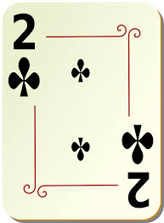 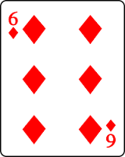 “**Eight!”**

**Ten-Twenty-Thirty**

**Objective:** Remove piles of cards when the sum equal 10, 20 or 30.

**Grades:** 1-2

1 player

**Materials**: Deck of cards (face cards have a value of 10, ace has a value of 1)

**Set Up:**  Shuffle the deck of cards. Create a row of seven cards, face up. Place two cards, face up, on top of each of the seven. You will now have seven piles with three cards in each. Be sure you can see the face value of all of the cards. (See the picture below)

**How to Play:**

1. Look at each pile of cards. You may remove a whole pile has a sum of 10, 20, 30, 40, etc. .
2. After you remove any piles with a sum of 10, 20…, you may deal a fourth card on top of the existing piles.
3. Continue to look for new piles that have a sum of 10, 20, 30, 40…(multiples of 10).
4. Each time you have removed all piles with a multiple of 10, deal another card.
5. Continue adding cards and removing piles with multiples of 10 until your deck is depleted or the piles have all been removed.
6. If you remove all the piles before you have used all the cards in the deck, you have won!

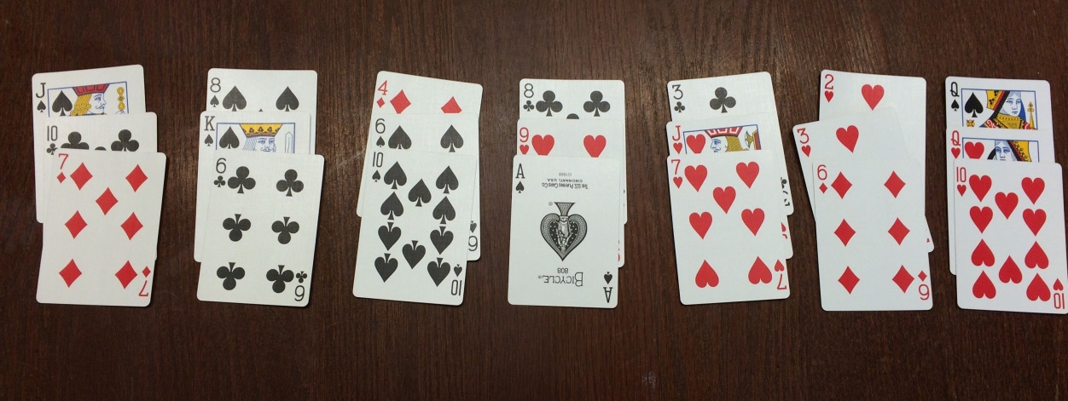

**4 +6 + 10=20 (remove this pile); 3 + 10 (Jack) + 7= 20 (remove this pile);**

**10 (queen) + 10 (queen) + 10=30 (remove this pile)**

**Dealing**

**with the**

**Basic Facts**

**Games for using a deck of playing cards to practice basic math facts: K-2**

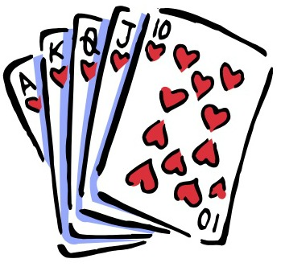

**Exploratorium, March 24, 2015**

**Presented by Beth Finkelstein and Kerri Gristina**