Name: _________________________________ Date: _______________

STUDENT ACTIVITY - Precipitation and Solubility Rules

In general, solubility can mean “how much” of a substance (solute) can dissolve in a solvent. Some substances are soluble while others are insoluble. Then there are some substances that are only slightly soluble. Ionic compounds (such as salts) dissolve in water by a process known as dissociation. Dissociation is when the salt crystals break down to form free ions that move on solution. This allows for electrical conductivity. In an aqueous solution, when two different ionic compounds are mixed, one of two things may occur. If all of the ions remain “free,” then there will be no reaction and the solution will remain clear. However, if the oppositely charged ions attract each other to form an insoluble compound, then a cloudy precipitate will form.
In this activity, several different aqueous solutions will be mixed in different combinations. All of the reactions are double replacement reactions. Some of these mixtures will result in “no reaction.” This means all of the ions will remain free in solution. Other combinations will result in the formation of a precipitate. For these reactions, you will write out the “net ionic reactions.” Your teacher will show you how to write out these reactions. You will then state a hypothesis about the solubility or insolubility of certain ions in solution.

Materials
Transparency sheet

Solutions
0.1 M AgNO₃ 0.1 M BaCl₂ . 2H₂O 0.1 M Na₂CO₃ 0.1 M (NH₄) ₂SO₄
0.1 M Ca(NO₃) ₂ 0.1 M K₃PO₄

- Clean and dry the transparent data sheet provided.
- Set up a data chart similar to the one in this lab (see Data Table below).
- Observe what occurs when two different solutions are mixed. To do this, add a drop from each solution to each clear box as indicated on the top column of the transparency sheet. Then add a drop from the other solutions to each clear box as indicated on each row of the transparency sheet.
- Record in your data table either “PPT” meaning a precipitate was formed, or “NR” meaning no reaction was observed in each box of your data table.

Data - Solubility and Precipitate Data

 | AgNO₃ | BaCl₂ | Na₂CO₃ | (NH₄) ₂SO₄ | Ca(NO₃) ₂
BaCl₂
Na₂CO₃
(NH₄) ₂SO₄
Ca(NO₃) ₂
K₃PO₄

1. Show the dissociation for each salt in solution
AgNO₃ _______________________________________________________________

BaCl₂ _______________________________________________________________

Na₂CO₃ _______________________________________________________________

(NH₄) ₂SO₄ _______________________________________________________________

Ca(NO₃) ₂ _______________________________________________________________

K₃PO₄ _______________________________________________________________

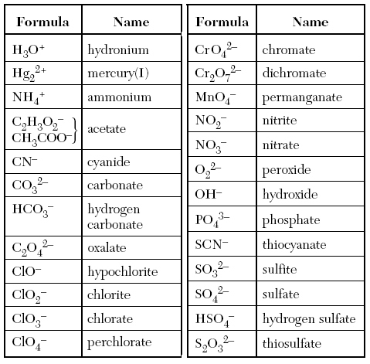
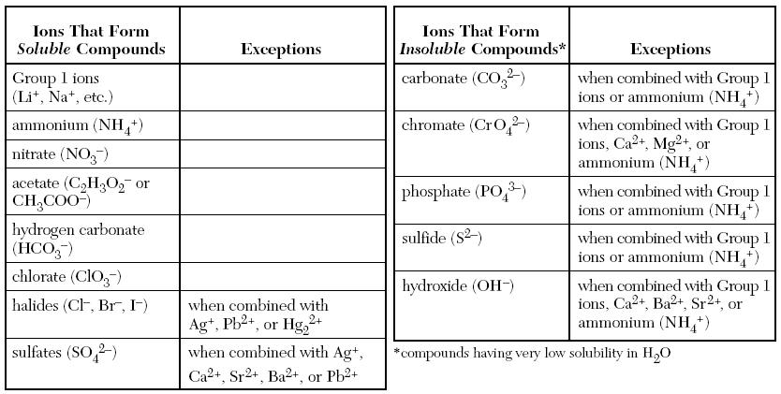

2. For each precipitate formed, write out (a) the double replacement reaction, (b) the total ionic reaction and (c) the net ionic reaction that occurred. Your teacher will demonstrate how to do this.

______________________________________________________________________________

______________________________________________________________________________

______________________________________________________________________________

______________________________________________________________________________

______________________________________________________________________________

______________________________________________________________________________

______________________________________________________________________________

______________________________________________________________________________

______________________________________________________________________________

______________________________________________________________________________

______________________________________________________________________________

______________________________________________________________________________

______________________________________________________________________________

______________________________________________________________________________

______________________________________________________________________________

______________________________________________________________________________

______________________________________________________________________________

______________________________________________________________________________

______________________________________________________________________________

______________________________________________________________________________

______________________________________________________________________________

______________________________________________________________________________

______________________________________________________________________________

______________________________________________________________________________

______________________________________________________________________________

______________________________________________________________________________

______________________________________________________________________________

______________________________________________________________________________

______________________________________________________________________________

______________________________________________________________________________

3. From all of the ions you tested, which ones tend to form soluble compounds (spectator ions)?

______________________________________________________________________________

______________________________________________________________________________

4. From all of the ions you tested, which ones tend to form insoluble compounds?

______________________________________________________________________________

______________________________________________________________________________

