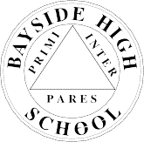Bayside High School
32-24 Corporal Kennedy Street, Bayside, New York 11361 Telephone (718) 229-7600 Michael Athy, Principal

Return this to room 128.

CUNY Information Sheet (Post Grad)

Student Name Student OSIS

Guidance Counselor

Check the CUNY school that you will be attending

- Queens College | - Baruch College | - Brooklyn College □ City College
- Hunter College | - York College | - College of Staten Island
- Lehman College | - John Jay College | - Queensborough CC

- LaGuardia CC □ Kingsborough CC □ Bronx CC
- Borough of Manhattan CC □ NY City Tech □ Hostos □ Medgar Evers Transcripts are sent automatically.

