Create a Children’s Book:

Create a children’s book about the content we are learning.



The book must include:

1. Cover page

2. Table of Contents

3. Illustrations (pictures in color)

4. Must be in complete sentences.

5. It must fully explain the content we

are covering.

Research a Scientist

Find a scientist that has contributed to the content we are studying. Then, research him/her and write a report about that scientist.

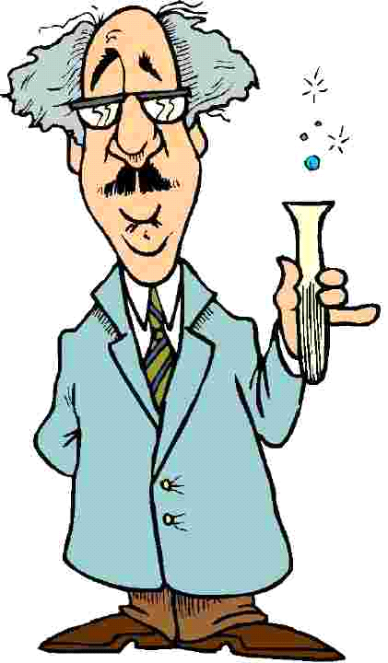

Report must include:

1. The scientist’s name

2. Where he/she is from?

3. How has that scientist

contributed to what we are

learning?

4. At least 6 interesting facts

5. Be a page in length.

Create a Brochure

Create a brochure about the create information we are learning.

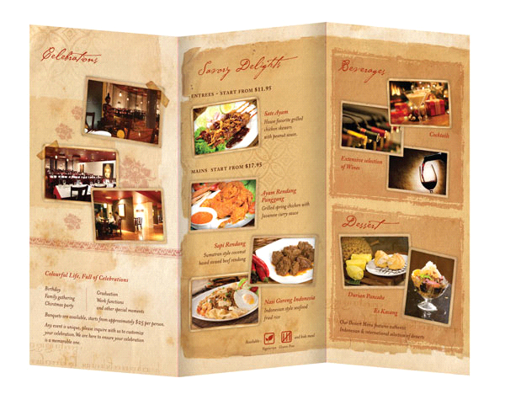

Must include:

1. Cover page

2. Information in complete sentences.

3. Illustrations (drawing in color)

4. It must fully cover the information we are covering.

Current Events Summary

Find a current events article (teen biz) about what we are studying and write a summary about the article.

Must include:

1. Title of Article

2. Who wrote the Article?

3. Summary of article

4. How does the article relate to what we are studying?

5. Must be in complete sentences.

6. Must be a page in length.