How to Score the Open Response
Step 1: Sign in to Edulastic
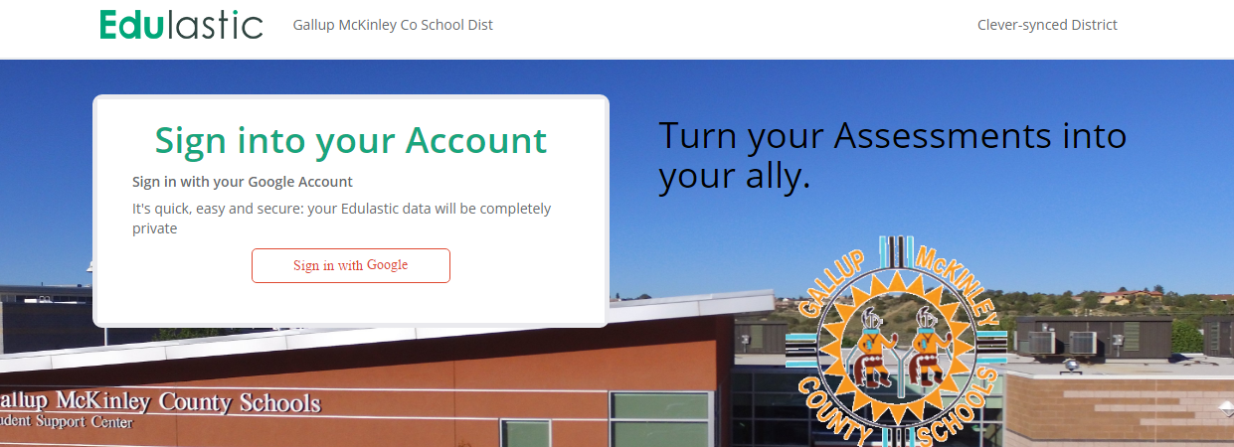

Step 2: Click on the Subject You Want to Grade
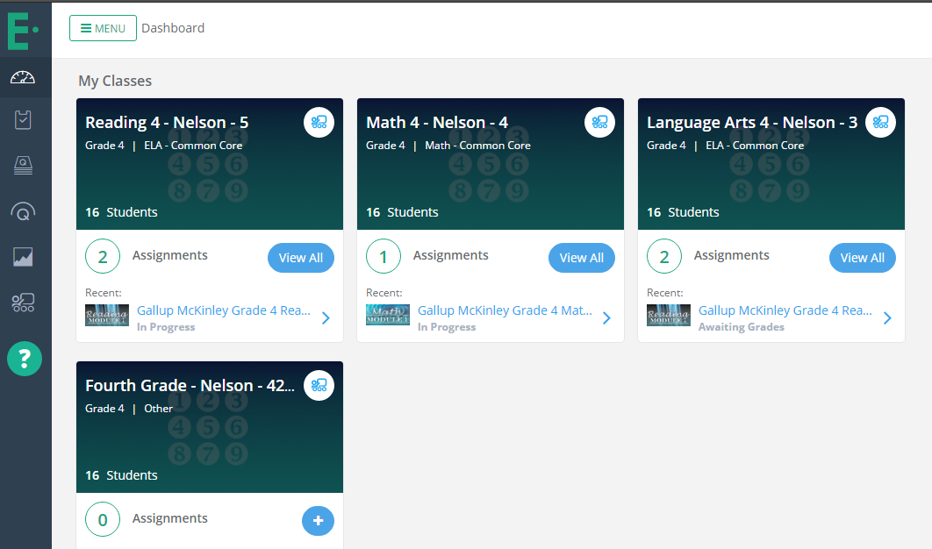

Step 3: Click on the Test You Want to Grade
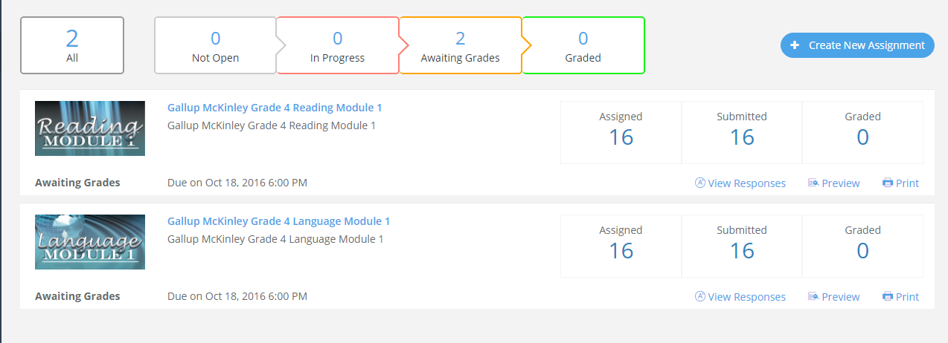
Step 4: Click on “View Detailed Response” under a Student
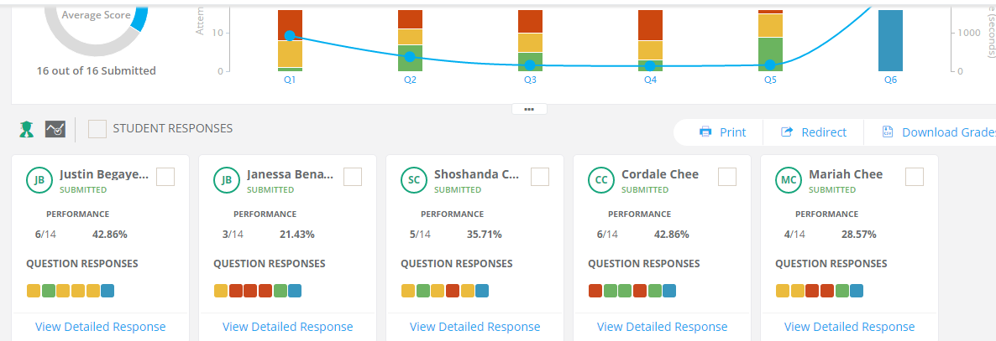
Step 5: Click on “Not Graded”
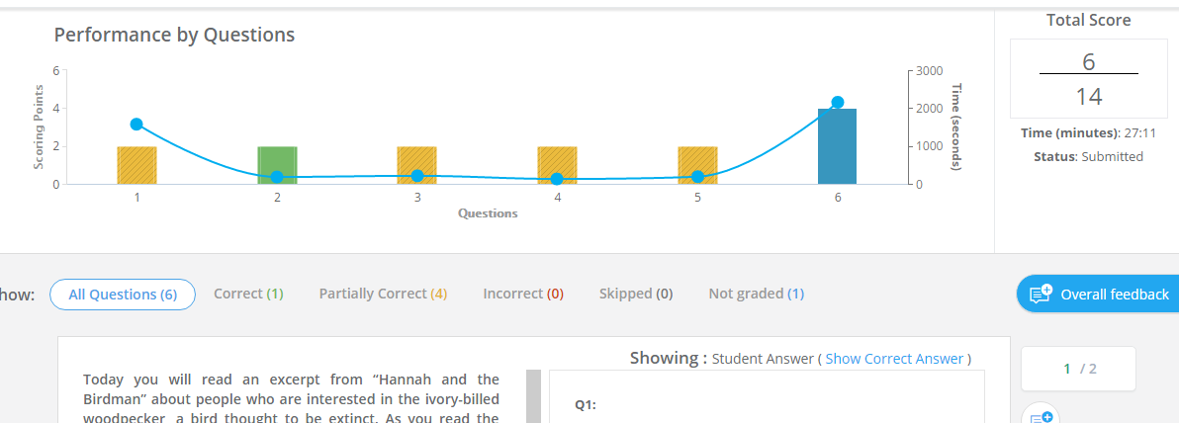

Step 6: Read the Student’s Response
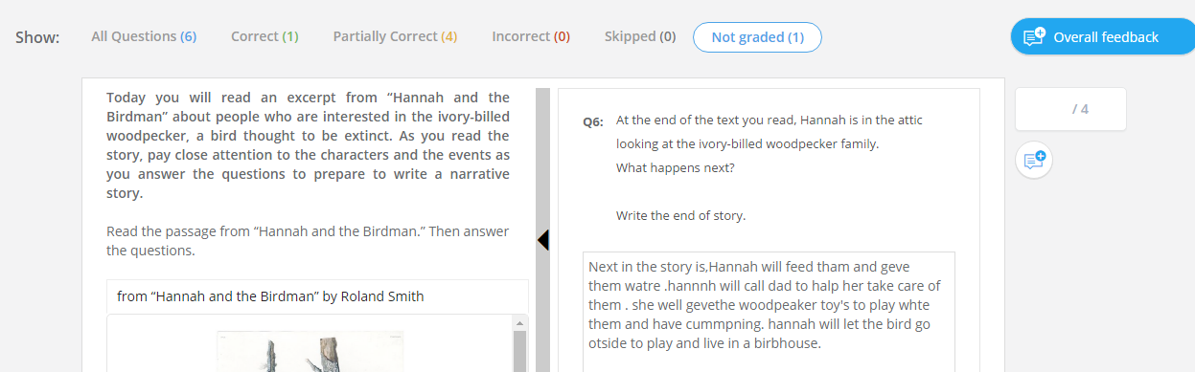

Step 7: Enter a Score for the Student (out of 4)
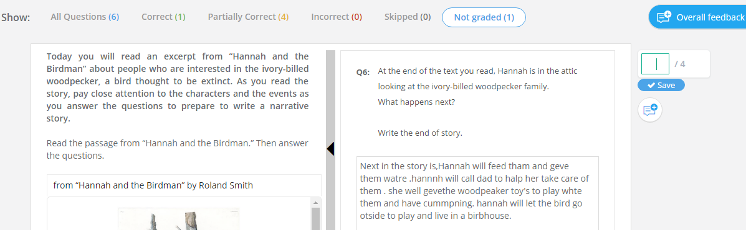

Step 8: Click “Save”

Step 9: Click on “Student” to Select the Next Student to Grade
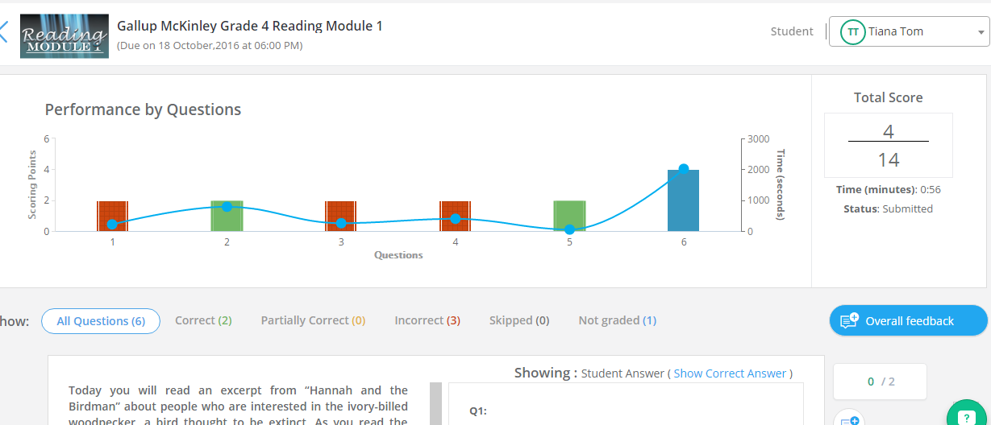

This number should match the number of tests that were submitted.
Step 10: Check to Make Sure You are Done
