Lesson #7 – Light and Light Equations
What we know as light is more properly called electromagnetic radiation.
We know from experiments that light acts as a wave. As such, it can be
described as having a frequency and a wavelength. The wavelength of light
is the distance between corresponding points in two adjacent light cycles,
and the frequency of light is the number of cycles of light that pass a given point
in one second. Therefore, the longer the wavelength a type of light has, the smaller
its frequency will be. The shorter the wavelength, the greater the frequency.
See the diagram below.

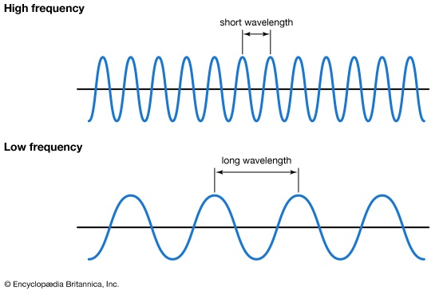
1 second

Wavelength is typically represented by λ, the lowercase Greek letter lambda,
while frequency is represented by ν, the lowercase Greek letter nu
Wavelength has units of length (meters, centimeters, etc.), while frequency has
units of per second, written as s⁻¹ and sometimes called a hertz (Hz).

The speed of light is a universal constant. The measured speed of light, c,
is 3.00 × 10⁸ m/s. The equation that relates wavelength and frequency is as follows:

c = λ x ν
Speed of light = wavelength x frequency

The relationship between wavelength and frequency is inverse. This means
that as wavelength increases, frequency decreases.

Though we tend to think of light as that which can see with the naked eye, light is
actually a collection of many different forms of the electromagnetic spectrum.
The electromagnetic spectrum is the range of all types of radiation and includes
such components as: radio waves, microwaves, infrared, visible light, UV,
X-rays and gamma-rays.

The chart below shows the electromagnetic spectrum. Note that the part we call
visible light is less than 1% of what scientist call light. But even visible light can be
broken down into the various colors of the rainbow: red, orange, yellow, green,
blue, indigo, and violet (ROYGBIV). Note also that the larger the wavelength, the
smaller the frequency.
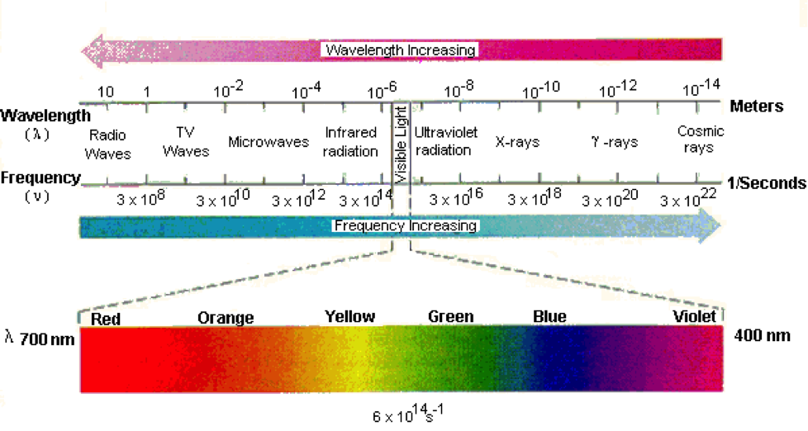

Light is also a form of energy. Each frequency of the light spectrum proportional
to its energy. The mathematical equation that relates the energy, E, of light to its
frequency is:

E = h x ν

where ν is the frequency of the light, and h is a constant called Planck’s constant.
Its value is 6.626 × 10⁻³⁴ J·s and is another fundamental constant of our universe,
like the speed of light. As the frequency of light increases, so does its energy.

So for example: A RED light beam has a wavelength of around 700 nm and
a frequency of 4 x 10¹⁴ Hz. This gives red light an energy of 3 x 10⁻¹⁹ Joules.
Since red has the longest wavelength of all the colors, it has the smallest frequency,
and therefore, the least amount of energy in the visible spectrum.

A VIOLET light beam has a wavelength of around 400 nm and a frequency of
7 x 10¹⁴ Hz. This gives violet light an energy of 5 x 10⁻¹⁹ Joules. Since violet has
the shortest wavelength of all the colors, it has the largest frequency, and therefore
the greatest amount of energy in the visible spectrum.

A continuous spectrum contains many different colors, or wavelengths, with no
gaps. When “white light” is shined through a prism, it causes dispersion of the
light, and we see a rainbow. This is a continuous spectrum.

Atoms contain within them specific amounts of energy based on where its electrons
are located within the atom. The lowest possible energy level that an atom can
occupy is called the ground state. This is the energy state that would be considered
normal for the atom. When an atom is infused with energy, electrons may jump to
higher levels within the atom. An excited state is an energy level of an atom, ion,
or molecule in which an electron is at a higher energy level than its ground state.

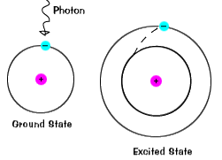

A photon is the smallest discrete amount of electromagnetic radiation or energy.
It is the basic unit of all light. This discrete amount of energy of light is called a
quantum (plural: quanta)

When an electron gets “excited” and jumps to a higher energy level, it will
immediately fall back down to the ground state. When the electron returns to its
lower level, it must release the energy it originally absorbed from its jump. The
energy is released in the form of a photon of light. This photon has a specific
wavelength and energy. It therefore gives off a specific color. When viewed
through a light measuring device called a spectrometer, this wavelength appears as
an emission line. When multiple electrons jump and return to their ground states,
what is seen through a spectrometer is called a line-emission spectrum.

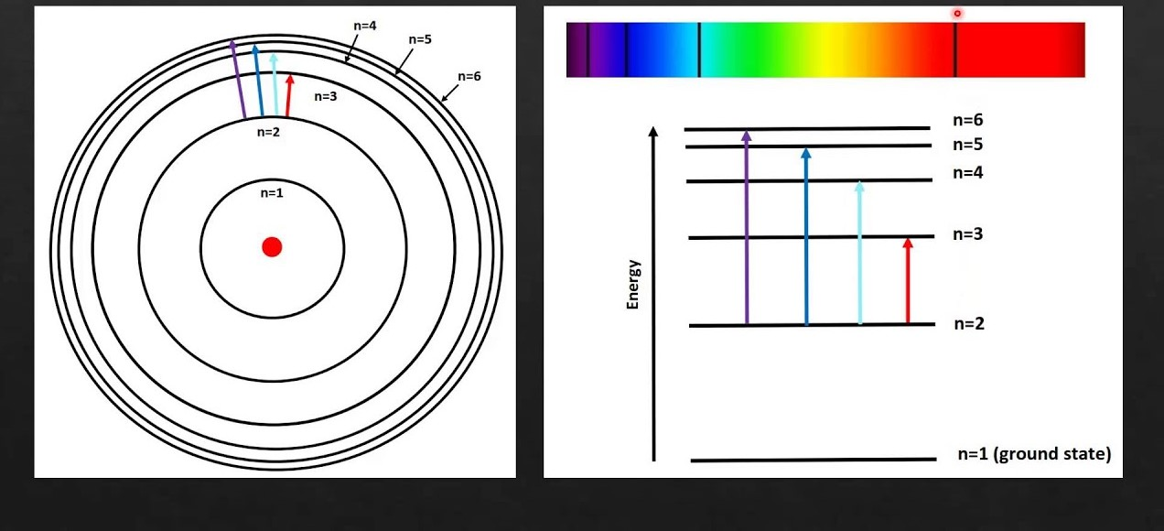

Though we tend to draw electrons travelling around the nucleus of an atom in a
circular pattern, this is simply not true. Electrons do not “orbit” an atom in a
specific trajectory. Instead they travel in random paths within a three-dimensional
areas of space around the atom. We call this region of space where the electron
resides an orbital.

When light hits a material (usually a metal), electrons can be emitted (discharged)
from the atoms on the surface of that material. The photoelectric effect is the
emission of electrons when electromagnetic radiation, such as light, hits a material.
This may not seem important, but both Einstein and Millikan studied this
phenomenon that helped show that light can sometimes act not only a wave, but
also as a particle. For this, they both received the Nobel Prize in Physics.

