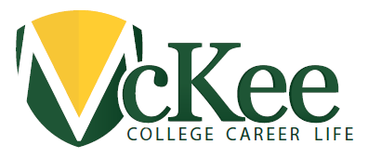
ralph McKee High School
290 St. Marks Place
Staten Island, New York 10301
Sharon Henry, Principal
Email: shenry2@schools.nyc.gov
Phone (718) 420-2600 Fax (718) 981-8776

Greetings Parents, Guardians & Caregivers:

Parents.

It’s time for the
NYC SCHOOL SURVEY
Every year, all parents, all teachers, and students in grades 6-12 take the NYC School Survey. The survey ranks among the largest surveys of any kind ever conducted nationally.
The survey helps school leaders understand what key members of the school community say about the learning environment at each school. The information captured by the survey is designed to support a dialogue among all members of the school community about how to make the school a better place to learn. Take Survey.
Please fill out the survey. Click where you see the word survey or click here or copy and paste the link:http://schools.nyc.gov/Accountability/tools/survey/default.htm in your web browser and take the survey on line. We need to you the parents. You can also mail in the lovely green envelopes in the mail or have your child bring the envelope in to room 107 and we will mail your survey.

In addition, we will provide all parents the opportunity to fill out the surveys in person in the McKee school auditorium during the upcoming Parent Teacher Conferences (Thursday, March 23, 2017 between 5pm-8pm and Friday, March 24, 2017 between 12pm-2:30pm).

Sharon A. Henry
Principal

P - 718.420.2623
F - 718.981.8776
E - shenry2@schools.nyc.gov
Instructional Focus: If teachers use AVID methodologies (collaborative, subject specific learning groups, inquiry methods, and writing as a tool for learning) then all students will develop the skills to be college and career-ready, independent, critical thinkers as they journey through their post-secondary options.

