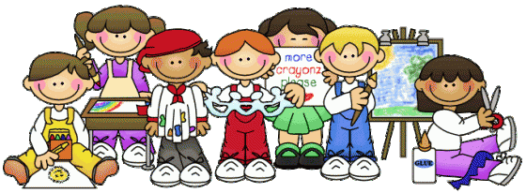
Kindergarten School Supply List
2020-2021

4 – boxes of (24) Crayola Crayons
1 – plastic Pencil Box (flip top)
1 – pair of blunt tip Scissors (Fiskar)
2 – packages of Glue Sticks ( a minimum of 20)
2 – plastic coated Pocket Folders (3 prongs)
2 – packages of sharpened #2 Pencils
1 – blanket or towel (optional)
1 – regular size Book Bag (no small)
1 – container of Clorox Wipes
1 – bottle of Hand Sanitizer
1 – container of Baby Wipes
1 – box of tissues
1 – box of Ziploc Gallon Bags (Boys)
1 – box of Ziploc Quart Bags (Girls)
1 – Lunch Box (optional if needed)
1 – Change of clothes
1 – head phones for computer lab use

- Additional supplies may be requested by your child’s teacher at Kindergarten Orientation

