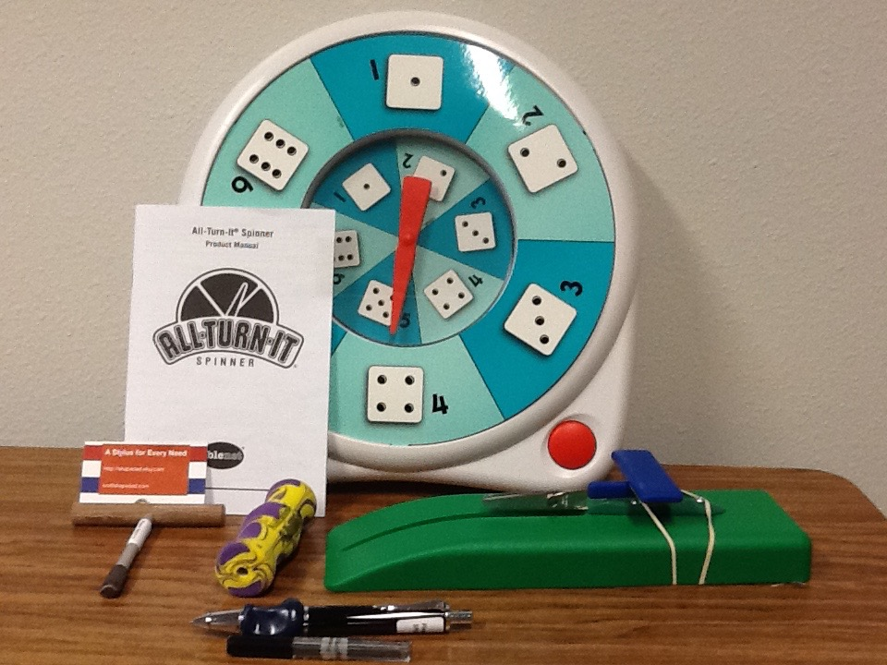

Fine Motor Skills Tools

- All Turn It Spinner

- Pencil Grip (can be used for silverware also)

- Table Top Scissors

- Weighted Pen Stylus for Mobility

- Stylus Tool for iPad (Steady Stylus)

- Pencil Grip Ergo Stylus (Easy Grip Stylus-Wide Body)

