Zoom Meeting Setup Instructions
Several platforms are suitable for conducting business during PA/PTA meetings, including voting on motions. For elections, however, some platforms are less desirable because key features—waiting room, co-hosting, audio and text recording, polling and break-out rooms, dial-in—are either not available or are only available with a paid subscription. We strongly recommend PA/PTAs use DOE-supported accounts so that they can access the necessary premium features without cost to them. Zoom is the preferred platform because it is easy to use and feature-rich; Google Meet and Teams each have some drawbacks but may be good alternatives for PA/PTAs that have already become familiar with them.
FACE has tested the Zoom platform and recommends it for elections based on the following
functionalities:
- Ability to transfer hosting and have more than one host. This is important because it allows
members to share the various tasks of running the meeting and elections: the meeting chair
can focus on recognizing speakers (unmute/mute) and screen sharing; other members can
manage the waiting room, the chat and polling.

Parents are not locked into utilizing Zoom. If you find another platform that supports the above features and is readily accessible to the general membership, you are free to use it. However, the following instructions uses Zoom as an example for meeting setup:

Step 1: Login to Zoom account a click on Meetings tab on top left-hand corner. On top right-hand corner is the ‘schedule meeting’ tab – please click.
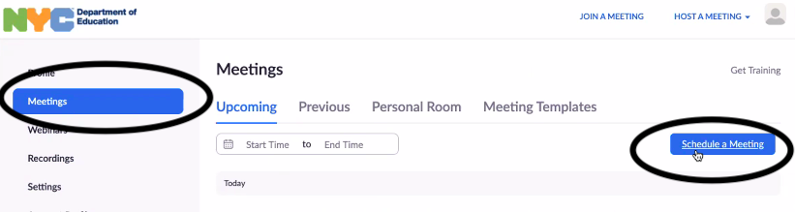
Step 2: Fill in elections meeting details on page. Be sure to click on the ‘registration required’ box to check.
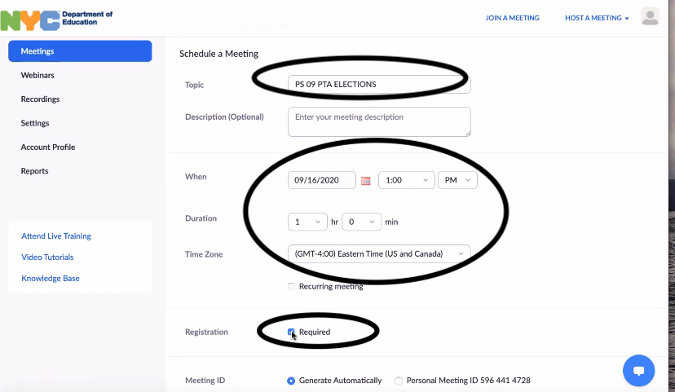
Step 3: Add alternate hosts if needed. This will be the person/people who will support the running of the election and WILL NOT run for any position during the election.
Step 4: Press save button.
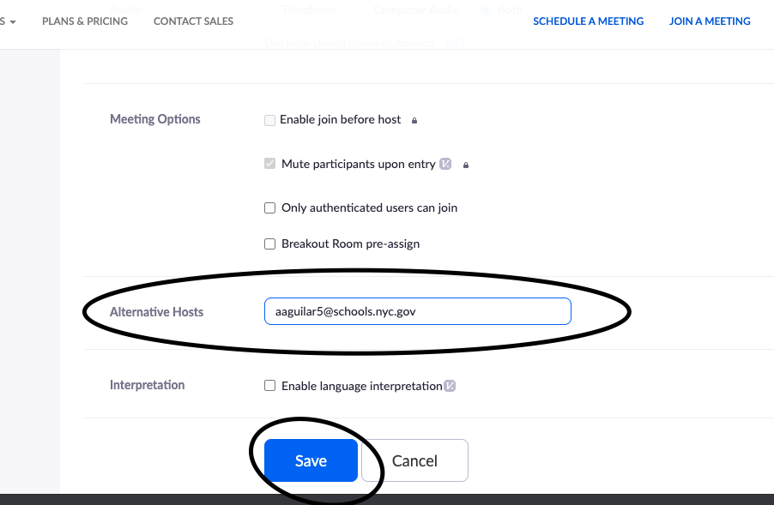
Step 5: Once saved, you should be redirected to manage *meeting name* page.
Step 6: Scroll to bottom of page and click on edit button where it says ‘registration options.
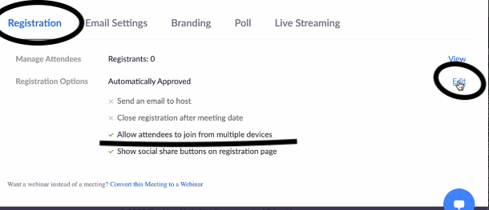
Step 7: You will be redirected to registration page, where you will then click the ‘automatically approve’ button and untick the ‘allow attendees to join from multiple platforms’ box. In doing so you will ensure that participants can login from one device at a time and, therefore, have one vote during the election.
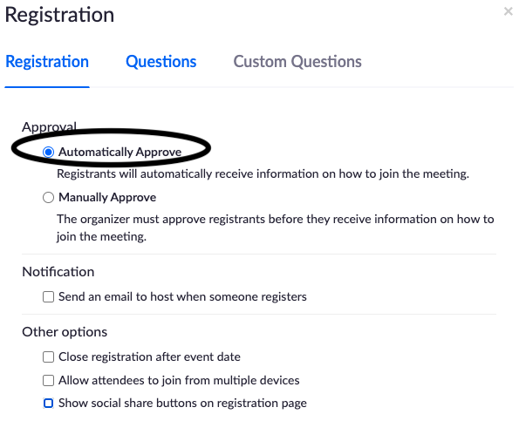

Step 8: On top of registration page, there is a question tab – please click it and add information that you need to use to verify parents (e.g. name, phone number, etc.).
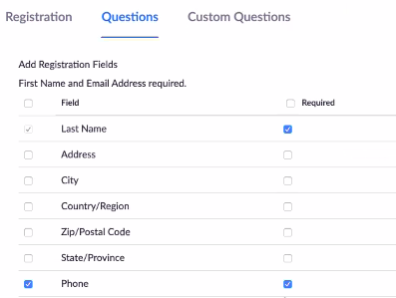
Step 9: On top of the same page you will click on ‘custom questions’ tab. Here you will create other questions you’d like to ask for verification purposes - Example: indicate how participant will join meeting (phone, tablet, laptop) or verification code. This will help make the voting process easier to help verify voters.
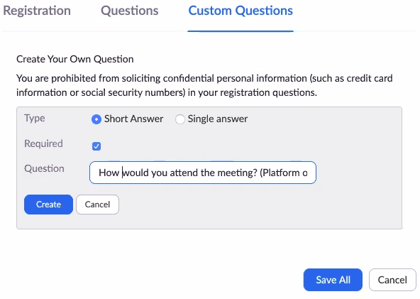
Step 10: After you have completed adding your questions, click on ‘save all’ button.
Step 11: Copy registration link invite and send to participants at least 10 days in advance of elections in accordance with Chancellor’s Regulation’s A-660 so that they may register.

