Name: ________________________________ Date: ______________

**Pythagorean Theorem:**

**Find the Missing Leg**

Objective: I can apply the Pythagorean Theorem to find the missing leg of a right triangle.

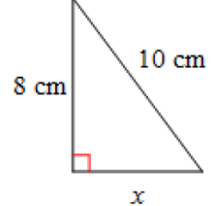

1. 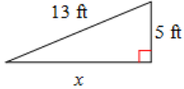

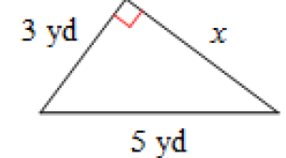



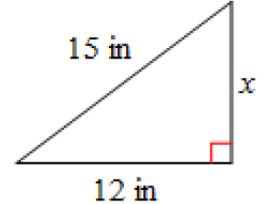



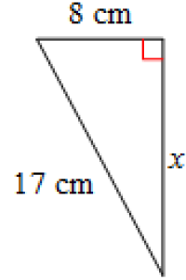

2. 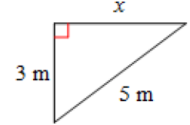

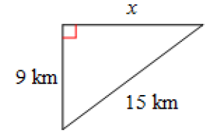



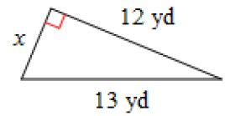

2. 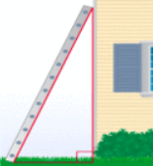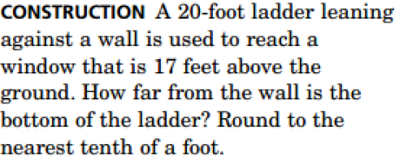
3. 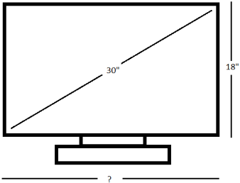Televisions are advertised by their diagonal length. If a 3 inch television measures 18 inches high, how wide is the television?