What is a First-Then board?
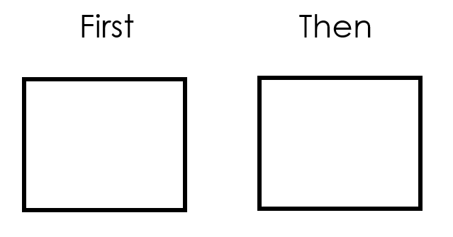
A First-Then board is a simple visual used to communicate a schedule. A First-Then board can be used to help children complete an activity. The “First” is a less desirable activity or the work that you are requesting of your child. The “Then” is a desirable activity or the child’s choice or reward. The idea is to show your child a desirable activity or item is available after completing the task/activity that they may not want to do.

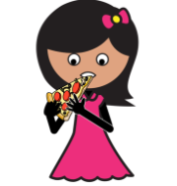
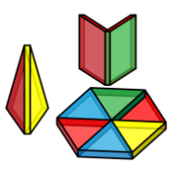

How can I create one at home?
A First-Then can be presented through words or pictures, on the I-pad, a dry erase board or even a piece of paper:
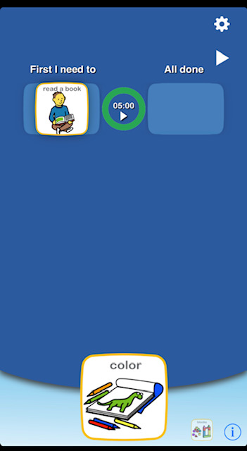

- Choiceworks is an easy to use app that allows you to create a First-Then board with visuals and an optional timer.

How do I teach it?
- Draw a picture and/or write a word that represents the “First” and “Then” activity. Place the board in front of your child and say “First ______, then ________”. It may be helpful to point to the pictures/words as you are saying it.
- When the “First” task is complete, point back at the board and say “All done_____, now _____!” It may be helpful to say it with excitement- your child just completed a task! You can also symbolize the completion of the activity by turning the picture over, putting a check mark or crossing out the activity.
Some Helpful Tips:

- It may be helpful to introduce the First-Then board for tasks that your child likes and can do successfully such as First : Eat lunch - Then: Play with blocks. This will help your child understand the concept of First-Then and the sequence of events.

- A First-Then board is best used proactively, in other words, introduce the board before presenting the less desirable task or activity. Symbolize the completion of the activity by turning the picture over, putting a check mark or crossing out the activity.
- If your child is having a difficult time following the schedule or is resistant to starting the activity, refer back to the board. Point to the board and say “First ______, Then______”. Use simple directives and focus your attention on the board (instead of their behavior).
- Remember to take a deep breath and take some time for yourself! This is tough time and you are doing the best that you can!

