Name: _________________________________________ Date: ___________________

- Student Activity -
Atoms and Isotopes

An atom is the smallest component of an element having the chemical properties of the element. It consists of a nucleus containing combinations of neutrons and protons. An atom's electrons are in areas around the nucleus drawn by electrical attraction. Since different atoms have different amounts of protons, the number of protons in an atom determines the identity of the element. An atom is identified by its Atomic Number. The atomic number of an atom is its number of protons. All atoms also contain electrons. The number of electrons in an atom is always equal to the number of its protons. The number of neutrons in an atom can vary.

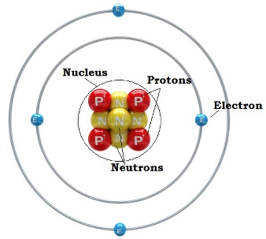
Parts of an atom
An atom has three subatomic particles: protons, neutrons and electrons. Protons have a relative mass of 1 amu (atomic mass unit) and have a relative charge of +1. Neutrons also have a relative mass of about 1 amu and have a relative charge of 0. Electrons are so small that the mass of a one electron is approximately 1/1836 that of a proton. Therefore we say that electrons have a relative mass of 0 amu. Electrons have a relative charge of -1.
Fill in the chart below
Subatomic Particles | Relative Charge | Relative Mass (amu)
Proton
Neutron
Electron
Atomic Symbol Notation
The atomic symbol notation shows the chemical symbol of the element, the mass number and the atomic number of the atom. The mass number (or the atomic mass) is sum of the masses of all of the protons and neutrons in an atom. Note that the mass of an atom does not include the number of electrons because the mass of the electron is so small, making it insignificant in weight. The mass number is placed at the top left side of the atomic symbol. The atomic number (number of protons) is placed on the bottom left side of the atomic symbol. Below is an example of the atomic symbol notation for nitrogen, which has the atomic symbol, N.
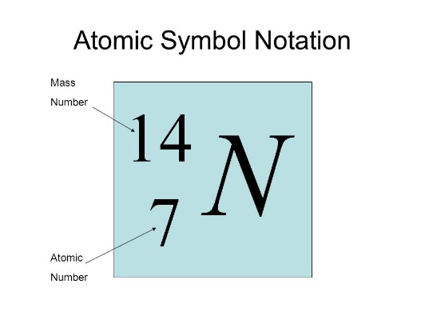
Another way of writing an atom is using the hyphen-notation. The name of the element is written out followed by a hyphen and its mass number. Below is an example of the hyphen-notation for a lithium atom with a mass number of 7.
lithium-7
Since lithium has an atomic number of 3, answer the following questions:
How many protons does lithium-7 have? ______________
How many electrons does lithium-7 have? ______________
How many neutrons does lithium-7 have? ______________
Lithium has the symbol Li. Therefore its atomic symbol notation is...
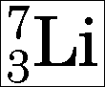

Here are the symbols for the 1st 20 elements of the periodic table. Try to memorize them.
Element Name | Atomic Symbol | Atomic Number
Hydrogen | H | 1
Helium | He | 2
Lithium | Li | 3
Beryllium | Be | 4
Boron | B | 5
Carbon | C | 6
Nitrogen | N | 7
Oxygen | O | 8
Fluorine | F | 9
Neon | Ne | 10
Sodium | Na | 11
Magnesium | Mg | 12
Aluminum | Al | 13
Silicon | Si | 14
Phosphorous | P | 15
Sulfur | S | 16
Chlorine | Cl | 17
Argon | Ar | 18
Potassium | K | 19
Calcium | Ca | 20

1st Activity
Using your computer, log unto the following website: https://phet.colorado.edu/en/simulations/build-an-atom

Click on the play button, . Then click on the 1st box labelled, Atom
Make the atom, carbon, using 6 protons, 6 neutrons and 6 electrons.
Click open the box labelled, Net Charge. Is the net charge zero? __________
Explain why.

_______________________________________________________________________

Click open the box labelled, Mass number. What is the mass number? __________
Explain why. _________________________________________________________

Write both the atomic symbol notation and the hyphen-notation for the atom you just made.
Atomic Symbol Notation Hyphen-notation
_______________________

Now add two more neutrons to the atom.
Is it still carbon? _________
Is the net charge still zero? _________
Is the mass number still 12? _________ If not, what is it? ________

Write both the atomic symbol notation and the hyphen-notation for this new atom you just made.
Atomic Symbol Notation Hyphen-notation
_______________________

There is a name for each of two or more forms of the same element that contain equal numbers of protons but different numbers of neutrons in their nuclei. They are called isotopes. Though isotopes of the same element have the same atomic number, they have different mass numbers. Explain why.
______________________________________________________________________________

______________________________________________________________________________

______________________________________________________________________________

Now see if you can build the isotopes neon-19 and neon-20.

2nd Activity
At the very bottom of the screen, click on the box labelled, Symbol.
See if you can build helium-4.
How many protons did you add? __________
How many neutrons did you add? __________
How many electrons did you add? __________

Now build lithium-7.
How many protons did you add? __________
How many neutrons did you add? __________
How many electrons did you add? __________

Now take away one of the electrons. There is now a net charge in the upper right corner of the atomic symbol notation. What is the net charge? ____
Explain why there is a net charge now?

______________________________________________________________________________

______________________________________________________________________________

Congratulations! You have made your 1st ion. But what is an ion?

An ion is an atom or molecule with a net electric charge due to the loss or gain of one or more electrons.
What charge does an atom gain when it loses electrons? ______________________
What charge does an atom gain when it gains electrons? ______________________

Now let’s make a fluorine-19 ion with a charge of -1.
How many protons did you use? _______
How many neutrons did you use? _______
How many electrons did you use? _______

Write down both the atomic symbol notations and the hyphen-notations for the ion you just made. Include the net charge on the atomic symbol notation.

Atomic Symbol Notation Hyphen-notation
_______________________

Now take away one neutron. Is it still fluorine? ______ Is it an isotope of fluorine? _______
Does it still have a charge of -1? ______ Is it still an ion? ______

Write down both the atomic symbol notations and the hyphen-notations for the ion you just made. Include the net charge on the atomic symbol notation.

Atomic Symbol Notation Hyphen-notation
_______________________

Fill in the chart below

Name | Symbol | Atomic # | Mass # | # of neutrons | # of electrons | Net charge
hydrogen-2 | ²H | 1 | 2 | 1 | 1 | 0
 | ³H
sodium-22 | ²²Na⁺¹ |  |  |  | 10
 |  | 12 | 24 |  | 12
 |  | 13 | 27 |  | 10
 | ¹²C⁻⁴
 | ²⁸Si
 | ¹⁹F⁻¹
neon-20 |  |  |  |  |  | 0
carbon-13 |  |  |  |  |  | 0
carbon-14 |  |  |  |  |  | 0
chlorine-35 |  |  |  |  |  | -1
calcium-40 |  |  |  |  |  | +2
 |  | 7 |  | 9 | 9

Now have some fun!
At the very bottom of the screen, click on the box labelled, Game.
Choose one of the four games and play with your partner. Take turns. See who can get the most correct answers.

