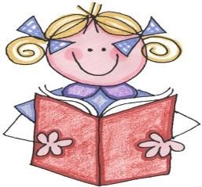 Get your minds ready to read different types of passages!
Fiction | Nonfiction | Poetry | Argumentative
Where and when does this take place?  How does the character change throughout the story?  How does the character feel?  What kind of person is the character? (trait)  What is the problem/ solution in the story?  What is the turning point or important part of the story?  What is the theme?  What is the lesson?  What is the structure? | What is the author trying to inform you about and why?  What do you already know about this topic?  What is the main idea?  What details support the main idea?  What is the structure?  What is the author’s point of view?  What information are you learning from the text features? | What pictures or sounds do you get in your mind as you read this poem?  What is the mood or feeling of this poem?  Is there anything being compared in the poem?  Who is talking in the poem?  What is the message the poet is trying to get across? | What is the author’s opinion, point of view, or claim they are stating?  What reasons support their opinions or claim?  What evidence or examples are provided?  What is the structure?

