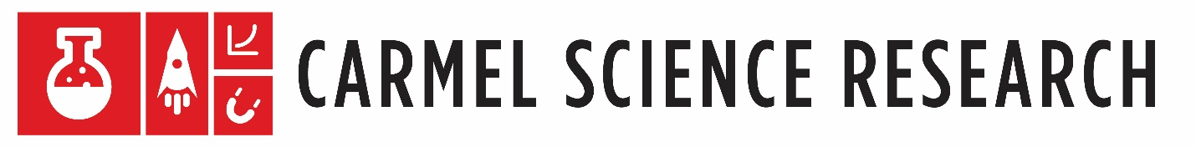

If you are a freshmen and interested in a class that allows you to choose what you study, offers the opportunity to earn up to 12 college credits and to compete in local, state, and national science competitions, then we encourage you to apply!

Carmel Science Research is a three-year program that affords students the opportunity to participate in the community of scientific research as part of their high school experience.

By participating, a student will choose and explore a topic of interest from the physical, natural, or social sciences using professional literature, develop skills in using the internet, and learn to conduct searches of a wide range of databases.

In addition, the student will prepare a plan of novel intended research, communicate with scientists to serve as a mentor, design and conduct a research investigation under the supervision of the science research coordinator and scientist mentor.

Following completion of the authentic research, the student will write a formal research paper and present their findings at local, state, and national competitions.

Applications can be obtained on the Carmel Science Research Website at https://bit.ly/2ekByc4 and must be submitted by Tuesday, May 9, 2023 by 11:59 pm.

All portions of the application are available and to be submitted via the links below:
- Two Essays: https://forms.office.com/r/uwvLnnNR2b
- Teacher Recommendation: https://forms.office.com/r/vBhZ5kQwkm
- Two Article with Summaries: https://forms.office.com/r/HgcitLZL48
- Four Possible Research Questions: https://forms.office.com/r/z9NaFmqn99
- Signed Parent/Guardian Letter: https://forms.office.com/r/bRJmTXcQuE

If you have any questions, please email Dr. Griffin at ngriffin@carmelschools.org!

Visit our website at https://bit.ly/2ekByc4 for more information about the program!

