Creating New Forms for New IEPs

It is very important to create a new form each time you have a new IEP. You can’t simply change the old form that is there. If you do, the data for the 2 IEPs combines and is no longer useful.

When you have a new IEP that is finalized, please follow these steps:

- Log in to portal.office.com

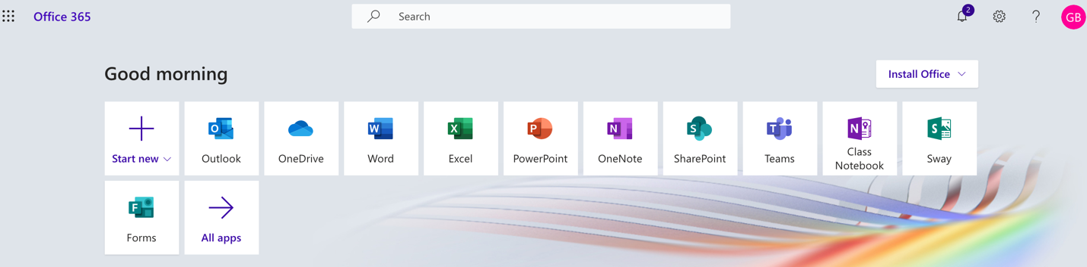

- Click on Forms

- On the forms page, click on the form of the student who just had an IEP:
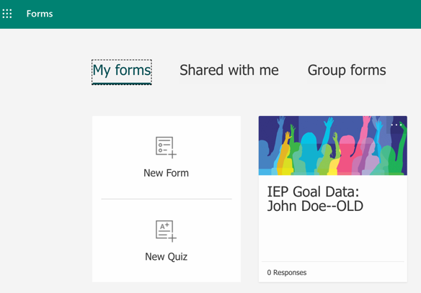

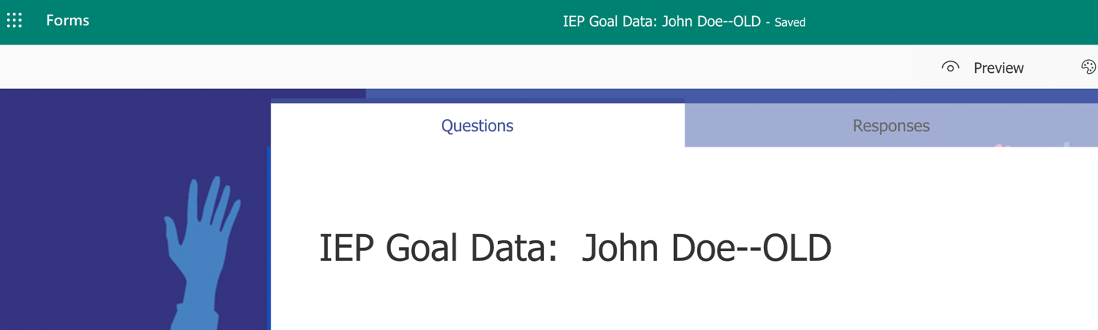
- Type in “OLD” on that form

- Click on “Forms” to go back to the main page

- On the forms page, click on the 3 small dots … on the upper right corner of the student whose form you want to copy.

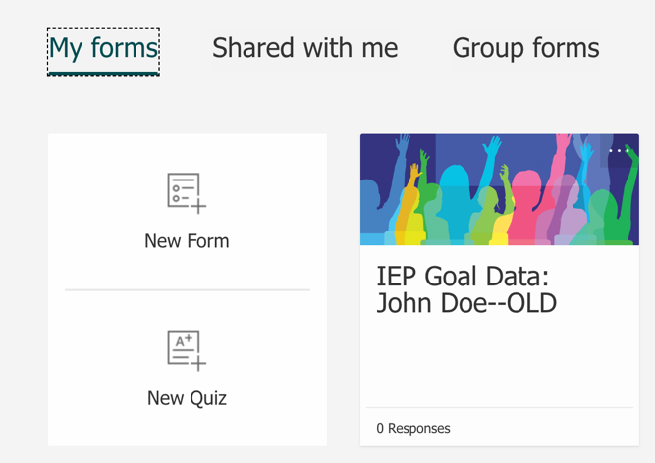

- Click on Copy

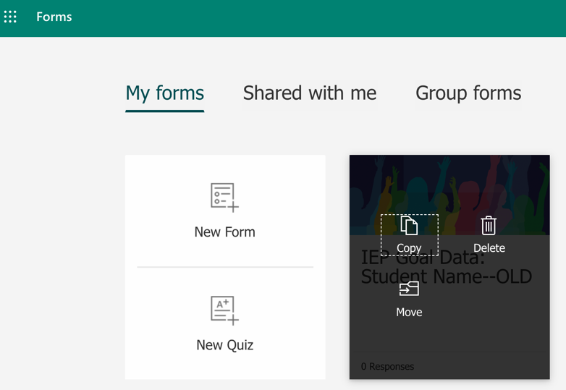

- Click on the new form to go into it.
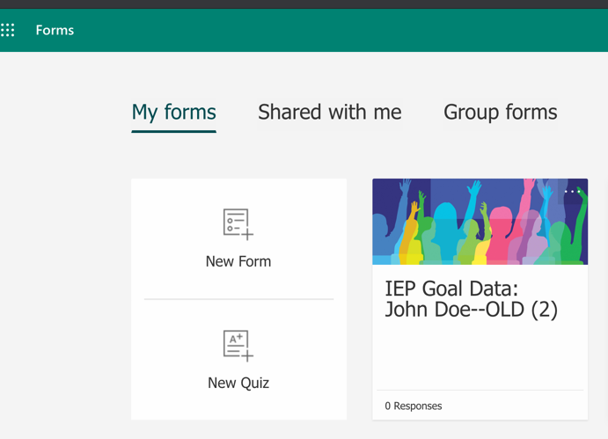

- Change “OLD” to “New” on the form

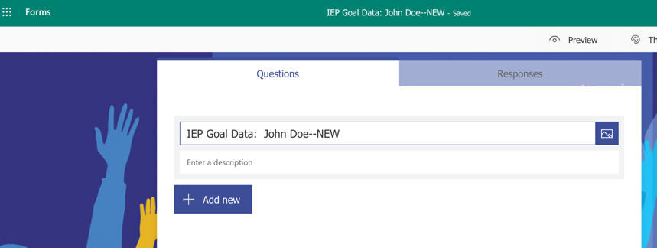

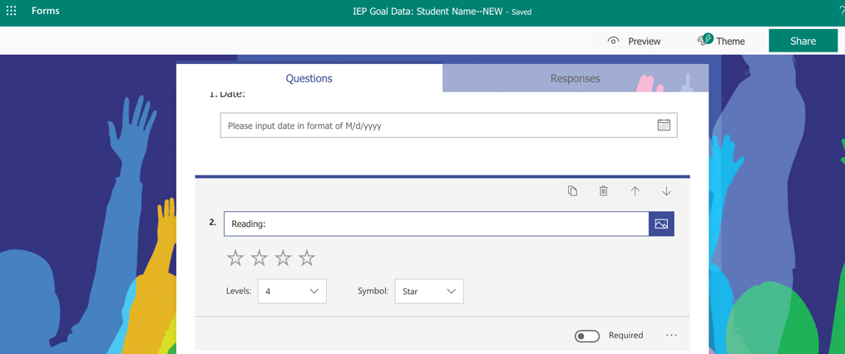
- Update the IEP goals in the NEW Form by deleting the old goals and typing in the new ones. BE SURE YOU ARE IN THE NEW FORM when you do this.

- Copy the link: Click on Share.
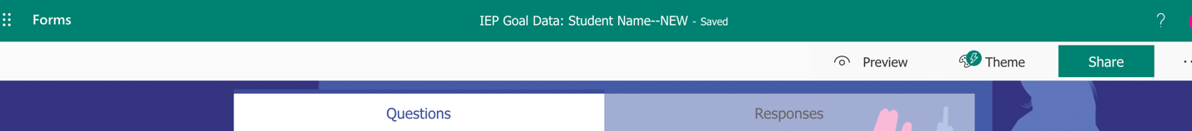

- Click on “Get a Link to View and Edit” under “Share to Collaborate”
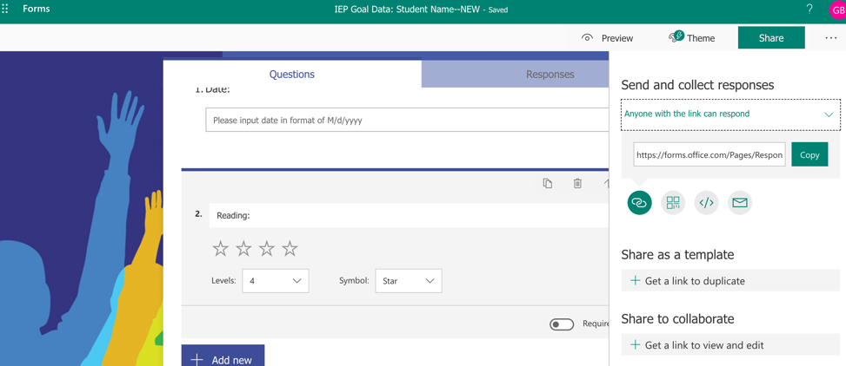

- Click on Copy to copy the link.

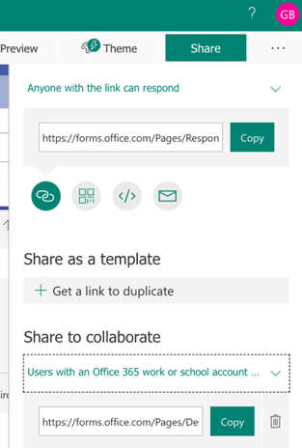

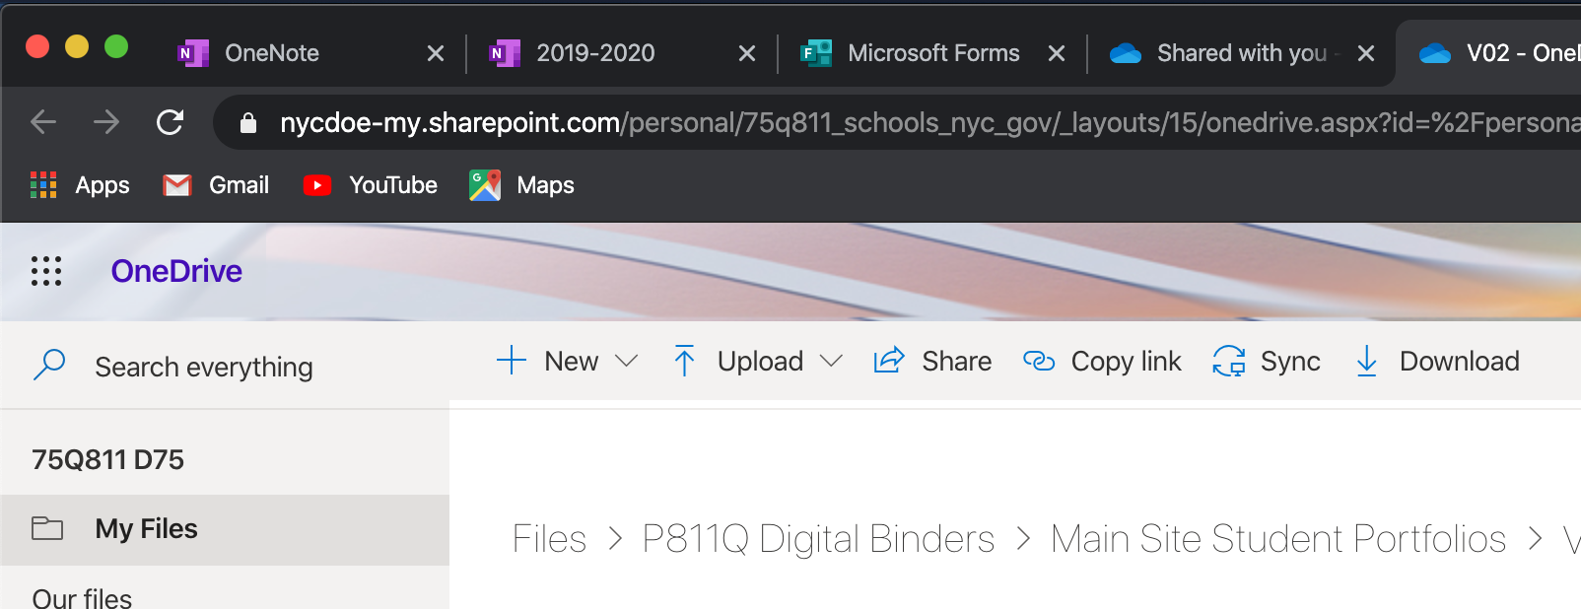
- Open a new tab in the browser and go to One Drive and open the digital binder for the student.

- Click on the IEP Goals Data 2 page.

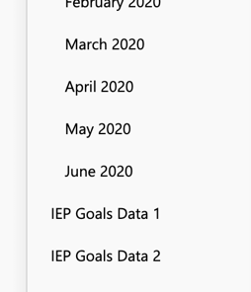

- Click on Insert
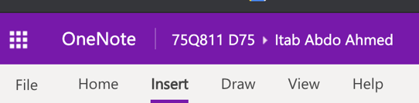

- Click on Link
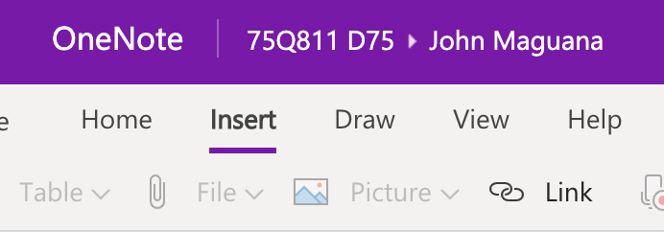

- Paste the link into the address field. (You can hold down the Command Key and “v” to do this on a Mac or you can right click on the mouse and click on paste)
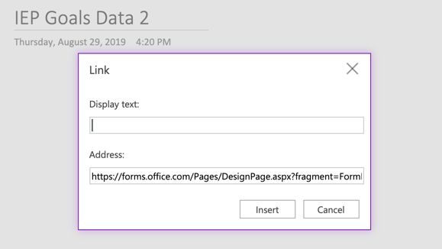

- Type “Link to Shared Form” in the Display Text field.
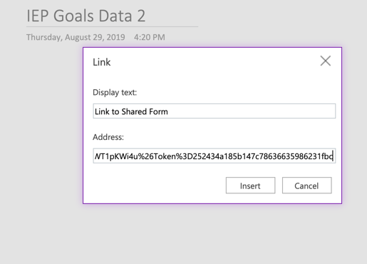

- Click “Insert”
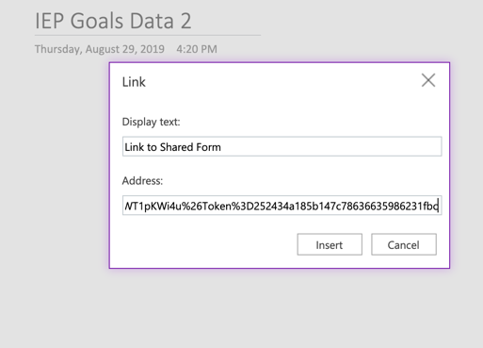

- This is what you should see:
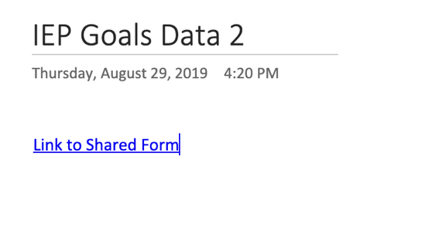

- Hit “Enter” or “Return” on the keyboard twice after “Link to Shared Form” to get to a new line.
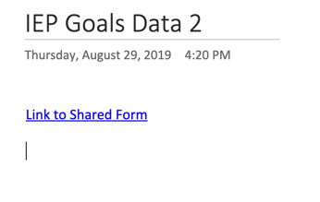

- Click on “Insert” and then “Forms”

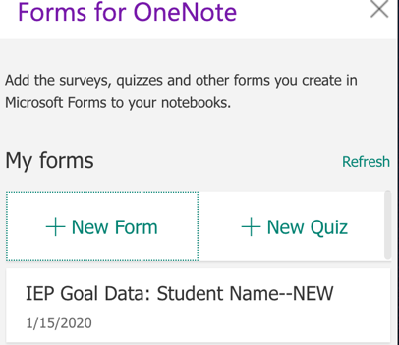
- Hover over the form you want to insert

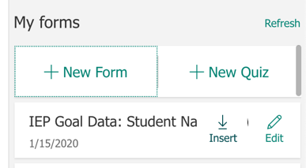
- Click on “Insert:

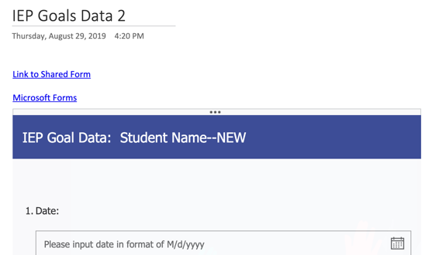
- Your form should be there.

- Use this form when you go to enter data for this student until the next IEP meeting.

