EQUILIBRIUM

- Equilibrium is a state where the concentrations of the reactants and products no longer change with time.

- In equilibrium, the rates of the forward reaction and reverse reaction are equal. This is also true for equilibrium phase changes and solution equilibrium.

- Solution equilibrium is the physical state described by the opposing processes of dissolution and recrystallization occurring at the same rate.
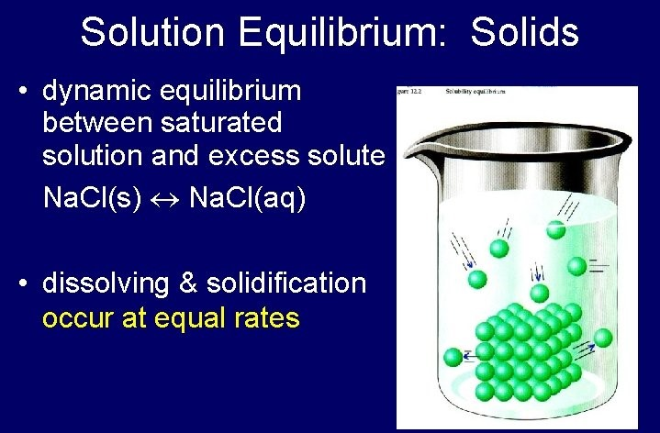

- Phase equilibrium is the study of the equilibrium which exists between or within different states of matter namely solid, liquid and gas.

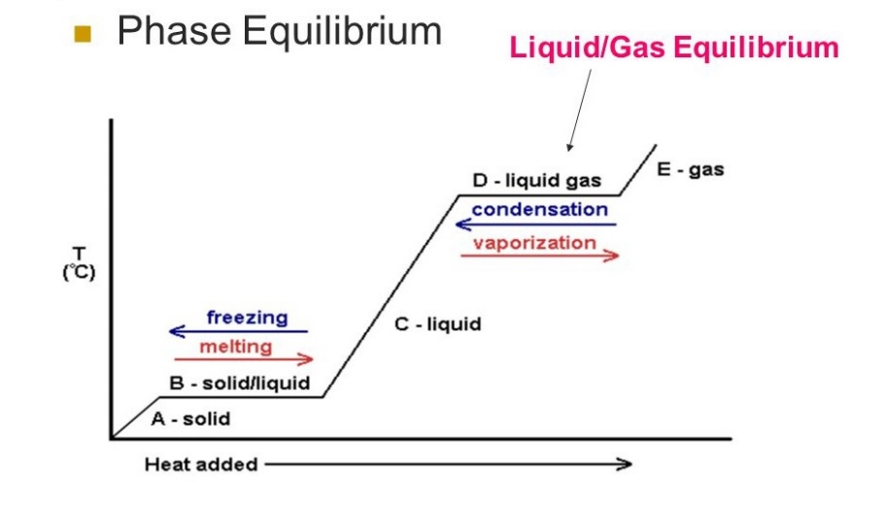

- Rates must be equal in an equilibrium, however, concentrations need not be equal, only constant in a dynamic equilibrium. (See pictures below)

- In order for equilibrium to be maintained when a gas is involved, the reaction must be in a closed container.
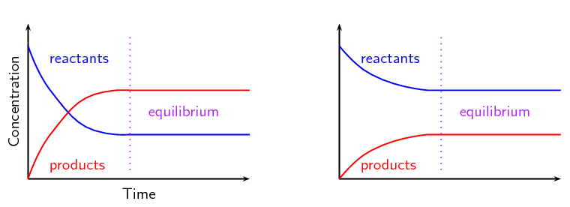
K_{eq} >1 K_{eq} <1

What is K_{eq}?

- K_{eq} is the equilibrium constant.

- It is a ratio of concentrations of products over reactants when they reach equilibrium. Brackets around a chemical mean molarity of that substance. Example: [NO₂] means the molarity of NO₂ at equilibrium.

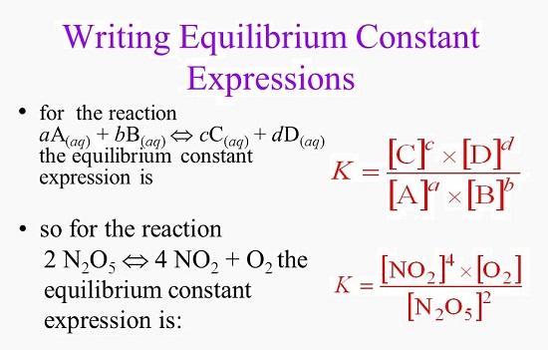

So if at equilibrium the concentrations of the reactants and products are as follows:

[NO₂] = 0.500 M [O₂] = 1.00 M [N₂O₅] = 0.100 M

Then K_{eq} = [0.500]⁴ x [1.00] = 6.25
[0.100]²

Why have we not seen this before?

Many reaction “go to completion.” That means that there is no reverse process because the products created are stable enough to prevent a reverse reaction from occurring. When this occurs, the K_{eq} is a very large number. Remember that K_{eq} is a ratio of concentrations of products over reactants at equilibrium. If there is a much larger concentration of products compared to reactants at equilibrium, we generally don’t consider it a reversible reaction, and just say the reaction mostly goes only fin the forward direction.

Le Châtelier’s Principle?

Le Châtelier's principle states that changes in the temperature, pressure, volume, or concentration of a system will result in a “shifting of equilibrium” to either the product side (right) or the reactant side (left). When equilibrium “shifts,” it means that the reaction will favor that direction.

For example, if a reaction shifts to the right, that means more products will form. If a reaction shifts to the left, that means more reactants will form.

Le Châtelier's Principle can be stated as follows: When a system at equilibrium is stressed, the equilibrium will shift to minimize the effect of the stress.

There are four ways to put a stress on an equilibrium system, thereby shifting equilibrium:

1. Change concentration. By increasing or decreasing concentration, the equilibrium shift to recreate the balance. Note that this will only work on “concentrations”. Adding more “non-dissolving solid” to a reaction will not do anything to equilibrium.

2. Common ion effect. By adding a new salt that contains a “common ion” to an already existing equilibrium, equilibrium will shift just as it would by increasing concentration.

3. Changing Pressure By changing pressure, the equilibrium will shift to the side that is most ”favorable” for the amount of gas particles in the container. Note that changing volume also changes the pressure (Boyle’s Law).

4. Changing Temperature. By changing temperature, the equilibrium will shift to the left if the reaction is exothermic, and to the right if the reaction is endothermic. Both the rates of the forward are reverse reactions will increase as well. Finally, changing temperature is the only way to change the value of the equilibrium constant, K.

The addition of a catalyst changes the rate at which equilibrium is established, but it does NOT affect the position of the equilibrium.

